Table of Contents

UNITED STATES

SECURITIES AND EXCHANGE COMMISSION

Washington, D.C. 20549

FORM 10-Q

(Mark One)

- QUARTERLY REPORT PURSUANT TO SECTION 13 OR 15(d) OF THE SECURITIES EXCHANGE ACT OF 1934

For the quarterly period ended September 30, 2024

OR

- TRANSITION REPORT PURSUANT TO SECTION 13 OR 15(d) OF THE SECURITIES EXCHANGE ACT OF 1934

For the transition period from | to
Commission File Number 001-40836

Brilliant Earth Group, Inc.

(Exact name of registrant as specified in its charter)

 |  | Delaware |  |  |  |  | 87-1015499
(State or other jurisdiction of incorporation or organization) |  |  |  |  |  |  | (I.R.S. Employer Identification Number)
 | 300 Grant Avenue, Third Floor
 | San Francisco, CA |  |  |  |  |  | 94108
 | (Address of principal executive offices) |  |  |  |  |  |  | (Zip Code)
 |  |  |  | (800) 691-0952
 |  |  |  | (Registrant's telephone number, including area code)
 |  |  |  |  | N/A
 |  | (Former name, former address and former fiscal year, if changed since last report)
 |  |  |  | Securities registered pursuant to Section 12(b) of the Act:
 | Title of each class |  |  |  | Trading Symbol(s) |  |  | Name of each exchange on which registered
Class A common stock, $0.0001 par value per share |  |  |  |  | BRLT |  |  |  | The Nasdaq Global Market

Indicate by check mark whether the registrant (1) has filed all reports required to be filed by Section 13 or 15(d) of the Securities Exchange Act of 1934 during the preceding 12 months (or for such shorter period that the registrant was required to file such reports), and (2) has been subject to such filing requirements for the past 90 days. Yes ☒ No ☐

Indicate by check mark whether the registrant has submitted electronically every Interactive Data File required to be submitted pursuant to Rule 405 of Regulation S-T (§232.405 of this chapter) during the preceding 12 months (or for such shorter period that the registrant was required to submit such files). Yes ☒ No ☐

Indicate by check mark whether the registrant is a large accelerated filer, an accelerated filer, a non-accelerated filer, a smaller reporting company or an emerging growth company. See the definitions of "large accelerated filer," "accelerated filer," "smaller reporting company" and "emerging growth company" in Rule 12b-2 of the Exchange Act.

Large accelerated filer | ☐ | Accelerated filer | ☐
Non-accelerated filer | ☒ | Smaller reporting company | ☒
 |  | Emerging growth company | ☒

If an emerging growth company, indicate by check mark if the registrant has elected not to use the extended transition period for complying with any new or revised financial accounting standards provided pursuant to Section 13(a) of the Exchange Act. ☐
Indicate by check mark whether the registrant is a shell company (as defined in Rule 12b-2 of the Exchange Act). Yes ☐ No ☒

As of November 4, 2024, there were 13,624,810 shares of the registrant's Class A common stock, $0.0001 par value per share, outstanding, 35,806,812 shares of the registrant's Class B common stock, $0.0001 par value per share, outstanding, 49,119,976 shares of the registrant's Class C common stock, $0.0001 par value per share, outstanding and no shares of the registrant's Class D common stock, $0.0001 per share, outstanding.

1

Table of Contents

 |  |  |  |  |  |  |  |  |  |  |  |  | Table of Contents
 |  |  |  |  |  |  |  |  |  |  |  |  |  |  | Page
Part I - Financial Information
 | Item 1. Financial Statements. |  |  |  |  |  |  |  |  |  |  |  |  |  | 5
 | Item 2. Management's Discussion and Analysis of Financial Condition and Results of Operations. |  |  |  |  |  |  |  |  |  |  |  |  |  |  | 24
 | Item 3. Quantitative and Qualitative Disclosures About Market Risk. |  |  |  |  |  |  |  |  |  |  |  |  |  |  | 38
 | Item 4. Controls and Procedures. |  |  |  |  |  |  |  |  |  |  |  |  |  | 39
Part II - Other Information
 | Item 1. Legal Proceedings. |  |  |  |  |  |  |  |  |  |  |  |  |  | 41
 | Item 1A. Risk Factors. |  |  |  |  |  |  |  |  |  |  |  |  |  |  | 41
 | Item 2. Unregistered Sales of Equity Securities and Use of Proceeds |  |  |  |  |  |  |  |  |  |  |  |  |  |  | 41
 | Item 3. Defaults Upon Senior Securities. |  |  |  |  |  |  |  |  |  |  |  |  |  | 42
 | Item 4. Mine Safety Disclosures. |  |  |  |  |  |  |  |  |  |  |  |  |  |  | 42
 | Item 5. Other Information. |  |  |  |  |  |  |  |  |  |  |  |  |  |  | 42
 | Item 6. Exhibits. |  |  |  |  |  |  |  |  |  |  |  |  |  |  | 43
Signatures |  |  |  |  |  |  |  |  |  |  |  |  |  |  |  | 44

2

Table of Contents

CAUTIONARY NOTE REGARDING FORWARD-LOOKING STATEMENTS

This Quarterly Report on Form 10-Q contains forward-looking statements. We intend such forward-looking statements to be covered by the safe harbor provisions for forward-looking statements contained in Section 27A of the Securities Act of 1933, as amended (the “Securities Act”), and Section 21E of the Securities Exchange Act of 1934, as amended (the “Exchange Act”). All statements other than statements of historical facts contained in this Quarterly Report on Form 10-Q may be forward-looking statements. Statements regarding our future results of operations and financial position, business strategy, plans and objectives of management for future operations, including, among others, statements regarding expected growth, introduction of new products, future capital expenditures, and debt service obligations, are forward-looking statements. In some cases, you can identify forward-looking statements by terms, such as “anticipate,” “believe,” “contemplate,” “continue,” “could,” “estimate,” “evolve,” “expect,” “intend,” “may,” “plan,” “potential,” “predict,” “seek,” “should,” “strategy,” “target,” “will,” or “would,” or the negative of these terms or other similar expressions. Accordingly, we caution you that any such forward-looking statements are not guarantees of future performance and are subject to risks, assumptions, and uncertainties that are difficult to predict.
We have based these forward-looking statements largely on our current expectations and projections about future events and trends that we believe may affect our financial condition, results of operations, business strategy, short-term and long-term business operations and objectives, and financial needs. Although we believe that the expectations reflected in these forward-looking statements are reasonable as of the date made, actual results may prove to be materially different from the results expressed or implied by the forward-looking statements. These forward-looking statements are subject to a number of risks, uncertainties, and assumptions, including, but not limited to risks related to: fluctuations in the pricing and supply of diamonds, other gemstones, and precious metals, particularly responsibly sourced natural and lab-grown diamonds and recycled precious metals such as gold; increases in labor costs for manufacturing such as wage rate increases, as well as inflation, and energy prices; risks related to an overall decline in the health of the economy and other factors impacting consumer spending, such as recessionary or inflationary conditions, governmental instability, war and fears of war, and natural disasters; our ability to cost-effectively turn existing customers into repeat customers or to acquire new customers; our rapid growth in recent years and limited operating experience at our current scale of operations; our ability to manage growth effectively; increased lead times, and supply shortages and supply changes; our expansion plans in the United States ("U.S."); our ability to compete in the fine jewelry retail industry; our ability to maintain and enhance our brand and to engage or expand our base of customers may be impaired and our business, financial condition, and results of operations may suffer; our ability to effectively develop and expand our sales and marketing capabilities and increase our customer base and achieve broader market acceptance of our e-commerce and omnichannel approach to shopping for fine jewelry; our profitability and cash flows may be negatively affected if we are not successful in managing our inventory balances and inventory shrinkage; a decline in sales of Design Your Own rings; our heavy reliance on our information technology systems, as well as those of our third-party vendors and service providers, for our business to effectively operate and to safeguard confidential information and risks related to any significant failure, inadequacy or interruption of these systems, security breaches or loss of data; the impact of environmental, social, and governance matters on our business and reputation; our ability to manage risks related to our e-commerce and omnichannel business; our ability to effectively anticipate and respond to changes in consumer preferences and shopping patterns, and introduce new products and programs that appeal to new or existing customers; our dependence on distributions from Brilliant Earth, LLC, our principal asset, to pay our taxes and expenses, including payments under the Tax Receivable Agreement (as defined herein) to Continuing Equity Owners (as defined herein) in respect to certain tax benefits; risks related to our obligations to make substantial cash payments under the Tax Receivable Agreement and risks related to our organizational structure; and the other risks, uncertainties and factors described in Part I, Item 1A, "Risk Factors" in our Annual Report on Form 10-K for the fiscal year ended December 31, 2023 (the "2023 Form 10-K") filed with the Securities and Exchange Commission (the "SEC") on March 28, 2024. Other sections of this Quarterly Report on Form 10-Q include additional factors that could adversely impact our business and financial performance.

Moreover, we operate in a very competitive and rapidly changing environment and new risks emerge from time to time. In light of these risks, uncertainties, and assumptions, the future events and trends discussed in this Quarterly Report on Form 10-Q may not occur and actual results could differ materially and adversely from those anticipated or implied in the forward-looking statements.

3

Table of Contents

You should not rely upon forward-looking statements as predictions of future events. This Quarterly Report on Form 10-Q and the documents that we have filed as exhibits should be read with the understanding that our actual future results, levels of activity, performance and achievements may be materially different from what we expect. We qualify all of our forward-looking statements by these cautionary statements. These forward-looking statements speak only as of the date of this Quarterly Report on Form 10-Q. Except as required by applicable law, we undertake no obligation to update or revise any forward-looking statements contained in this Quarterly Report on Form 10-Q, whether as a result of any new information, future events or otherwise.

BASIS OF PRESENTATION

As used in this Quarterly Report on Form 10-Q, unless the context otherwise requires, references to:

- "we," "us," "our," the "Company," "Brilliant Earth," and similar references refer to Brilliant Earth Group, Inc., and, unless otherwise stated, all of its subsidiaries, including Brilliant Earth, LLC.
- "Continuing Equity Owners" refers collectively to holders of LLC Interests (as defined below) and our Class B common stock and Class C common stock, including our Founders (as defined below) and Mainsail (as defined below), who may, exchange at each of their respective options, in whole or in part from time to time, their LLC Interests (along with an equal number of shares of Class B common stock or Class C common stock (and such shares shall be immediately cancelled), as applicable), for, at our election (determined solely by our independent directors (within the meaning of the Nasdaq rules) who are disinterested), cash or newly-issued shares of our Class A common stock or Class D common stock, as applicable.

- "Founders" refers to Beth Gerstein, our Co-Founder and Chief Executive Officer, Eric Grossberg, our Co-Founder and Executive Chairman, and Just Rocks, Inc., a Delaware corporation, which is jointly owned and controlled by our Founders.

- "LLC Interests" or "LLC Units" refers to the common units of Brilliant Earth, LLC, including those that we purchased with the net proceeds from our initial public offering ("IPO"), which occurred on September 23, 2021.

- "LLC Agreement" refers to Brilliant Earth, LLC's amended and restated limited liability company agreement, which became effective prior to the consummation of the IPO.

- "Mainsail" refers to Mainsail Partners III, L.P., our sponsor and a Delaware limited partnership, and certain funds affiliated with Mainsail Partners III, L.P., including Mainsail Incentive Program, LLC, and Mainsail Co-Investors III, L.P.
- "TRA" refers to the Tax Receivable Agreement with Brilliant Earth, LLC and the Continuing Equity Owners that provides for the payment by Brilliant Earth Group, Inc. to the Continuing Equity Owners of 85% of the amount of tax benefits, if any, that Brilliant Earth Group, Inc. actually realizes (or in some circumstances is deemed to realize) related to certain tax basis adjustments and payments made under the TRA.

4

Table of Contents

Part I - Financial Information

Item 1. Financial Statements

Brilliant Earth Group, Inc.

UNAUDITED CONDENSED CONSOLIDATED BALANCE SHEETS

(in thousands except share and per share amounts)

 | September 30, |  |  |  | December 31,
 | 2024 |  |  |  | 2023
Assets
Current assets:
Cash and cash equivalents | $ | 152,653 |  | $ | 155,809
Restricted cash |  | 215 |  |  | 211
Inventories, net |  | 38,530 |  |  | 37,788
Prepaid expenses and other current assets |  | 11,346 |  |  | 11,048
Total current assets |  | 202,744 |  |  | 204,856
Property and equipment, net |  | 21,768 |  |  | 22,047
Deferred tax assets |  | 9,335 |  |  | 9,745
Operating lease right of use assets |  | 36,026 |  |  | 34,248
Other assets |  | 3,373 |  |  | 2,687
Total assets | $ | 273,246 |  | $ | 273,583
Liabilities and stockholders' equity
Current liabilities:
Accounts payable | $ | 2,199 |  | $ | 4,511
Accrued expenses and other current liabilities |  | 36,252 |  |  | 43,824
Deferred revenue |  | 21,538 |  |  | 19,556
Current portion of operating lease liabilities |  | 5,930 |  |  | 4,993
Current portion of long-term debt |  | 6,500 |  |  | 4,063
Total current liabilities |  | 72,419 |  |  | 76,947
Long-term debt, net of debt issuance costs |  | 51,588 |  |  | 55,573
Operating lease liabilities |  | 37,056 |  |  | 35,572
Payable pursuant to the Tax Receivable Agreement |  | 7,828 |  |  | 8,035
Total liabilities |  | 168,891 |  |  | 176,127
Commitments and contingencies (Note 10)
Stockholders' equity
Preferred stock, $0.0001 par value, 10,000,000 shares authorized, none issued and outstanding at September 30, 2024 and December 31, 2023, respectively |  | — |  |  | —
Class A common stock, $0.0001 par value, 1,200,000,000 shares authorized; 13,844,407 shares issued and 13,669,852 shares outstanding at September 30, 2024 and |  | 1 |  |  | 1
12,522,146 shares outstanding at December 31, 2023 |  | 1 |  |  | 1
Class B common stock, $0.0001 par value, 150,000,000 shares authorized; 35,799,762 and 35,688,349 shares outstanding at September 30, 2024 and December 31, 2023, |  | 4 |  |  | 4
respectively |  | 4 |  |  | 4
Class C common stock, $0.0001 par value, 150,000,000 shares authorized; 49,119,976 shares outstanding at September 30, 2024 and December 31, 2023, respectively |  | 5 |  |  | 5
Class D common stock, $0.0001 par value, 150,000,000 shares authorized; none issued and outstanding at September 30, 2024 and December 31, 2023, respectively |  | — |  |  | —
Additional paid-in capital |  | 10,467 |  |  | 8,275
Treasury stock, at cost; 174,555 shares and none at September 30, 2024 and December 31, 2023, respectively |  | (438) |  |  | —
Retained earnings |  | 4,430 |  |  | 4,247
Stockholders' equity attributable to Brilliant Earth Group, Inc. |  | 14,469 |  |  | 12,532
Non-controlling interests attributable to Brilliant Earth, LLC |  | 89,886 |  |  | 84,924
Total stockholders' equity |  | 104,355 |  |  | 97,456
Total liabilities and stockholders' equity | $ | 273,246 |  | $ | 273,583

The accompanying notes are an integral part of these unaudited condensed consolidated financial statements.

5

Table of Contents

Brilliant Earth Group, Inc.

UNAUDITED CONDENSED CONSOLIDATED STATEMENTS OF OPERATIONS

(in thousands except share and per share amounts)

 |  | Three Months Ended |  |  |  |  |  | Nine Months Ended
 |  | September 30, |  |  |  |  |  | September 30,
 |  | 2024 |  |  | 2023 |  |  | 2024 |  |  | 2023
Net sales | $ | 99,873 |  | $ | 114,154 |  | $ | 302,636 |  | $ | 322,036
Cost of sales |  | 39,103 |  |  | 47,327 |  |  | 119,483 |  |  | 138,044
Gross profit |  | 60,770 |  |  | 66,827 |  |  | 183,153 |  |  | 183,992
Operating expenses:
Selling, general and administrative |  | 61,839 |  |  | 64,813 |  |  | 182,213 |  |  | 180,708
(Loss) income from operations |  | (1,069) |  |  | 2,014 |  |  | 940 |  |  | 3,284
Interest expense |  | (1,320) |  |  | (1,322) |  |  | (3,827) |  |  | (3,808)
Other income, net |  | 1,525 |  |  | 1,401 |  |  | 4,476 |  |  | 3,436
(Loss) income before tax |  | (864) |  |  | 2,093 |  |  | 1,589 |  |  | 2,912
Income tax expense |  | (211) |  |  | (95) |  |  | (222) |  |  | (119)
Net (loss) income |  | (1,075) |  |  | 1,998 |  |  | 1,367 |  |  | 2,793
Net (loss) income allocable to non-controlling interest |  | (934) |  |  | 1,753 |  |  | 1,184 |  |  | 2,452
Net (loss) income allocable to Brilliant Earth Group, Inc. | $ | (141) |  | $ | 245 |  | $ | 183 |  | $ | 341
Earnings per share:
Basic | $ | (0.01) |  | $ | 0.02 |  | $ | 0.01 |  | $ | 0.03
Diluted | $ | (0.01) |  | $ | 0.02 |  | $ | 0.01 |  | $ | 0.02
Weighted average shares of common stock outstanding:
Basic |  | 13,545,256 |  |  | 12,149,770 |  |  | 13,203,551 |  |  | 11,780,905
Diluted |  | 13,545,256 |  |  | 97,194,920 |  |  | 98,527,171 |  |  | 96,918,465

The accompanying notes are an integral part of these unaudited condensed consolidated financial statements.

6

Table of Contents

Brilliant Earth Group, Inc.

UNAUDITED CONDENSED CONSOLIDATED STATEMENTS OF CHANGES IN STOCKHOLDERS' EQUITY

(in thousands except share amounts)

 |  |  |  |  |  |  |  |  | Brilliant Earth Group, Inc. Stockholders' Equity
 | Class A Common Stock |  |  |  |  | Class B Common Stock |  |  |  |  | Class C Common Stock |  |  |  |  |  |  |  |  |  |  |  |  |  |  |  |  | Non-Controlling Interest
 |  |  |  |  |  |  |  |  |  |  |  |  |  |  |  |  | Additional |  |  |  |  |  |  |  |  |  |  |  |  |  |  |  |  | Total
 | Shares |  |  | Amount |  | Shares |  |  | Amount |  | Shares |  |  | Amount |  |  | Paid-In |  |  | Treasury |  |  | Retained |  |  | Stockholders' |  | Units |  |  | Amounts |  |  | Stockholders'
 |  |  |  |  |  |  |  |  |  |  |  |  |  |  |  |  | Capital |  |  | Stock |  |  | Earnings |  |  | Equity |  |  |  |  |  |  |  | Equity
Balance, January 1, 2024 | 12,522,146 |  | $ | 1 |  | 35,688,349 |  | $ | 4 |  | 49,119,976 |  | $ | 5 |  | $ | 8,275 |  | $ | — |  | $ | 4,247 |  | $ | 12,532 |  | 84,808,325 |  | $ | 84,924 |  | $ | 97,456
Tax distributions to | — |  |  | — |  | — |  |  | — |  | — |  |  | — |  |  | — |  |  | — |  |  | — |  |  | — |  | — |  |  | (988) |  |  | (988)
members |  |  |  |  |  |  |  |  |  |  |  |  |  |  |  |  |  |  |  |  |  |  |  |  |  |  |  |  |  |  | (988) |  |  | (988)
Conversion of Class B to | 16,260 |  |  | — |  | (16,260) |  |  | — |  | — |  |  | — |  |  | — |  |  | — |  |  | — |  |  | — |  | (16,260) |  |  | — |  |  | —
Class A common stock | 16,260 |  |  |  |  | (16,260) |  |  |  |  |  |  |  |  |  |  |  |  |  |  |  |  |  |  |  |  |  | (16,260) |  |  |  |  |  | —
RSU vesting during period | 506,264 |  |  | — |  | — |  |  | — |  | — |  |  | — |  |  | — |  |  | — |  |  | — |  |  | — |  | — |  |  | — |  |  | —
Repurchases of common | (32,371) |  |  | — |  | — |  |  | — |  | — |  |  | — |  |  | — |  |  | (100) |  |  | — |  |  | (100) |  | — |  |  | — |  |  | (100)
stock | (32,371) |  |  |  |  |  |  |  |  |  |  |  |  |  |  |  |  |  |  | (100) |  |  |  |  |  | (100) |  |  |  |  |  |  |  | (100)
Class B shares issued upon | — |  |  | — |  | 84,187 |  |  | — |  | — |  |  | — |  |  | — |  |  | — |  |  | — |  |  | — |  | 84,187 |  |  | — |  |  | —
vesting of LLC units |  |  |  |  |  | 84,187 |  |  |  |  |  |  |  |  |  |  |  |  |  |  |  |  |  |  |  |  |  | 84,187 |  |  |  |  |  | —
Change in deferred tax
asset and TRA liability
related to redemption of | — |  |  | — |  | — |  |  | — |  | — |  |  | — |  |  | (164) |  |  | — |  |  | — |  |  | (164) |  | — |  |  | — |  |  | (164)
LLC Units |  |  |  |  |  |  |  |  |  |  |  |  |  |  |  |  | (164) |  |  |  |  |  |  |  |  | (164) |  |  |  |  |  |  |  | (164)
Equity-based compensation | — |  |  | — |  | — |  |  | — |  | — |  |  | — |  |  | 2,541 |  |  | — |  |  | — |  |  | 2,541 |  | — |  |  | 46 |  |  | 2,587
Net income | — |  |  | — |  | — |  |  | — |  | — |  |  | — |  |  | — |  |  | — |  |  | 139 |  |  | 139 |  | — |  |  | 928 |  |  | 1,067
Rebalancing of controlling | — |  |  | — |  | — |  |  | — |  | — |  |  | — |  |  | (1,674) |  |  | — |  |  | — |  |  | (1,674) |  | — |  |  | 1,674 |  |  | —
and non-controlling interest |  |  |  |  |  |  |  |  |  |  |  |  |  |  |  |  | (1,674) |  |  |  |  |  |  |  |  | (1,674) |  |  |  |  | 1,674 |  |  | —
Balance, March 31, 2024 | 13,012,299 |  | $ | 1 |  | 35,756,276 |  | $ | 4 |  | 49,119,976 |  | $ | 5 |  | $ | 8,978 |  | $ | (100) |  | $ | 4,386 |  | $ | 13,274 |  | 84,876,252 |  | $ | 86,584 |  | $ | 99,858
Tax distributions to | — |  |  | — |  | — |  |  | — |  | — |  |  | — |  |  | — |  |  | — |  |  | — |  |  | — |  | — |  |  | (539) |  |  | (539)
members | — |  |  |  |  |  |  |  |  |  |  |  |  | — |  |  | — |  |  | — |  |  | — |  |  |  |  |  |  |  | (539) |  |  | (539)
RSU vesting during period | 484,548 |  |  | — |  | — |  |  | — |  | — |  |  | — |  |  | — |  |  | — |  |  | — |  |  | — |  | — |  |  | — |  |  | —
Repurchases of common | (61,694) |  |  | — |  | — |  |  | — |  | — |  |  | — |  |  | — |  |  | (159) |  |  | — |  |  | (159) |  | — |  |  | — |  |  | (159)
stock | (61,694) |  |  |  |  |  |  |  |  |  |  |  |  |  |  |  |  |  |  | (159) |  |  |  |  |  | (159) |  |  |  |  |  |  |  | (159)
Class B shares issued upon | — |  |  | — |  | 22,338 |  |  | — |  | — |  |  | — |  |  | — |  |  | — |  |  | — |  |  | — |  | 22,338 |  |  | — |  |  | —
vesting of LLC units |  |  |  |  |  | 22,338 |  |  |  |  |  |  |  |  |  |  |  |  |  |  |  |  |  |  |  |  |  | 22,338 |  |  |  |  |  | —
Change in deferred tax
asset and TRA liability
related to redemption of | — |  |  | — |  | — |  |  | — |  | — |  |  | — |  |  | (11) |  |  | — |  |  | — |  |  | (11) |  | — |  |  | — |  |  | (11)
LLC Units |  |  |  |  |  |  |  |  |  |  |  |  |  |  |  |  | (11) |  |  |  |  |  |  |  |  | (11) |  |  |  |  |  |  |  | (11)
Equity-based compensation | — |  |  | — |  | — |  |  | — |  | — |  |  | — |  |  | 2,398 |  |  | — |  |  | — |  |  | 2,398 |  | — |  |  | 27 |  |  | 2,425
Net income | — |  |  | — |  | — |  |  | — |  | — |  |  | — |  |  | — |  |  | — |  |  | 185 |  |  | 185 |  | — |  |  | 1,190 |  |  | 1,375
Rebalancing of controlling | — |  |  | — |  | — |  |  | — |  | — |  |  | — |  |  | (1,621) |  |  | — |  |  | — |  |  | (1,621) |  | — |  |  | 1,621 |  |  | —
and non-controlling interest |  |  |  |  |  |  |  |  |  |  |  |  |  |  |  |  | (1,621) |  |  |  |  |  |  |  |  | (1,621) |  |  |  |  | 1,621 |  |  | —
Balance, June 30, 2024 | 13,435,153 |  | $ | 1 |  | 35,778,614 |  | $ | 4 |  | 49,119,976 |  | $ | 5 |  | $ | 9,744 |  | $ | (259) |  | $ | 4,571 |  | $ | 14,066 |  | 84,898,590 |  | $ | 88,883 |  | $ | 102,949
Tax distributions to | — |  |  | — |  | — |  |  | — |  | — |  |  | — |  |  | — |  |  | — |  |  | — |  |  | — |  | — |  |  | (50) |  |  | (50)
members |  |  |  |  |  |  |  |  |  |  |  |  |  |  |  |  |  |  |  |  |  |  |  |  |  |  |  |  |  |  | (50) |  |  | (50)
RSU vesting during period | 315,189 |  |  | — |  |  |  |  | — |  | — |  |  | — |  |  | — |  |  | — |  |  | — |  |  | — |  | — |  |  | — |  |  | —
Repurchases of common | (80,490) |  |  | — |  | — |  |  | — |  | — |  |  | — |  |  | — |  |  | (179) |  |  | — |  |  | (179) |  | — |  |  | — |  |  | (179)
stock | (80,490) |  |  |  |  |  |  |  |  |  |  |  |  |  |  |  |  |  |  | (179) |  |  |  |  |  | (179) |  |  |  |  |  |  |  | (179)
Class B shares issued upon | — |  |  | — |  | 21,148 |  |  | — |  | — |  |  | — |  |  | — |  |  | — |  |  | — |  |  | — |  | 21,148 |  |  | — |  |  | —
vesting of LLC units |  |  |  |  |  | 21,148 |  |  |  |  |  |  |  |  |  |  |  |  |  |  |  |  |  |  |  |  |  | 21,148 |  |  |  |  |  | —
Change in deferred tax
asset and TRA liability
related to redemption of | — |  |  | — |  | — |  |  | — |  | — |  |  | — |  |  | 186 |  |  | — |  |  | — |  |  | 186 |  | — |  |  | — |  |  | 186
LLC Units |  |  |  |  |  |  |  |  |  |  |  |  |  |  |  |  | 186 |  |  |  |  |  |  |  |  | 186 |  |  |  |  |  |  |  | 186
Equity-based compensation | — |  |  | — |  | — |  |  | — |  | — |  |  | — |  |  | 2,497 |  |  | — |  |  | — |  |  | 2,497 |  | — |  |  | 27 |  |  | 2,524
Net loss | — |  |  | — |  | — |  |  | — |  | — |  |  | — |  |  | — |  |  | — |  |  | (141) |  |  | (141) |  | — |  |  | (934) |  |  | (1,075)
Rebalancing of controlling | — |  |  | — |  | — |  |  | — |  | — |  |  | — |  |  | (1,960) |  |  | — |  |  | — |  |  | (1,960) |  | — |  |  | 1,960 |  |  | —
and non-controlling interest |  |  |  |  |  |  |  |  |  |  |  |  |  |  |  |  | (1,960) |  |  |  |  |  |  |  |  | (1,960) |  |  |  |  | 1,960 |  |  | —
Balance, September 30, | 13,669,852 |  | $ | 1 |  | 35,799,762 |  | $ | 4 |  | 49,119,976 |  | $ | 5 |  | $ | 10,467 |  | $ | (438) |  | $ | 4,430 |  | $ | 14,469 |  | 84,919,738 |  | $ | 89,886 |  | $ | 104,355
2024 | 13,669,852 |  | $ | 1 |  | 35,799,762 |  | $ | 4 |  | 49,119,976 |  | $ | 5 |  | $ | 10,467 |  | $ | (438) |  | $ | 4,430 |  | $ | 14,469 |  | 84,919,738 |  | $ | 89,886 |  | $ | 104,355

The accompanying notes are an integral part of these unaudited condensed consolidated financial statements.

7

Table of Contents

Brilliant Earth Group, Inc.

UNAUDITED CONDENSED CONSOLIDATED STATEMENTS OF CHANGES IN STOCKHOLDERS' EQUITY

(in thousands except share amounts)

 |  |  |  |  |  |  |  | Brilliant Earth Group, Inc. Stockholders' Equity
 | Class A Common Stock |  |  |  |  | Class B Common Stock |  |  |  |  | Class C Common Stock |  |  |  |  |  |  |  |  |  |  |  |  |  | Non-Controlling Interest
 |  |  |  |  |  |  |  |  |  |  |  |  |  |  |  |  | Additional |  |  |  |  |  |  |  |  |  |  |  |  |  | Total
 | Shares |  |  | Amount |  | Shares |  |  | Amount |  | Shares |  |  | Amount |  |  | Paid-In |  |  | Retained |  |  | Stockholders' |  | Units |  |  | Amounts |  |  | Stockholders'
 |  |  |  |  |  |  |  |  |  |  |  |  |  |  |  |  | Capital |  |  | Earnings |  |  | Equity |  |  |  |  |  |  |  | Equity
Balance, January 1, 2023 | 11,246,694 |  | $ | 1 |  | 35,482,534 |  | $ | 4 |  | 49,119,976 |  | $ | 5 |  | $ | 7,256 |  | $ | 3,663 |  | $ | 10,929 |  | 84,602,510 |  | $ | 82,212 |  | $ | 93,141
Tax distributions to members | — |  |  | — |  | — |  |  | — |  | — |  |  | — |  |  | — |  |  | — |  |  | — |  | — |  |  | (1,468) |  |  | (1,468)
Conversion of Class B to Class
A common stock | 71,886 |  |  | — |  | (71,886) |  |  | — |  | — |  |  | — |  |  | — |  |  | — |  |  | — |  | (71,886) |  |  | — |  |  | —
RSU vesting during period | 252,941 |  |  | — |  | — |  |  | — |  | — |  |  | — |  |  | — |  |  | — |  |  | — |  | — |  |  | — |  |  | —
Class B shares issued upon
vesting of LLC units | — |  |  | — |  | 115,437 |  |  | — |  | — |  |  | — |  |  | — |  |  | — |  |  | — |  | 115,437 |  |  | — |  |  | —
Change in deferred tax asset and
TRA liability related to
redemption of LLC Units | — |  |  | — |  | — |  |  | — |  | — |  |  | — |  |  | (65) |  |  | — |  |  | (65) |  | — |  |  | — |  |  | (65)
Equity-based compensation | — |  |  | — |  | — |  |  | — |  | — |  |  | — |  |  | 2,204 |  |  | — |  |  | 2,204 |  | — |  |  | 54 |  |  | 2,258
Net loss | — |  |  | — |  | — |  |  | — |  | — |  |  | — |  |  | — |  |  | (52) |  |  | (52) |  | — |  |  | (388) |  |  | (440)
Rebalancing of controlling and
non-controlling interest | — |  |  | — |  | — |  |  | — |  | — |  |  | — |  |  | (1,780) |  |  | — |  |  | (1,780) |  | — |  |  | 1,780 |  |  | —
Balance, March 31, 2023 | 11,571,521 |  | $ | 1 |  | 35,526,085 |  | $ | 4 |  | 49,119,976 |  | $ | 5 |  | $ | 7,615 |  | $ | 3,611 |  | $ | 11,236 |  | 84,646,061 |  | $ | 82,190 |  | $ | 93,426
Tax distributions to members | — |  |  | — |  | — |  |  | — |  | — |  |  | — |  |  | — |  |  | — |  |  | — |  | — |  |  | (3,660) |  |  | (3,660)
Conversion of Class B to Class
A common stock | 54,600 |  |  | — |  | (54,600) |  |  | — |  | — |  |  | — |  |  | — |  |  | — |  |  | — |  | (54,600) |  |  | — |  |  | —
RSU vesting during period | 411,444 |  |  | — |  | — |  |  | — |  | — |  |  | — |  |  | — |  |  | — |  |  | — |  | — |  |  | — |  |  | —
Class B shares issued upon
vesting of LLC units | — |  |  | — |  | 112,115 |  |  | — |  | — |  |  | — |  |  | — |  |  | — |  |  | — |  | 112,115 |  |  | — |  |  | —
Change in deferred tax asset and
TRA liability related to
redemption of LLC Units | — |  |  | — |  | — |  |  | — |  | — |  |  | — |  |  | 6 |  |  | — |  |  | 6 |  | — |  |  | — |  |  | 6
Equity-based compensation | — |  |  | — |  | — |  |  | — |  | — |  |  | — |  |  | 2,574 |  |  | — |  |  | 2,574 |  | — |  |  | 53 |  |  | 2,627
Net income | — |  |  | — |  | — |  |  | — |  | — |  |  | — |  |  | — |  |  | 148 |  |  | 148 |  | — |  |  | 1,087 |  |  | 1,235
Rebalancing of controlling and
non-controlling interest | — |  |  | — |  | — |  |  | — |  | — |  |  | — |  |  | (2,313) |  |  | — |  |  | (2,313) |  | — |  |  | 2,313 |  |  | —
Balance, June 30, 2023 | 12,037,565 |  | $ | 1 |  | 35,583,600 |  | $ | 4 |  | 49,119,976 |  | $ | 5 |  | $ | 7,882 |  | $ | 3,759 |  | $ | 11,651 |  | 84,703,576 |  | $ | 81,983 |  | $ | 93,634
Tax distributions to members | — |  |  | — |  | — |  |  | — |  | — |  |  | — |  |  | — |  |  | — |  |  | — |  | — |  |  | (4,733) |  |  | (4,733)
Conversion of Class B to Class
A common stock | 19,865 |  |  | — |  | (19,865) |  |  | — |  | — |  |  | — |  |  | — |  |  | — |  |  | — |  | (19,865) |  |  | — |  |  | —
RSU vesting during period | 203,512 |  |  | — |  | — |  |  | — |  | — |  |  | — |  |  | — |  |  | — |  |  | — |  | — |  |  | — |  |  | —
Class B shares issued upon
vesting of LLC units | — |  |  | — |  | 105,489 |  |  | — |  | — |  |  | — |  |  | — |  |  | — |  |  | — |  | 105,489 |  |  | — |  |  | —
Change in deferred tax asset and
TRA liability related to
redemption of LLC Units | — |  |  | — |  | — |  |  | — |  | — |  |  | — |  |  | (23) |  |  | — |  |  | (23) |  | — |  |  | — |  |  | (23)
Equity-based compensation | — |  |  | — |  | — |  |  | — |  | — |  |  | — |  |  | 2,518 |  |  |  |  |  | 2,518 |  | — |  |  | 51 |  |  | 2,569
Net income | — |  |  | — |  | — |  |  | — |  | — |  |  | — |  |  | — |  |  | 245 |  |  | 245 |  | — |  |  | 1,753 |  |  | 1,998
Rebalancing of controlling and
non-controlling interest | — |  |  | — |  | — |  |  | — |  | — |  |  | — |  |  | (2,586) |  |  | — |  |  | (2,586) |  | — |  |  | 2,586 |  |  | —
Balance, September 30, 2023 | 12,260,942 |  | $ | 1 |  | 35,669,224 |  | $ | 4 |  | 49,119,976 |  | $ | 5 |  | $ | 7,791 |  | $ | 4,004 |  | $ | 11,805 |  | 84,789,200 |  | $ | 81,640 |  | $ | 93,445

The accompanying notes are an integral part of these unaudited condensed consolidated financial statements.

8

Table of Contents

Brilliant Earth Group, Inc.

UNAUDITED CONDENSED CONSOLIDATED STATEMENTS OF CASH FLOWS

(in thousands)

Nine Months Ended

September 30,

 | 2024 |  |  |  | 2023
Operating activities
Net income | $ | 1,367 |  | $ | 2,793
Adjustments to reconcile net income to net cash provided by operating activities:
Depreciation |  | 3,846 |  |  | 2,996
Equity-based compensation |  | 7,536 |  |  | 7,454
Non-cash operating lease cost |  | 3,821 |  |  | 3,487
Amortization of debt issuance costs |  | 218 |  |  | 202
Deferred tax expense |  | 222 |  |  | 118
Other |  | (118) |  |  | 63
Changes in assets and liabilities:
Inventories |  | (585) |  |  | 2,025
Prepaid expenses and other current assets |  | 301 |  |  | 1,808
Other assets |  | (726) |  |  | 547
Accounts payable, accrued expenses and other current liabilities |  | (10,582) |  |  | (7,554)
Deferred revenue |  | 1,982 |  |  | 4,502
Operating lease liabilities |  | (3,778) |  |  | (2,927)
Net cash provided by operating activities |  | 3,504 |  |  | 15,514
Investing activities
Purchases of property and equipment |  | (2,730) |  |  | (10,729)
Net cash used in investing activities |  | (2,730) |  |  | (10,729)
Financing activities
Payments on SVB term loan |  | (1,625) |  |  | (2,438)
Repurchases of common stock |  | (438) |  |  | —
Payment of debt issuance costs |  | (100) |  |  | —
Tax distributions and TRA payments to members |  | (1,763) |  |  | (9,861)
Net cash used in financing activities |  | (3,926) |  |  | (12,299)
Net decrease in cash, cash equivalents and restricted cash |  | (3,152) |  |  | (7,514)
Cash, cash equivalents and restricted cash at beginning of period |  | 156,020 |  |  | 154,854
Cash, cash equivalents and restricted cash at end of period | $ | 152,868 |  | $ | 147,340
Reconciliation of cash, cash equivalents and restricted cash
Cash and cash equivalents | $ | 152,653 |  | $ | 147,131
Restricted cash |  | 215 |  |  | 209
Total cash, cash equivalents, and restricted cash | $ | 152,868 |  | $ | 147,340
Non-cash investing and financing activities
Right-of-use assets obtained in exchange for new operating lease liabilities | $ | 6,199 |  | $ | 12,449
Change in deferred tax assets associated with redemption of LLC Units |  | (188) |  |  | 442
TRA Obligation associated with redemption of LLC Units |  | (199) |  |  | 524
Purchases of property and equipment included in accounts payable and accrued liabilities |  | 877 |  |  | 964
Change in APIC related to redemption of LLC Units |  | 11 |  |  | (82)

The accompanying notes are an integral part of these unaudited condensed consolidated financial statements

9

Table of Contents

Brilliant Earth Group, Inc.

NOTES TO THE UNAUDITED CONDENSED CONSOLIDATED FINANCIAL STATEMENTS

- DESCRIPTION OF BUSINESS AND SUMMARY OF SIGNIFICANT ACCOUNTING POLICIES

Brilliant Earth Group, Inc. was formed as a Delaware corporation on June 2, 2021 for the purpose of facilitating an initial public offering ("IPO") and executing other related organizational transactions to acquire and carry on the business of Brilliant Earth, LLC. Brilliant Earth, LLC was originally incorporated in Delaware on August 25, 2005, and subsequently converted to a limited liability company on November 29, 2012. Brilliant Earth Group, Inc., the sole managing member of Brilliant Earth, LLC, consolidates Brilliant Earth, LLC and both are collectively referred to herein as the "Company".

The Company designs, procures and sells ethically sourced diamonds, gemstones and jewelry online and through showrooms operating within the United States ("U.S.").

Co-headquarters are located in San Francisco, California and Denver, Colorado.

Basis of Presentation

The unaudited condensed consolidated financial statements have been prepared in accordance with U.S. generally accepted accounting principles ("U.S. GAAP" or "GAAP") and the requirements of the Securities and Exchange Commission (the "SEC") for interim reporting. As permitted under those rules, certain footnotes or other financial information that are normally required by U.S. GAAP can be condensed or omitted. These interim results are not necessarily indicative of the results to be expected for the fiscal year ending December 31, 2024, or for any other interim period or for any other future year.

The condensed consolidated balance sheet as of December 31, 2023 has been derived from the audited consolidated financial statements of the Company, which are included in the Company's Annual Report on Form 10-K for the year ended December 31, 2023 (the "2023 Form 10-K"). In the opinion of management, the unaudited condensed consolidated financial statements reflect all adjustments consisting only of normal recurring adjustments necessary to state fairly the financial position, results of operations and cash flows for the periods presented in conformity with U.S. GAAP applicable to interim periods. These unaudited condensed consolidated financial statements should be read in conjunction with the audited consolidated financial statements and the related notes thereto as of and for the year ended December 31, 2023, as disclosed in the 2023 Form 10-K.

There have been no material changes or updates to the Company's significant accounting policies from those described in the audited consolidated financial statements included in the 2023 Form 10-K except for the updates noted below.

Principles of Consolidation and Non-Controlling Interest

The unaudited condensed consolidated financial statements include the accounts of the Company and its controlled subsidiary, Brilliant Earth, LLC. All intercompany balances and transactions have been eliminated in consolidation.

The non-controlling interest on the unaudited condensed consolidated statements of operations represents the portion of earnings or loss attributable to the economic interest in Brilliant Earth, LLC held by the Continuing Equity Owners. The non-controlling interest on the unaudited condensed consolidated

10

Table of Contents

balance sheets represents the portion of net assets of the Company attributable to the Continuing Equity Owners, based on the portion of the LLC Interests owned by such unit holders. As of September 30, 2024, the non-controlling interest was 86.1%. At the end of each reporting period, equity related to Brilliant Earth, LLC that is attributable to Brilliant Earth Group, Inc. and the Continuing Equity Owners is rebalanced to reflect Brilliant Earth Group, Inc.'s and the Continuing Equity Owners' ownership in Brilliant Earth, LLC.

Use of Estimates

The preparation of financial statements in conformity with U.S. GAAP requires management to make estimates and assumptions that affect the reported amounts of assets and liabilities, the disclosure of contingent assets and liabilities at the date of the financial statements and the reported amounts of revenues and expenses during the reporting period. Estimates are based on historical experience and on various other assumptions that are believed to be reasonable under the circumstances. Some of the more significant estimates include inventory valuation, allowance for sales returns, estimates of current and deferred income taxes payable pursuant to the TRA, useful lives and depreciation of long-lived assets. Actual results could differ materially from those estimates. On an ongoing basis, the Company reviews its estimates to ensure that they appropriately reflect changes in its business or new information available.

Fair Value Measurements

Fair value is the price that would be received to sell an asset or paid to transfer a liability in an orderly transaction between market participants at the measurement date. U.S. GAAP establishes a fair value hierarchy which requires an entity to maximize the use of observable inputs and minimize the use of unobservable inputs when measuring fair value. U.S. GAAP prescribes three levels of inputs that may be used to measure fair value:

Level 1 Valuation based on quoted prices (unadjusted) observed in active markets for

identical assets or liabilities.

Level 2 Valuation techniques based on inputs that are quoted prices of similar

instruments in active markets; quoted prices for identical or similar instruments

in markets that are not in active markets; inputs other than quoted prices used in a

valuation model that are observable for that instrument; and inputs that are

derived from, or corroborated by, observable market data by correlation or other

means.

Level 3 Valuation techniques with significant unobservable market inputs.

The Company is required to disclose its estimate of the fair value of material financial instruments, including those recorded as assets or liabilities in its financial statements, in accordance with U.S. GAAP.

At September 30, 2024 and December 31, 2023, there were no financial instruments (assets or liabilities) measured at fair value on a recurring basis.

11

Table of Contents

The carrying amounts of cash and cash equivalents, restricted cash, accounts payable and accrued expenses and other current liabilities approximate fair value due to their short-term maturities. The carrying value of long-term debt, net of debt issuance costs, also approximates its fair value, which has been estimated by management based on the consideration of applicable interest rates (including certain instruments at variable or floating rates) for similar types of borrowing arrangements and were classified as Level 2.

Marketing Expenses

Marketing and advertising costs are generally expensed as incurred, except for certain production costs that are expensed the first time the advertising takes place. The Company recorded marketing and advertising costs of $26.9 million and $77.7 million, for the three and nine months ended September 30, 2024, respectively, and $30.8 million and $82.6 million for the three and nine months ended September 30, 2023, respectively, which are included in selling, general and administrative expenses in the unaudited condensed consolidated statements of operations.

Recent Accounting Pronouncements

Accounting Pronouncements Issued but Not Yet Adopted

In November 2023, the Financial Accounting Standards Board ("FASB") issued Accounting Standard Update ("ASU") 2023-07, Segment Reporting (Topic 280): Improvements to Reportable Segment Disclosures. The new standard requires enhanced disclosures about significant segment expenses and other segment items and requires companies to provide all annual disclosures about segments in interim periods. All disclosure requirements are also required for public entities with a single reportable segment. The ASU is effective for the Company’s Annual Report on Form 10-K for the fiscal year ending December 31, 2024, and subsequent interim periods, with early adoption permitted. The Company is currently evaluating the impact of adopting this ASU on the Company's consolidated financial statements and related disclosures.

In December 2023, the FASB issued ASU 2023-09, Income Taxes (Topic 740): Improvements to Income Tax Disclosures. The amendments in this update are intended to enhance the transparency and decision usefulness of income tax disclosures primarily through changes to the rate reconciliation and income taxes paid information. This update is effective for annual periods beginning after December 15, 2024, with early adoption permitted. The Company is currently evaluating the ASU to determine its impact on the Company's consolidated financial statements and related disclosures.

2. EARNINGS PER SHARE

Basic earnings per share is computed by dividing net (loss) income applicable to Brilliant Earth Group, Inc. by the weighted average shares of Class A common stock outstanding (and Class D common stock, if outstanding) during the period. Diluted earnings per share is computed by adjusting the net (loss) income available to Brilliant Earth Group, Inc. and the weighted average shares outstanding to give effect to potentially dilutive securities. Shares of Class B and Class C common stock are not entitled to receive any distributions or dividends and are therefore excluded from this presentation since they are not participating securities.

12

Table of Contents

Basic and diluted earnings per share of Class A common stock for the three and nine months ended September 30, 2024 and 2023 have been computed as follows (in thousands, except share and per share amounts):

 |  | Three Months Ended September 30, |  |  |  |  |  | Nine Months Ended
 |  |  |  |  |  |  |  | September 30,
Numerator:
Numerator: |  | 2024 |  |  | 2023 |  |  | 2024 |  |  | 2023
Net (loss) income attributable to Brilliant Earth Group, Inc., BASIC | $ | (141) |  | $ | 245 |  | $ | 183 |  | $ | 341
Add: Net (loss) income impact from assumed redemption of all LLC Units to |  | (934) |  |  | 1,753 |  |  | 1,184 |  |  | 2,452
common stock |  | (934) |  |  | 1,753 |  |  | 1,184 |  |  | 2,452
Add (less): Income tax benefit (expense) on net (loss) income attributable to |  | 239 |  |  | (454) |  |  | (302) |  |  | (634)
NCI |  | 239 |  |  | (454) |  |  | (302) |  |  | (634)
Net (loss) income attributable to Brilliant Earth Group, Inc., after adjustment | $ | (836) |  | $ | 1,544 |  | $ | 1,065 |  | $ | 2,159
for assumed conversion, DILUTED | $ | (836) |  | $ | 1,544 |  | $ | 1,065 |  | $ | 2,159
Denominator:
Weighted average shares of common stock outstanding, BASIC |  | 13,545,256 |  |  | 12,149,770 |  |  | 13,203,551 |  |  | 11,780,905
Dilutive effects of:
Vested LLC Units that are exchangeable for common stock |  | — |  |  | 84,727,903 |  |  | 85,180,049 |  |  | 84,661,708
Unvested LLC Units that are exchangeable for common stock |  | — |  |  | 265,750 |  |  | 55,708 |  |  | 380,006
RSUs |  | — |  |  | 51,497 |  |  | 87,863 |  |  | 95,846
Weighted average shares of common stock outstanding, DILUTED |  | 13,545,256 |  |  | 97,194,920 |  |  | 98,527,171 |  |  | 96,918,465
BASIC earnings per share | $ | (0.01) |  | $ | 0.02 |  | $ | 0.01 |  | $ | 0.03
DILUTED earnings per share | $ | (0.01) |  | $ | 0.02 |  | $ | 0.01 |  | $ | 0.02

Net (loss) income attributable to the non-controlling interest is added back to net (loss) income in the fully dilutive computation and has been adjusted for income taxes which would have been expensed had the (loss) income been recognized by Brilliant Earth Group, Inc., a taxable entity. The weighted average common shares outstanding in the diluted computation per share assumes all outstanding LLC Units are converted and the Company will elect to issue shares of common stock upon redemption rather than cash-settle.

For the three and nine months ended September 30, 2024 and 2023, the dilutive impact of LLC Units convertible into common stock were included in the computation of diluted earnings per share under the if-converted method, except when the effect would be anti-dilutive. The dilutive impact of unvested LLC Units and RSUs were included using the treasury stock method, except when the effect would be anti-dilutive.

13

Table of Contents

The following table presents the securities for the three and nine months ended September 30, 2024 and 2023, that have been excluded from the computations of earnings per share because such impact would have been anti-dilutive:

 | Three Months Ended |  |  |  |  |  | Nine Months Ended
 | September 30, |  |  |  |  |  | September 30,
 | 2024 |  |  | 2023 |  | 2024 |  |  |  | 2023
Vested LLC Units | 84,905,562 |  |  | — |  |  | — |  |  | —
RSUs | 4,386,404 |  |  | 3,226,891 |  |  | 3,616,374 |  |  | 3,075,461
Stock options | 681,592 |  |  | 788,020 |  |  | 723,667 |  |  | 806,339
Unvested LLC Units | 59,969 |  |  | — |  |  | 14,864 |  |  | —

3. REVENUE

Disaggregation of Revenue

The following table discloses total net sales by geography for the three and nine months ended September 30, 2024 and 2023 (in thousands):

 |  | Three Months Ended |  |  |  |  |  | Nine Months Ended
 |  | September 30, |  |  |  |  |  | September 30,
 | 2024 |  |  | 2023 |  |  | 2024 |  |  |  | 2023
United States | $ | 95,571 |  | $ | 108,413 |  | $ | 290,845 |  | $ | 305,882
International |  | 4,302 |  |  | 5,741 |  |  | 11,791 |  |  | 16,154
Total net sales | $ | 99,873 |  | $ | 114,154 |  | $ | 302,636 |  | $ | 322,036

Contract Balances

Transactions where payment has been received from customers, but control has not transferred, are recorded as customer deposits in deferred revenue and revenue recognition is deferred until delivery has occurred.

As of September 30, 2024, December 31, 2023, and December 31, 2022, total deferred revenue that includes our contract balances was $21.5 million, $19.6 million, and $18.6 million, respectively.

During the three months ended September 30, 2024 and 2023, the Company recognized $20.2 million and $20.2 million, respectively, of revenue that was deferred as of June 30, 2024 and June 30, 2023, respectively.

During the nine months ended September 30, 2024 and 2023, the Company recognized $18.9 million and $18.0 million, respectively, of revenue that was deferred as of December 31, 2023 and December 31, 2022, respectively.

14

Table of Contents

Sales Returns and Allowances

A returns asset account and a refund liabilities account are maintained to record the effects of estimated product returns and sales returns allowance. Returns asset and refund liabilities are updated at the end of each financial reporting period and the effect of such changes are accounted for in the period in which such changes occur.

The Company estimates anticipated product returns in the form of a refund liability based on historical return percentages and current period sales levels and accrues a related returns asset for goods expected to be returned in salable condition less any expected costs to recover such goods, including return shipping costs that the Company may incur.

As of September 30, 2024 and December 31, 2023, refund liabilities balances were $1.4 million and $2.4 million, respectively, and are included as a provision for sales returns and allowances within accrued expenses and other current liabilities in the unaudited condensed consolidated balance sheets.

As of September 30, 2024 and December 31, 2023, returns asset balances were $0.5 million and $1.0 million, respectively, and are included within prepaid expenses and other current assets in the unaudited condensed consolidated balance sheets.

4. INVENTORIES, NET

Inventories, net consist of the following (in thousands):

 | September 30, |  |  |  | December 31,
 | 2024 |  |  |  | 2023
Loose diamonds | $ | 7,032 |  | $ | 8,168
Fine jewelry and other |  | 31,696 |  |  | 29,975
Allowance for inventory obsolescence |  | (198) |  |  | (355)
Total inventories, net | $ | 38,530 |  | $ | 37,788

The allowance for inventory obsolescence consists of the following (in thousands):

Nine Months Ended

September 30,

 | 2024 |  |  |  | 2023
Balance at beginning of period | $ | (355) |  | $ | (307)
Change in allowance for inventory obsolescence |  | 157 |  |  | (49)
Balance at end of period | $ | (198) |  | $ | (356)

As of September 30, 2024 and December 31, 2023, the Company had $16.3 million and $24.8 million, respectively, in consigned inventory held on behalf of suppliers which is not recorded in the unaudited condensed consolidated balance sheets.

15

Table of Contents

5. ACCRUED EXPENSES AND OTHER CURRENT LIABILITIES

Accrued expenses and other current liabilities consist of the following (in thousands):

 | September 30, |  |  |  | December 31,
 | 2024 |  |  |  | 2023
Vendor expenses | $ | 12,383 |  | $ | 12,400
Inventory received not billed |  | 9,122 |  |  | 12,686
Accrued payroll expenses |  | 5,058 |  |  | 6,027
Sales and other tax payable accrual |  | 2,667 |  |  | 4,040
Provision for sales returns and allowances |  | 1,380 |  |  | 2,449
Current portion of TRA |  | — |  |  | 186
Other |  | 5,642 |  |  | 6,036
Total accrued expenses and other current liabilities | $ | 36,252 |  | $ | 43,824

Included in accrued expenses and other current liabilities is a provision for sales returns and allowances. Returns are estimated based on past experience and current expectations and are recorded as an adjustment to revenue. Activity for the nine months ended September 30, 2024 and 2023, was as follows (in thousands):

Nine Months Ended

September 30,

 | 2024 |  |  |  | 2023
Balance at beginning of period | $ | 2,449 |  | $ | 2,332
Provision |  | 18,505 |  |  | 16,136
Returns and allowances |  | (19,574) |  |  | (16,927)
Balance at end of period | $ | 1,380 |  | $ | 1,541

6. LEASES

The Company leases its executive offices, retail showrooms, office and operational locations under operating leases. The fixed, non-cancelable terms of our real estate leases are generally 5-10 years. Certain lease agreements include options to renew or terminate the lease, which are not reasonably certain to be exercised and therefore are not factored into the determination of lease payments. Most of the real estate leases require payment of real estate taxes, insurance and certain common area maintenance costs in addition to future minimum lease payments.

In May 2024, the Company entered into a sublet of a portion of leased office space to a third party for the remaining lease term. Sublease income is recognized on a straight-line basis over the sublease agreement.

16

Table of Contents

Total operating lease costs were as follows (in thousands):

 |  |  |  | Three Months Ended |  |  |  |  |  | Nine Months Ended
 |  |  |  | September 30, |  |  |  |  |  | September 30,
 | Classification |  |  | 2024 |  |  | 2023 |  |  | 2024 |  |  | 2023
Operating lease costs | Selling, general and administrative expense |  | $ | 1,997 |  | $ | 1,789 |  | $ | 5,780 |  | $ | 5,141
Operating lease costs | Cost of sales |  |  | 69 |  | $ | — |  |  | 205 |  |  | —
Variable lease costs | Selling, general and administrative expense |  |  | 437 |  |  | 343 |  |  | 1,255 |  |  | 936
Variable lease costs | Cost of sales |  |  | 34 |  |  | — |  |  | 102 |  |  | —
Sublease income | Selling, general and administrative expense |  |  | (52) |  |  | — |  |  | (88) |  |  | —
Total lease costs |  |  | $ | 2,485 |  | $ | 2,132 |  | $ | 7,254 |  | $ | 6,077

The maturity analysis of the operating lease liabilities as of September 30, 2024 was as follows (in thousands):

 |  | Amount
For the remainder of the year ending December 31, 2024 | $ | 1,522
Years ending December 31,
2025 |  | 9,031
2026 |  | 8,844
2027 |  | 7,511
2028 |  | 6,532
2029 |  | 5,710
Thereafter |  | 13,263
Total minimum lease payments⁽¹⁾ |  | 52,413
Less: imputed interest |  | (9,427)
Net present value of operating lease liabilities |  | 42,986
Less: current portion |  | (5,930)
Long-term portion | $ | 37,056

- Future minimum lease payments exclude $1.6 million of future payments required under a signed lease agreement that has not yet commenced. The operating lease will commence after September 30, 2024 with a lease term of five years.

As of September 30, 2024, future minimum tenant operating receipts remaining under the third party sublease were $0.5 million with a remaining sublease term of 2.2 years.

The weighted-average remaining lease term and weighted-average discount rate on long-term leases was as follows:

Nine Months Ended

September 30,

2024 |  |  |  | 2023
Weighted-average remaining lease term - operating leases |  |  | 6.6 years |  | 7.3 years
Weighted-average discount rate - operating leases |  |  | 5.9 % | 5.5 %

17

Table of Contents

Cash paid for amounts included in the measurement of lease liabilities was $5.9 million and $4.5 million for the nine months ended September 30, 2024 and 2023, respectively.

7. DEBT

The following table summarizes the net carrying amount of the Company's outstanding debt as of September 30, 2024 and December 31, 2023, net of debt issuance costs (in thousands):

 |  |  |  |  | September 30, 2024 |  |  |  |  |  |  |  |  | December 31, 2023
 | Outstanding principal |  |  |  | Debt issuance costs |  |  | Net carrying amount |  | Outstanding principal |  |  |  | Debt issuance costs |  |  | Net carrying amount
Current portion | $ | 6,500 |  | $ | — |  | $ | 6,500 |  | $ | 4,063 |  | $ | — |  | $ | 4,063
Long term |  | 52,000 |  |  | (412) |  |  | 51,588 |  |  | 56,063 |  |  | (490) |  |  | 55,573
Total debt | $ | 58,500 |  | $ | (412) |  | $ | 58,088 |  | $ | 60,126 |  | $ | (490) |  | $ | 59,636

Credit Agreement - Silicon Valley Bank

On May 24, 2022, Brilliant Earth, LLC, as borrower, and Silicon Valley Bank ("SVB"), as administrative agent and collateral agent for the lenders, entered into a credit agreement (the "SVB Credit Agreement") which provides for a secured term loan credit facility of $65.0 million (the "SVB Term Loan") and a secured revolving credit facility in an amount of up to $40.0 million (the "SVB Revolving Facility," and together with the SVB Term Loan, the "SVB Credit Facilities").

The SVB Credit Facilities are subject to customary affirmative covenants and negative covenants as well as financial maintenance covenants. The financial covenants are tested at the end of each fiscal quarter, and require that (a) the Company and its subsidiaries not have a Consolidated Fixed Charge Coverage Ratio (defined as the ratio of (i) Consolidated EBITDA, less cash taxes (including tax distributions), less certain capital expenditures, less cash dividends and other cash restricted payments, to (ii) the sum of cash interest expense and scheduled principal payments on outstanding debt (in each case, as further defined in the SVB Credit Agreement)) of less than 1.25 to 1.00, (b) the Company and its subsidiaries not have a Consolidated Total Leverage Ratio of more than 4.00 to 1.00, and (c) Brilliant Earth, LLC and its subsidiaries not have a Consolidated Borrower Leverage Ratio (defined substantially similar as Consolidated Total Leverage Ratio, but limited to Brilliant Earth, LLC and its subsidiaries) in excess of 3.00 to 1.00 (which level is subject to temporary increases to 4.00 to 1.00 in connection with certain acquisitions).

On February 21, 2024, we entered into the First Amendment to the SVB Credit Agreement (the "First Amendment"), pursuant to which the lenders agreed to suspend the requirement to comply with the Consolidated Fixed Charge Coverage Ratio covenant on the last day of the fiscal quarters ending December 31, 2023, March 31, 2024, and June 30, 2024. The First Amendment also required us to maintain Balance Sheet Cash (defined as unrestricted cash and cash equivalents held in accounts with the lenders and their affiliates) in an amount greater than the sum of the aggregate principal amount outstanding under the SVB Revolving Facility (including issued letters of credit) and the aggregate principal amount of the SVB Term Loan outstanding at such time, which requirement applied at all times commencing on February 21, 2024 until the last day of the fiscal quarter ending June 30, 2024. After such time, the minimum Balance Sheet Cash covenant no longer applied.

18

Table of Contents

As of September 30, 2024, the Company was in compliance with all applicable covenants under the SVB Credit Agreement.

The Company's debt effective interest rate was 8.49% and 8.49% for the three months ended September 30, 2024 and 2023, respectively.

The Company's debt effective interest rate was 8.44% and 8.14% for the nine months ended September 30, 2024 and 2023, respectively.

As of September 30, 2024, there were no amounts outstanding under the SVB Revolving Facility.

As of September 30, 2024, the aggregate future principal payments under the SVB Term Loan were as follows (in thousands):

 |  | Principal
For the remainder of the year ending December 31, 2024 | $ | 2,437
Years ending December 31,
2025 |  | 5,688
2026 |  | 6,500
2027 |  | 43,875
Total aggregate future principal payments | $ | 58,500

19

Table of Contents

8. EQUITY-BASED COMPENSATION

Grants of Restricted Stock Units

The following table summarizes the activity related to the Company's restricted stock units ("RSUs") for the nine months ended September 30, 2024:

 | Number of RSUs |  |  |  | Weighted average grant date fair value
Balance as of December 31, 2023, unvested |  | 3,942,052 | $ |  | 6.10
Granted |  | 2,050,158 | $ |  | 2.77
Vested |  | (1,306,101) | $ |  | 6.18
Forfeited |  | (446,651) | $ |  | 6.16
Balance as of September 30, 2024, unvested |  | 4,239,458 | $ |  | 4.46

Total compensation expense for RSUs was $2.4 million and $7.0 million for the three and nine months ended September 30, 2024, respectively, and $2.3 million and $6.7 million for the three and nine months ended September 30, 2023, respectively, which are included in selling, general and administrative expenses in the unaudited condensed consolidated statements of operations.

As of September 30, 2024, total compensation cost related to unvested RSUs not yet recognized is $17.0 million and is expected to be recognized over a weighted-average period of approximately 2.2 years.

Grants of Stock Options

The following table summarizes the activity related to the outstanding and exercisable stock options for the nine months ended September 30, 2024:

 | Number of options |  |  | Weighted average |  |  | Weighted average |  | Weighted average remaining
 | Number of options |  |  | exercise price |  |  | grant date fair value |  | contractual term (years)
Outstanding as of December 31, 2023 | 758,458 | $ |  | 12.00 |  | $ | 4.27 |  | 7.7
Forfeited | (92,553) | $ |  | 12.00 |  | $ | 4.28 |  | —
Outstanding as of September 30, 2024 | 665,905 | $ |  | 12.00 |  | $ | 4.27 |  | 7.0
Exercisable as of September 30, 2024 | 596,663 | $ |  | 12.00 |  | $ | 4.27 |  | 7.0
Unvested as of September 30, 2024 | 69,242 | $ |  | 12.00 |  | $ | 4.29 |  | 7.0
Vested and expected to vest as of September 30, 2024 | 665,905 | $ |  | 12.00 |  | $ | 4.27 |  | 7.0

As of September 30, 2024, the vested stock options did not have an aggregated intrinsic value as the exercise price exceeded the estimated fair market value of the stock

options.

20

Table of Contents

Total compensation expense for stock options was approximately $0.1 million and $0.4 million, for the three and nine months ended September 30, 2024, respectively, and $0.2 million and $0.6 million for the three and nine months ended September 30, 2023, respectively, which are included in selling, general and administrative expenses in the unaudited condensed consolidated statements of operations.

As of September 30, 2024, total compensation cost related to unvested options not yet recognized is $0.3 million and is expected to be recognized over a weighted-average period of less than 1.0 year.

9. INCOME TAXES AND TAX RECEIVABLE AGREEMENT

Overview of Income Taxes

Brilliant Earth Group, Inc. is taxed as a subchapter C corporation and is subject to federal and state income taxes. Brilliant Earth Group, Inc.'s sole material asset is its ownership interest in Brilliant Earth, LLC, which is a limited liability company that is taxed as a partnership for U.S. federal and certain state and local income tax purposes. Brilliant Earth, LLC's net taxable income or loss and related tax credits, if any, are passed through to its members on a pro-rata basis and included in the member's tax returns. The income tax burden on the earnings taxed to the non-controlling interest holders is not reported by the Company in its unaudited condensed consolidated financial statements under U.S. GAAP.

The Company files U.S. federal and certain state income tax returns. The income tax returns of the Company are subject to examination by U.S. federal and state taxing authorities for various time periods, depending on those jurisdictions' rules, generally after the income tax returns are filed.

Tax Provision and Deferred Tax Asset

At the end of each interim period, Brilliant Earth Group, Inc. estimates the effective tax rate expected to be applicable for the full fiscal year. This differs from the method utilized at the end of an annual period. The Company's effective tax rate of 13.97% for the nine months ended September 30, 2024, differs from the U.S. federal statutory tax rate of 21% primarily due to income associated with the non-controlling interest, state tax expense and other permanent items.

The Company recorded net decreases in deferred tax assets of $0.4 million during the nine months ended September 30, 2024, with a corresponding decrease primarily to additional paid in capital, resulting from changes in the outside basis difference on Brilliant Earth Group Inc.'s investment in Brilliant Earth, LLC. The Company has determined it is more-likely-than-not that it will be able to realize this deferred tax asset in the future.

Tax Receivable Agreement

As each of the Continuing Equity Owners elect to convert their LLC Interests into Class A common stock or Class D common stock, as applicable, Brilliant Earth Group, Inc. will succeed to their aggregate historical tax basis which will create a net tax benefit to the Company. These tax benefits are expected to be amortized over 15 years pursuant to Sections 743(b) and 197 of the Code. The Company will only recognize a deferred tax asset for financial reporting purposes when it is "more-likely-than-not" that the tax benefit will be realized.

21

Table of Contents

In addition, as part of the IPO, the Company entered into a the TRA with the Continuing Equity Owners to pay 85% of the tax savings from the tax basis adjustment to them as such savings are realized. Amounts payable under the TRA are contingent upon, among other things, generation of sufficient future taxable income during the term of the TRA. The amounts to be recorded for both the deferred tax assets and the liability for our obligations under the TRA will be estimated at the time of any purchase or redemption as a reduction to shareholders' equity, and the effects of changes in any of our estimates after this date will be included in net income. Similarly, the effect of subsequent changes in the enacted tax rates will be included in net income.

As of September 30, 2024, related to the TRA, the Company has recorded (i) a deferred tax asset in the amount of $8.7 million, (ii) a corresponding estimated liability with a balance of $7.8 million representing 85% of the projected tax benefits to the Continuing Equity Owners; and (iii) $0.9 million of additional paid-in capital.

10. COMMITMENTS AND CONTINGENCIES

Legal Proceedings

In the ordinary course of business, the Company may be subject from time to time to various proceedings, lawsuits, disputes or claims. In addition, the Company is regularly audited by various tax authorities. Although the Company cannot predict with assurance the outcome of any litigation or audit, it does not believe there are currently any such actions that, if resolved unfavorably, would have a material impact on the Company's financial condition, results of operations or cash flows. The Company accrues for loss contingencies when losses become probable and are reasonably estimable. If the reasonable estimate of the loss is a range and no amount within the range is a better estimate, the minimum amount of the range is recorded as a liability. The Company does not accrue for contingent losses that, in its judgment, are considered to be reasonably possible, but not probable; however, to the extent possible, the Company discloses the range of such reasonably possible losses.

On December 5, 2022, plaintiff Veronica Cusimano, a former employee of the Company, filed a representative action against the Company pursuant to the Private Attorneys General Act of 2004 in California Superior Court, Los Angeles County. The complaint alleges, on behalf of the plaintiff and similarly situated employees and former employees in California, various claims under the California Labor Code related to wages, overtime, meal and rest breaks, reimbursement of business expenses, wage statements and records, and other similar allegations. The plaintiff seeks civil penalties, attorneys' fees and costs in unspecified amounts, and other unspecified damages. On February 10, 2023, the Company filed a petition to compel arbitration on the basis of an agreement between the plaintiff and the Company to arbitrate any claims between them. On April 28, 2023, the petition was denied. The Company intends to vigorously defend the alleged individual and representative claims, and, on May 9, 2023, the Company appealed the Superior Court's denial of its petition to compel arbitration to the California Court of Appeal, Second Appellate District, and the appeal remains pending as of the date of this Quarterly Report on Form 10-Q. At this time, any liability related to the alleged claims is not currently probable or reasonably estimable.

22

Table of Contents

Purchase Obligations

In August and September 2024, the Company entered into three agreements with third parties to provide technology services. The total minimum contractual payments relating to these agreements with a term in excess of 12 months totaled approximately $2.9 million.

23

Table of Contents

Item 2. MANAGEMENT'S DISCUSSION AND ANALYSIS OF FINANCIAL CONDITION AND RESULTS OF OPERATIONS

The following discussion and analysis of our financial condition and results of operations should be read in conjunction with the information presented in the unaudited condensed consolidated financial statements and related notes included elsewhere in this Quarterly Report on Form 10-Q, as well as our audited consolidated financial statements and related notes for the fiscal year ended December 31, 2023, as disclosed in our 2023 Form 10-K. In addition to historical information, the following discussion contains forward-looking statements, such as statements regarding our expectation for future performance, growth, liquidity and capital resources, that involve risks, uncertainties and assumptions that could cause actual results to differ materially from our expectations. Our actual results may differ materially from those contained in or implied by any forward-looking statements. Factors that could cause such differences include those identified below and those described in "Cautionary Note Regarding Forward-Looking Statements," and "Risk Factors" in this Quarterly Report on Form 10-Q and Part I, Item 1A. "Risk Factors" in our 2023 Form 10-K. We assume no obligation to update any of these forward-looking statements.

Company Overview

Brilliant Earth is an innovative, digitally native omnichannel jewelry company, and a global leader in ethically sourced fine jewelry. We offer exclusive designs with superior craftsmanship and supply chain transparency, delivered to customers through a highly personalized omnichannel experience.

Our extensive collection of premium-quality diamond engagement and wedding rings, gemstone rings, and fine jewelry is conceptualized by our leading in-house design studio and then brought to life by expert jewelers. From our award-winning jewelry designs to our responsibly sourced materials, at Brilliant Earth we aspire to exceptional standards in everything we do.

Our mission is to create a more transparent, sustainable, compassionate, and inclusive jewelry industry, and we are proud to offer customers distinctive and thoughtfully designed products that they can truly feel good about wearing.

We were founded in 2005 as an e-commerce company with an ambitious mission and a single showroom in San Francisco. We have rapidly scaled our business while remaining focused on our mission and elevating the omnichannel customer experience. Through our intuitive digital commerce platform and personalized individual appointments in our showrooms, we cater to the shopping preferences of tech-savvy next-generation consumers. We create an educational, joyful, and approachable experience that is unique in the jewelry industry.

Throughout our history, we have invested in technology to create a seamless customer experience, inform our data-driven decision-making, improve efficiencies, and advance our mission. Our technology enables dynamic product visualization, augmented reality try-on, blockchain-verified transparency, and rapid fulfillment of our flagship Design Your Own product, a custom design process. We leverage powerful data capabilities to improve our marketing and operational efficiencies, personalize the customer experience, curate showroom inventory and merchandising, inform real estate decisions, and develop new product designs that reflect consumer preferences. We believe the Brilliant Earth digital experience drives higher satisfaction, engagement, and conversion both online and in-showroom.

24

Table of Contents

Below is a summary of our performance for the three months ended September 30, 2024:

- Net sales of $99.9 million, down 12.5% compared to $114.2 million for the three months ended September 30, 2023;

- Net loss of $1.1 million, down 153.8% compared to net income of $2.0 million for the three months ended September 30, 2023;
- Net loss margin of 1.1%, compared to net income margin 1.8% for the three months ended September 30, 2023;

- Adjusted EBITDA of $3.6 million, down 52.3%, compared to $7.6 million for the three months ended September 30, 2023; and
- Adjusted EBITDA margin of 3.6%, compared to 6.7% for the three months ended September 30, 2023. Below is a summary of our performance for the nine months ended September 30, 2024:

- Net sales of $302.6 million, down 6.0% compared to $322.0 million for the nine months ended September 30, 2023;

- Net income of $1.4 million, down 51.1% compared to $2.8 million for the nine months ended September 30, 2023;

- Net income margin of 0.5%, compared to 0.9% for the nine months ended September 30, 2023;
- Adjusted EBITDA of $14.2 million, down 32.1%, compared to $20.9 million for the nine months ended September 30, 2023; and

- Adjusted EBITDA margin of 4.7%, compared to 6.5% for the nine months ended September 30, 2023.

See the section below titled “Non-GAAP Financial Measures” for information regarding Adjusted EBITDA and Adjusted EBITDA Margin, including reconciliations to the most directly comparable financial measures prepared in accordance with U.S. generally accepted accounting principles (“GAAP”).

We operate in one operating and reporting segment, the retail sale of diamonds, gemstones and jewelry.

Key Factors Affecting Our Performance

Our Ability to Increase Brand Awareness

Increasing brand awareness and growing favorable brand equity have been and remain key to our growth. We have a significant opportunity to continue to grow our brand awareness, broaden our customer reach, and maximize lifetime value through brand and performance marketing. We have made and expect to continue to make significant investments to strengthen the Brilliant Earth brand through our dynamic marketing strategy, which includes brand marketing campaigns across email, digital, social media, earned media, and media placements with key influencers. In order to compete effectively and increase our share of the jewelry market, we must maintain our strong customer experience, produce compelling products, and continue our mission of creating a more transparent, sustainable, compassionate and inclusive jewelry industry. Our performance will also depend on our ability to increase the number of consumers aware of Brilliant Earth and our product assortment. We believe our brand strength will enable

25

Table of Contents

us to continue to expand across categories and channels, to deepen relationships with consumers, and to expand our presence in the U.S. and international markets.

Cost-Effective Acquisition of New Customers and Retention of Existing Customers.

We have historically had attractive customer acquisition economics, including substantial first order profitability. To continue to grow our business, we must continue to acquire new customers and retain existing customers in a cost-effective manner. The success of our customer acquisition strategy depends on a number of factors, including the level and pattern of consumer spending in the product categories in which we operate, and our ability to cost-effectively drive traffic to our website and showrooms and to convert these visitors to customers. With our strong brand resonance and passionate customer base, we generate significant earned and organic traffic, impressions, and media placements. We continually evolve our dynamic marketing strategies, optimizing our messaging, creative assets, and spending across channels. We also believe our expanded fine jewelry assortment and strategic customer acquisition will continue to drive fine jewelry orders from new customers and repeat orders from existing customers.

Our Ability to Continue Successfully Growing and Managing our Omnichannel Presence

Our ability to successfully grow and manage our omnichannel presence in new markets and locations is an important factor to our success. Historically, we have been successful in new geographic markets we have entered, and we have continued to expand our premium showroom footprint nationwide. We intend to continue leveraging our marketing strategy and growing brand awareness to drive increased qualified consumer traffic to and sales from our website and premium showrooms.

We believe growing and managing our showrooms will drive accelerated growth by increasing our average order value ("AOV") compared to e-commerce orders, improving conversion in the showrooms’ metro regions compared to pre-opening conversion, and raising our brand awareness. We intend to strategically open showrooms in the future, and we believe we can achieve broad national showroom coverage with far fewer locations than many traditional retailers. We rely on this highly efficient showroom model to complement our digital strategy and to continue to drive growth and profitability.

Our Ability to Successfully Introduce New Products

Product expansion allows us significant opportunity to drive new and repeat purchases by expanding purchase occasions beyond engagement and bridal. We intend to leverage our in-house design capabilities and nimble data-driven product development to expand product assortment for special occasions and self-purchase. In addition, we will have more opportunity to enhance and leverage our customer relationship management ("CRM") and data-segmentation capabilities to increase repeat purchases and lifetime value. We have consistently invested in technology to create a seamless customer experience, including dynamic visualization, augmented reality try-on, and automated, rapid fulfillment, and we intend to continue investing in technology to enhance the digital and showroom experience and help drive conversion. Expanding affiliations and brand collaborations will also broaden our existing assortment, reinforce our brand ethos, and feature like-minded designers, which will help to drive both new and repeat purchases.

26

Table of Contents

International Expansion

We are in the early stages of expanding globally, and a larger geographic footprint will help drive future growth. Our proof-points from localizing our website for Canada, Australia, and the United Kingdom, and our sales to customers from over 50 countries, provide encouraging signs for future global expansion. We see strong potential in launching e-commerce in new overseas markets and new showrooms in countries where we have already established a localized digital presence. We plan to drive brand awareness through localized marketing channels and expect our data-driven technology platform to continue providing insights for product recommendations and inventory management.

Operational and Marketing Efficiency

We have a unique, asset-light operating model with attractive working capital dynamics, capital-efficient showrooms, and a vast virtual inventory of premium natural and lab-grown diamonds that allows us to offer a broad selection of diamonds while keeping our balance sheet inventory low. This has driven attractive inventory turns and allows us to operate with negative working capital, which we define as our current assets less cash minus our current liabilities. Our showroom strategy minimizes the inefficiencies of traditional, retail-first jewelers. Our showrooms are primarily appointment-driven with large catchment regions, so we are less reliant on expensive high foot traffic retail locations. Our showroom locations and formats vary from interior, upper floor locations to more recently higher traffic pedestrian and retail mall locations. In all locations, we also curate showroom inventory for scheduled visits and require limited inventory in each location. Our tech-enabled jewelry specialist team can support online customers when not in appointment, increasing workforce utilization. As we continue to scale our business, our future success is dependent on maintaining this capital efficient operating model and driving continued operational improvement as we expand to new locations both in the U.S. and internationally.

Costs of Operating as a Public Company

The costs of operating as a public company are significant as we are subject to the reporting, listing, and compliance requirements of various governing bodies and applicable securities laws and regulations. Since becoming a public company, compliance with rules and regulations has increased and may continue to increase our legal, financial, and technology compliance costs, and to make some activities more difficult, time-consuming, and costly. Remaining compliant and satisfying our obligations as a public company, while maintaining forecasted gross margins and operating results, and attracting and retaining qualified persons to serve on our board of directors, our board committees, or as our executive officers is critical to our future success.

Macroeconomic Trends

We believe we are well-positioned at the intersection of key macro-level trends impacting our industry. Consumers are increasingly becoming more conscious of the products they purchase, seeking brands that stand for sustainability, supply chain transparency, and social and environmental responsibility. This has contributed to our strong brand affinity and loyalty, and further differentiates us from our competitors. Consumers are increasingly favoring seamless omnichannel shopping experiences, and we believe our model is well-suited to satisfy these consumer preferences. The current inflationary environment and changes in macro-level consumer spending trends, due to volatile macro-economic conditions could negatively impact our operating results.

27

Table of Contents

Seasonality

A larger share of our annual revenues and profits traditionally occur in the fourth quarter because it includes the November and December holiday sales period.

Components of Results of Operations

For a description of the components of our results of operations, refer to Part II, Item 7, “Management’s Discussion and Analysis of Financial Condition and Results of Operations” of our 2023 Form 10-K."

Results of Operations

The results of operations data in the following table for the periods presented have been derived from the unaudited condensed consolidated financial statements included elsewhere in this Quarterly Report on Form 10-Q.

Comparison of Three Months Ended September 30, 2024 and 2023

The following table sets forth our statements of operations for the three months ended September 30, 2024 and 2023, including amounts and percentages of net sales for each period and the period-to-period change in dollars and percent (amounts in thousands):

 |  |  |  |  |  |  |  | Three months ended September 30,
 |  | 2024 |  |  |  |  |  | 2023 |  |  |  |  |  | Period change
 |  | Amount |  |  | Percent |  |  | Amount |  |  | Percent |  |  | Amount |  | Percent
Net sales | $ | 99,873 |  |  | 100.0 % |  | $ | 114,154 |  |  | 100.0 % |  | $ | (14,281) | (12.5)%
Cost of sales |  | 39,103 |  |  | 39.2 % |  |  | 47,327 |  |  | 41.5 % |  |  | (8,224) | (17.4)%
Gross profit |  | 60,770 |  |  | 60.8 % |  |  | 66,827 |  |  | 58.5 % |  |  | (6,057) | (9.1)%
Operating expenses:
Selling, general and administrative |  | 61,839 |  |  | 61.9 % |  |  | 64,813 |  |  | 56.8 % |  |  | (2,974) | (4.6)%
(Loss) income from operations |  | (1,069) |  |  | (1.1)% |  |  | 2,014 |  |  | 1.8 % |  |  | (3,083) | (153.1)%
Interest expense |  | (1,320) |  |  | 1.3 % |  |  | (1,322) |  |  | 1.2 % |  |  | (2) | (0.2)%
Other income, net |  | 1,525 |  |  | 1.5 % |  |  | 1,401 |  |  | 1.2 % |  |  | 124 | 8.9 %
(Loss) income before tax |  | (864) |  |  | (0.9)% |  |  | 2,093 |  |  | 1.8 % |  |  | (2,957) | (141.3)%
Income tax expense |  | (211) |  |  | (0.2)% |  |  | (95) |  |  | (0.1)% |  |  | (116) | (122.1)%
Net (loss) income |  | (1,075) |  |  | (1.1)% |  |  | 1,998 |  |  | 1.8 % |  |  | (3,073) | (153.8)%
Net (loss) income allocable to non-controlling interest |  | (934) |  |  | (0.9)% |  |  | 1,753 |  |  | 1.5 % |  |  | (2,687) | (153.3)%
Net (loss) income allocable to Brilliant Earth Group, Inc. | $ | (141) |  |  | (0.1)% |  | $ | 245 |  |  | 0.2 % |  | $ | (386) | (157.6)%

Amounts may not sum due to rounding

28

Table of Contents

Net Sales

Net sales for the three months ended September 30, 2024 decreased by $14.3 million, or 12.5%, compared to the three months ended September 30, 2023. The decrease in net sales was due to a decrease of 11.6% in AOV and a slight decrease in order volumes of 1.0%.

The decrease in AOV was driven by a higher mix of lower price point products, including fine jewelry.

Gross Profit

Gross profit for the three months ended September 30, 2024 decreased by $6.1 million, or 9.1%, compared to the three months ended September 30, 2023. Gross margin, expressed as a percentage and calculated as gross profit divided by net sales, increased by 230 basis points for the three months ended September 30, 2024 compared to the three months ended September 30, 2023, primarily driven by our premium brand and differentiated product offerings, performance of our pricing engine, procurement efficiencies and benefits from our extended warranty program. These improvements in gross margin were slightly offset by a 3.4% increase in average platinum spot prices and a 28.6% increase in average gold spot prices for the three months ended September 30, 2024 as compared to the three months ended September 30, 2023.

Selling, General and Administrative Expenses

Selling, general and administrative expenses for the three months ended September 30, 2024 decreased by $3.0 million, or 4.6%, compared to the three months ended September 30, 2023. Selling, general and administrative expenses as a percentage of net sales increased by 510 basis points for the quarter ended September 30, 2024 compared to the quarter ended September 30, 2023, driven by the impact of lower net sales. The decrease in selling, general and administrative expenses was primarily driven by a decrease in marketing expenses of $4.0 million and a decrease in other general and administrative expenses of $0.7 million. These decreases were partially offset by an increase in employment expenses of $1.7 million from the quarter ended September 30, 2023 to the quarter ended September 30, 2024.

The decrease in marketing expenses was a result of our continued focus on improving the effectiveness and efficiency of our marketing spend. The decrease in other general and administrative expenses was primarily related to decreases in pre-opening expenses from the opening of new showrooms partially offset by increases in rent, lease-related expenses and increases in information technology and other software-related costs compared to the quarter ended September 30, 2023. The increase in employment expenses was driven by an increase in salaries and wages, payroll taxes and other benefits expense primarily due to the addition of showroom staff to support our growth compared to the quarter ended September 30, 2023.

Other Income, net

Other income, net for the three months ended September 30, 2024 increased by $0.1 million, compared to the three months ended September 30, 2023, primarily due to increased interest income

29

Table of Contents

earned on our cash balances. Additionally, this amount includes immaterial losses on exchange rates on consumer payments and other miscellaneous income. Income tax expense

Income tax expense of $0.2 million for the three months ended September 30, 2024, increased compared to income tax expense of $0.1 million for the three months ended September 30, 2023 primarily due to an increase in the effective tax rate in the three months ended September 30, 2024.

Comparison of Nine Months Ended September 30, 2024 and 2023

The following table sets forth our statements of operations for the nine months ended September 30, 2024 and 2023, including amounts and percentages of net sales for each period and the period-to-period change in dollars and percent (amounts in thousands):

 |  |  |  |  |  |  |  | Nine Months Ended September 30,
 |  | 2024 |  |  |  |  |  | 2023 |  |  |  |  |  | Period change
 |  | Amount |  |  | Percent |  |  | Amount |  |  | Percent |  |  | Amount |  | Percent
Net sales | $ | 302,636 |  |  | 100.0 % |  | $ | 322,036 |  |  | 100.0 % |  | $ | (19,400) | (6.0)%
Cost of sales |  | 119,483 |  |  | 39.5 % |  |  | 138,044 |  |  | 42.9 % |  |  | (18,561) | (13.4)%
Gross profit |  | 183,153 |  |  | 60.5 % |  |  | 183,992 |  |  | 57.1 % |  |  | (839) | (0.5)%
Operating expenses:
Selling, general and administrative |  | 182,213 |  |  | 60.2 % |  |  | 180,708 |  |  | 56.1 % |  |  | 1,505 | 0.8 %
Income from operations |  | 940 |  |  | 0.3 % |  |  | 3,284 |  |  | 1.0 % |  |  | (2,344) | (71.4)%
Interest expense |  | (3,827) |  |  | 1.3 % |  |  | (3,808) |  |  | 1.2 % |  |  | (19) | (0.5)%
Other income, net |  | 4,476 |  |  | 1.5 % |  |  | 3,436 |  |  | 1.1 % |  |  | 1,040 | 30.3 %
Income before tax |  | 1,589 |  |  | 0.5 % |  |  | 2,912 |  |  | 0.9 % |  |  | (1,323) | (45.4)%
Income tax expense |  | (222) |  |  | (0.1)% |  |  | (119) |  |  | — % |  |  | (103) | (86.6)%
Net income |  | 1,367 |  |  | 0.5 % |  |  | 2,793 |  |  | 0.9 % |  |  | (1,426) | (51.1)%
Net income allocable to non-controlling interest |  | 1,184 |  |  | 0.4 % |  |  | 2,452 |  |  | 0.8 % |  |  | (1,268) | (51.7)%
Net income allocable to Brilliant Earth Group, Inc. | $ | 183 |  |  | 0.1 % |  | $ | 341 |  |  | 0.1 % |  | $ | (158) | (46.3)%

Amounts may not sum due to rounding

Net Sales

Net sales for the nine months ended September 30, 2024 decreased by $19.4 million, or 6.0%, compared to the nine months ended September 30, 2023. The decrease in net sales was due to a decrease of 10.5% in AOV, partially offset by an increase in order volumes of 5.0%.

30

Table of Contents

The decrease in AOV was driven by a higher mix of lower price point products, including fine jewelry.

The 5.0% increase in order volumes was due to strong performance in lower price point products, including fine jewelry, continued effectiveness of our customer acquisition and retention activities and the opening of new showrooms.

Gross Profit

Gross profit for the nine months ended September 30, 2024 decreased by $0.8 million, or 0.5%, compared to the nine months ended September 30, 2023. Gross margin, expressed as a percentage and calculated as gross profit divided by net sales, increased by 340 basis points for the nine months ended September 30, 2024 compared to the nine months ended September 30, 2023, primarily driven by our premium brand and differentiated product offerings, performance of our pricing engine, procurement efficiencies and benefits from our extended warranty program. Gross margin was further positively impacted by an 3.2% reduction in average platinum spot prices, and negatively impacted by an increase of 18.9% in average gold spot prices for the nine months ended September 30, 2024 as compared to the nine months ended September 30, 2023.

Selling, General and Administrative Expenses

Selling, general and administrative expenses for the nine months ended September 30, 2024 increased by $1.5 million, or 0.8%, compared to the nine months ended September 30, 2023. Selling, general and administrative expenses as a percentage of net sales increased by 410 basis points for the nine months ended September 30, 2024 compared to the nine months ended September 30, 2023. The increase in selling, general and administrative expenses was primarily driven by an increase in employment expenses of $6.7 million. This increase was partially offset by decreases in marketing expenses and other general and administrative expenses, which decreased by $5.0 million and $0.2 million, respectively, from the nine months ended September 30, 2023 to the nine months ended September 30, 2024.

The increase in employment expenses was driven by an increase in salaries and wages, payroll taxes and other benefits expense primarily due to the addition of showroom staff to support our growth. The decrease in marketing expenses resulted from our continued focus on improving the effectiveness and efficiency of our marketing program. The decrease in other general and administrative expenses was primarily driven by a decrease in pre-opening expenses from the opening of new showrooms and a decrease in charitable contributions compared to the nine months ended September 30, 2023. These decreases were partially offset by increases in rent, lease-related expenses and increases in information technology and other software-related costs compared to the nine months ended September 30, 2023.

Other Income, net

Other income, net for the nine months ended September 30, 2024 increased by $1.0 million, compared to the nine months ended September 30, 2023, primarily due to increased interest income

31

Table of Contents

earned on our cash balances. Additionally, this amount includes immaterial losses on exchange rates on consumer payments and other miscellaneous income. Income tax expense

Income tax expense of $0.2 million for the nine months ended September 30, 2024, increased compared to income tax expense of $0.1 million for the nine months ended September 30, 2023 primarily due to an increase in the effective tax rate in the nine months ended September 30, 2024.

Key Metrics

We monitor the key business metrics set forth below to help us evaluate our business and growth trends, establish budgets, measure the effectiveness of our sales and marketing efforts, and assess operational efficiencies. The calculation of the key metrics discussed below may differ from other similarly titled metrics used by other companies, securities analysts or investors.

The following table sets forth our key performance metrics for the periods presented (amounts in thousands, except for total orders and AOV):

 |  |  |  |  | Three Months Ended |  |  |  |  |  |  |  |  |  |  | Nine Months Ended
 |  |  |  |  | September 30, |  |  |  |  |  |  |  |  |  |  | September 30,
 |  | 2024 |  |  | 2023 |  |  | Change |  | % Change |  |  | 2024 |  |  | 2023 |  |  | Change |  | % Change
Net Sales | $ | 99,873 |  | $ | 114,154 |  | $ | (14,281) |  | (12.5)% |  | $ | 302,636 |  | $ | 322,036 |  |  | (19,400) |  | (6.0)%
Total Orders |  | 42,744 |  |  | 43,161 |  |  | (417) |  | (1.0)% |  |  | 127,673 |  |  | 121,641 |  |  | 6,032 |  | 5.0 %
AOV | $ | 2,337 |  | $ | 2,645 |  | $ | (308) |  | (11.6)% |  | $ | 2,370 |  | $ | 2,647 |  | $ | (277) |  | (10.5)%

Total Orders

We define total orders as the total number of customer orders delivered less total orders returned in a given period (excluding those repair, resize, and other orders which have no revenue). We view total orders as a key indicator of the velocity of our business and an indication of the desirability of our products to our customers. Total orders, together with AOV, is an indicator of the net sales we expect to recognize in a given period. Total orders may fluctuate based on the number of visitors to our website and showrooms, and our ability to convert these visitors to customers. We believe that total orders is a measure that is useful to investors and management in understanding our ongoing operations and in an analysis of ongoing operating trends.

Average Order Value

We define average order value, or AOV, as net sales in a given period divided by total orders in that period. We believe that AOV is a measure that is useful to investors and management in understanding our ongoing operations and in an analysis of ongoing operating trends. AOV varies depending on the product type and number of items per order. AOV may also fluctuate as we expand into and increase our presence in additional product lines and price points, and open additional showrooms.

32

Table of Contents

Non-GAAP Financial Measures

We report our financial results in accordance with GAAP. However, management believes that certain non-GAAP financial measures provide users of our financial information with additional useful information in evaluating our performance and liquidity, as applicable, and to more readily compare these financial measures between past and future periods. There are limitations to the use of the non-GAAP financial measures presented in this Quarterly Report on Form 10-Q. For example, our non-GAAP financial measures may not be comparable to similarly titled measures of other companies. Other companies, including companies in our industry, may calculate non-GAAP financial measures differently than we do, limiting the usefulness of those measures for comparative purposes.

Adjusted EBITDA and Adjusted EBITDA Margin

Adjusted EBITDA and Adjusted EBITDA margin, which are non-GAAP financial measures, are included in this Quarterly Report on Form 10-Q because they are used by management and our board of directors to assess our financial performance. We define Adjusted EBITDA as net (loss) income excluding interest expense, income taxes, depreciation expense, amortization of cloud-based software implementation costs, showroom pre-opening expense, equity-based compensation expense, certain non-operating expenses and income, and other unusual and/or infrequent costs, which we do not consider in our evaluation of ongoing operating performance. We define Adjusted EBITDA margin as Adjusted EBITDA calculated as a percentage of net sales. These non-GAAP financial measures provide users of our financial information with useful information in evaluating our operating performance and exclude certain items from net (loss) income that may vary substantially in frequency and magnitude from period to period. These non-GAAP financial measures are not meant to be considered as indicators of performance in isolation from or as a substitute for net (loss) income prepared in accordance with GAAP and should be read only in conjunction with financial information presented on a GAAP basis. Reconciliations of each of Adjusted EBITDA and Adjusted EBITDA margin to its most directly comparable GAAP financial measure, net (loss) income and net (loss) income margin, are presented below. We encourage you to review the reconciliations in conjunction with the presentation of the non-GAAP financial measures for each of the periods presented. In future periods, we may exclude similar items, may incur income and expenses similar to these excluded items, and may include other expenses, costs and non-recurring items.

33

Table of Contents

The following table presents a reconciliation of net (loss) income and net (loss) income margin, the most comparable GAAP financial measures, to Adjusted EBITDA and

Adjusted EBITDA margin, respectively, for the periods presented (amounts in thousands):

 |  | Three Months Ended |  |  |  |  |  | Nine Months Ended
 |  | September 30, |  |  |  |  |  | September 30,
 | 2024 |  |  | 2023 |  |  | 2024 |  |  |  | 2023
Net (loss) income | $ | (1,075) |  | $ | 1,998 |  | $ | 1,367 |  | $ | 2,793
Interest expense |  | 1,320 |  |  | 1,322 |  |  | 3,827 |  |  | 3,808
Income tax expense |  | 211 |  |  | 95 |  |  | 222 |  |  | 119
Depreciation expense |  | 1,341 |  |  | 1,105 |  |  | 3,846 |  |  | 2,996
Amortization of cloud-based software implementation costs |  | 241 |  |  | 145 |  |  | 659 |  |  | 408
Showroom pre-opening expense |  | 599 |  |  | 1,311 |  |  | 1,221 |  |  | 4,754
Equity-based compensation expense |  | 2,524 |  |  | 2,569 |  |  | 7,536 |  |  | 7,454
Other income, net ⁽¹⁾ |  | (1,525) |  |  | (1,401) |  |  | (4,476) |  |  | (3,436)
Transaction costs and other expense ⁽²⁾ |  | — |  |  | 480 |  |  | — |  |  | 2,012
Adjusted EBITDA | $ | 3,636 |  | $ | 7,624 |  | $ | 14,202 |  | $ | 20,908
Net (loss) income margin |  | (1.1)% |  |  | 1.8 % |  |  | 0.5 % |  |  | 0.9 %
Adjusted EBITDA margin |  | 3.6 % |  |  | 6.7 % |  |  | 4.7 % |  |  | 6.5 %

- Other income, net consists primarily of interest and other miscellaneous income, partially offset by expenses such as losses on exchange rates on consumer payments.

- These expenses are those that we did not incur in the normal course of business. For the nine month period ended September 30, 2023, costs included a $1 million charitable contribution.

Liquidity and Capital Resources

Overview

Our primary requirements for liquidity and capital are for purchases of inventory, payment of operating expenses, tax distributions to Continuing Equity Owners, debt service, and capital expenditures. Historically, these cash requirements have been met through cash provided by operating activities, cash and cash equivalents, proceeds from capital-raising activities and borrowings under our loan facilities. We have historically had negative working capital driven by our high inventory turns and typical collection of payment from customers prior to payment of suppliers. As of September 30, 2024, we had a cash balance, excluding restricted cash, of $152.7 million, and negative working capital, which we define as our current assets less cash minus our current liabilities, of ($22.3) million.

In addition, as of September 30, 2024, the SVB Term Loan (as defined below) had an outstanding principal balance of $58.5 million, excluding unamortized debt issuance costs of $0.4 million, of which $52.0 million is classified as long-term. Refer to Note 7. "Debt" to our unaudited condensed consolidated financial statements included elsewhere in this Quarterly Report on Form 10-Q for aggregate future principal payments under the SVB Term Loan.

For the nine months ended September 30, 2024, the Company declared and paid $1.8 million of tax distributions and TRA payments to, or on behalf of, members associated with their estimated income tax obligations. We are committed to continue to make quarterly distributions in connection with member estimated income tax obligations which we expect to fund with cash flow from operations.

34

Table of Contents

We believe, based on our current projections, that we have sufficient sources of liquidity to meet our projected operating, debt service, and tax distribution requirements for at least the next 12 months following the filing of this Quarterly Report on Form 10-Q.

Additional future liquidity needs may include payments under the TRA, and state and federal taxes to the extent not offset by our deferred income tax assets, including those arising as a result of purchases or exchanges of common units for Class A and Class D common stock. Although the actual timing and amount of any payments that may be made under the TRA will vary, we expect that the payments that we will be required to make to the Continuing Equity Owners will be significant. Any payments made by us to the Continuing Equity Owners under the TRA will generally reduce the amount of overall cash flow that might have otherwise been available to us or to Brilliant Earth, LLC, and, to the extent that we are unable to make payments under the TRA for any reason, the unpaid amounts generally will be deferred and will accrue interest until paid by us; provided, however, that nonpayment for a specified period may constitute a material breach of a material obligation under the TRA and therefore may accelerate payments due under the TRA.

To the extent that our current liquidity is insufficient to fund future activities, we may need to raise additional funds, such as attempts to raise additional capital through the sale of equity securities or through debt financing arrangements. If we raise additional funds by issuing equity securities, the ownership of our existing stockholders will be diluted. Any additional debt financing would result in debt service obligations, and any future instruments governing such debt could provide for operating and financing covenants that could restrict our operations. We cannot ensure that we could obtain refinancing or additional financing on favorable terms or at all.

Cash Flow Analysis

The following table summarizes our cash flows for the nine months ended September 30, 2024 and 2023 (in thousands):

 | Nine Months Ended September 30,
 | 2024 |  |  | 2023
Net cash provided by operating activities | $ | 3,504 |  | $ | 15,514
Net cash used in investing activities |  | (2,730) |  |  | (10,729)
Net cash used in financing activities |  | (3,926) |  |  | (12,299)
Net decrease in cash, cash equivalents and restricted cash |  | (3,152) |  |  | (7,514)
Cash, cash equivalents and restricted cash at beginning of period |  | 156,020 |  |  | 154,854
Cash, cash equivalents and restricted cash at end of period | $ | 152,868 |  | $ | 147,340

Net Cash Provided By Operating Activities

For the nine months ended September 30, 2024, net cash provided by operating activities was $3.5 million compared to net cash provided by operating activities of $15.5 million for the nine months ended September 30, 2023, a decrease of $12.0 million. This decrease was primarily driven by $11.8 million from changes in assets and liabilities related to working capital management activities and a decrease in net income adjusted for non-cash expense addbacks of $0.2 million. The decrease from changes in assets and liabilities related to operating activities was primarily due to an increase of $3.9 million in other assets and inventories, a decrease of $3.0 million in accounts payable, accrued expenses

35

Table of Contents

and other current liabilities, and a decrease of $0.9 million in operating lease liabilities. Also impacting the decrease from changes in assets and liabilities was a decrease of $2.5 million in deferred revenue and a decrease of $1.5 million in prepaid expenses and other current assets.

Net Cash Used In Investing Activities

For the nine months ended September 30, 2024, net cash used in investing activities was $2.7 million compared to $10.7 million for the nine months ended September 30, 2023. The decrease of $8.0 million was principally due to a decrease in purchases of property and equipment related to new facilities leased during the period.

Net Cash Used In Financing Activities

For the nine months ended September 30, 2024, net cash used in financing activities was $3.9 million compared to $12.3 million for the nine months ended September 30, 2023. The decrease of $8.4 million was primarily due to lower tax distributions paid to members pursuant to the LLC Agreement of $8.1 million and lower payments made on the SVB Term Loan (as defined below) of $0.8 million. The decrease in tax distributions paid to members and payments made on the SVB Term Loan (as defined below) were partially offset by the payment of debt issuance costs of $0.1 million in connection with the First Amendment (as defined below) and repurchases of $0.4 million of our Class A common stock under the share repurchase program.

Silicon Valley Bank Credit Facilities

On May 24, 2022, Brilliant Earth, LLC, as borrower, and Silicon Valley Bank ("SVB"), as administrative agent and collateral agent for the lenders, entered into a credit agreement ( the "SVB Credit Agreement"), which provides for a secured term loan credit facility of $65.0 million (the "SVB Term Loan") and a secured revolving credit facility in the amount of up to $40.0 million (the "SVB Revolving Facility" and together with the SVB Term Loan, the "SVB Credit Facilities").

On February 21, 2024, we entered into the First Amendment to the SVB Credit Agreement (the "First Amendment"), pursuant to which the lenders agreed to suspend the requirement to comply with the Consolidated Fixed Charge Coverage Ratio covenant on the last day of the fiscal quarters ending December 31, 2023, March 31, 2024, and June 30, 2024. The First Amendment also required us to maintain Balance Sheet Cash (defined as unrestricted cash and cash equivalents held in accounts with the lenders and their affiliates) in an amount greater than the sum of the aggregate principal amount outstanding under the SVB Revolving Facility (including issued letters of credit) and the aggregate principal amount of the SVB Term Loan outstanding at such time, which requirement applied at all times commencing on February 21, 2024 until the last day of the fiscal quarter ending June 30, 2024. After such time, the minimum Balance Sheet Cash covenant no longer applied. See Note 7. "Debt" to our unaudited condensed consolidated financial statements included elsewhere in this Quarterly Report on Form 10-Q for additional information on the SVB Credit Facilities. As of September 30, 2024, there were no amounts outstanding under the SVB Revolving Facility and $58.5 million outstanding under the SVB Term Loan, $52.0 million of which is classified as long-term.

36

Table of Contents

Additional Liquidity Requirements

We are a holding company and have no material assets other than our ownership of LLC Interests. We have no independent means of generating revenue. The LLC Agreement provides for the payment of certain distributions to the Continuing Equity Owners and to us in amounts sufficient to cover the income taxes imposed on such members with respect to the allocation of taxable income from Brilliant Earth, LLC as well as to cover our obligations under the TRA and other administrative expenses.

Regarding the ability of Brilliant Earth, LLC to make distributions to us, the terms of their financing arrangements, including the SVB Credit Facilities, contain covenants that may restrict Brilliant Earth, LLC from paying such distributions, subject to certain exceptions. Further, Brilliant Earth, LLC is generally prohibited under Delaware law from making a distribution to a member to the extent that, at the time of the distribution, after giving effect to the distribution, liabilities of Brilliant Earth, LLC (with certain exceptions), as applicable, exceed the fair value of its assets.

In addition, under the TRA, we are required to make cash payments to the Continuing Equity Owners equal to 85% of the tax benefits, if any, that we actually realize (or in certain circumstances are deemed to realize), as a result of (1) increases in our allocable share of the tax basis of Brilliant Earth, LLC's assets resulting from (a) our purchase of LLC Interests from each Continuing Equity Owner; (b) future redemptions or exchanges of LLC Interests for Class A common stock or cash; and (c) certain distributions (or deemed distributions) by Brilliant Earth, LLC; and (2) certain tax benefits arising from payments made under the TRA. We expect the amount of cash payments that we will be required to make under the TRA will be significant. The actual amount and timing of any payments under the TRA will vary depending upon a number of factors, including the timing of redemptions or exchanges by the Continuing Equity Owners, the amount of gain recognized by the Continuing Equity Owners, the amount and timing of the taxable income we generate in the future, and the federal tax rates then applicable. Any payments made by us to the Continuing Equity Owners under the TRA will generally reduce the amount of overall cash flow that might have otherwise been available to us.

Additionally, in the event we declare any cash dividends, we intend to cause Brilliant Earth, LLC to make distributions to us in amounts sufficient to fund such cash dividends declared by us to our shareholders. Deterioration in the financial condition, earnings, or cash flow of Brilliant Earth, LLC for any reason could limit or impair their ability to pay such distributions.

If we do not have sufficient funds to pay taxes or other liabilities or to fund our operations, we may have to borrow funds, which could materially adversely affect our liquidity and financial condition and subject us to various restrictions imposed by any such lenders. To the extent that we are unable to make payments under the TRA for any reason, such payments generally will be deferred and will accrue interest until paid; provided, however, that nonpayment for a specified period may constitute a material breach of a material obligation under the TRA and therefore accelerate payments due under the TRA. In addition, if Brilliant Earth, LLC does not have sufficient funds to make distributions, our ability to declare and pay cash dividends will also be restricted or impaired.

37

Table of Contents

Contractual Obligations and Commitments

As of September 30, 2024, there were no material changes to our contractual obligations and commitments as disclosed in Part II, Item 7, "Management's Discussion and Analysis of Financial Condition and Results of Operations" of our 2023 Form 10-K except for the update noted below.

In August and September 2024, the Company entered into three agreements with third parities to provide technology services. The total minimum contractual payments relating to these agreements with a term in excess of 12 months totaled approximately $2.9 million.

Critical Accounting Policies and Estimates

There have been no changes to the Company's critical accounting policies and estimates from those described under "Critical Accounting Policies and Estimates" in the Management's Discussion and Analysis of Financial Condition and Results of Operations of our 2023 Form 10-K.

Recent Accounting Pronouncements

For information regarding recent accounting pronouncements, see Note 1 to our unaudited condensed consolidated financial statements and related notes thereto included elsewhere in this Quarterly Report on Form 10-Q.

JOBS Act

We qualify as an "emerging growth company" pursuant to the provisions of the JOBS Act, enacted on April 5, 2012. Section 102 of the JOBS Act provides that, among other reporting exemptions, an "emerging growth company" can take advantage of the extended transition period provided in Section 7(a)(2) (B) of the Securities Act for complying with new or revised accounting standards. We are electing to delay the adoption of new or revised accounting standards, and as a result, we may not comply with new or revised accounting standards on the relevant dates on which adoption of such standards is required for non-emerging growth companies. As a result, our unaudited condensed consolidated financial statements may not be comparable to companies that comply with new or revised accounting pronouncements as of public company effective dates.

The exemptions afforded to emerging growth companies will apply until we no longer meet the requirements of being an emerging growth company. We will remain an emerging growth company until the earlier of (a) the last day of the fiscal year (i) following the fifth anniversary of the completion of our IPO (December 31, 2026), (ii) in which we have total annual gross revenue of at least $1.235 billion or (iii) in which we are deemed to be a large accelerated filer, which means the market value of our common stock that is held by non-affiliates exceeds $700.0 million as of the last business day of our prior second fiscal quarter, and (b) the date on which we have issued more than $1.0 billion in non-convertible debt during the prior three-year period.

Item 3. Quantitative and Qualitative Disclosures About Market Risk

We are a smaller reporting company as defined by Rule 12b-2 of the Securities Exchange Act of 1934 and are not required to provide the information under this item.

38

Table of Contents

Item 4. Controls and Procedures

Evaluation of disclosure controls and procedures

Our management, with the participation of our principal executive officer and principal financial officer, conducted an evaluation of the effectiveness of our disclosure controls and procedures (as such term is defined in Rules 13a-15(e) and 15d-15(e) under the Exchange Act) as of the end of the period covered by this Quarterly Report on Form 10-Q. Based on this evaluation, our principal executive officer and principal financial officer concluded that, as of September 30, 2024, our disclosure controls and procedures were not effective due to the material weakness previously identified by management and described in Part II, Item 9A of our 2023 Form 10-K.

Previously Reported Material Weakness

As previously disclosed in Part II, Item 9A of our 2023 Form 10-K, we identified a material weakness in internal control related to ineffective information technology general controls ("ITGCs") in the areas of change management, user access and segregation of duties related to certain information technology ("IT") systems that support the Company's financial reporting processes, resulting in ineffective design and implementation of IT-dependent controls, such as journal entry controls. We believe that these control deficiencies were due to gaps in the sufficiency of IT resources and risk-assessment processes to identify and assess access in certain IT environments that could impact internal controls over financial reporting.

The material weakness did not result in any identified misstatements in our consolidated financial statements, and there were no changes to previously issued financial results. However, because the material weakness creates a reasonable possibility that a material misstatement to our consolidated financial statements would not be prevented or detected on a timely basis, the Company's management concluded the Company's internal control over financial reporting was ineffective.

Remediation

In response to this material weakness in internal control over financial reporting related to ineffective ITGCs for key IT systems, the Company has taken and is continuing to take actions to remediate change management and access related control failures. Our remediation plan includes: (i) enhancing processes around reviewing privileged access to key financial systems and ensuring appropriate segregation of duties, (ii) strengthening change management procedures, (iii) we have hired a director of ITGC position to expand the management and governance over ITGCs, (iv) developed and implemented additional company wide training addressing internal controls, (v) enhancing the existing access management procedures and ownership; and (vi) establishing and monitoring metrics within information technology to track adherence to access and change management controls. Our remediation plan can only be accomplished over time and will be continually reviewed to determine that it is achieving its objectives.

The material weakness will not be considered remediated until the applicable controls operate for a sufficient period of time and management has concluded, through testing, that the controls are operating effectively. Furthermore, we cannot assure you that the measures we have taken to date, and actions we may take in the future, will be sufficient to remediate the control deficiencies that led to our material weakness in our internal control over financial reporting or that it will prevent or avoid potential future material weaknesses.

39

Table of Contents

Changes in Internal Control over Financial Reporting

Other than the actions to remediate the material weakness in our internal control over financial reporting as described above, which was ongoing as of the date of issuance of this Form 10-Q, there have been no other changes in our internal control over financial reporting (as defined in Rules 13a-15(f) and 15d-15(f) under the Exchange Act) during the quarter ended September 30, 2024 that have materially affected, or are reasonably likely to materially affect, our internal control over financial reporting.

40

Table of Contents

Part II - Other Information

Item 1. Legal Proceedings

We are, from time to time, party to various claims and legal proceedings arising out of our ordinary course of business, but we do not believe that any of these claims or proceedings will have a material effect on our business, consolidated financial condition or results of operations.

On December 5, 2022, plaintiff Veronica Cusimano, a former employee of the Company, filed a representative action against the Company pursuant to the Private Attorneys General Act of 2004 in California Superior Court, Los Angeles County. The complaint alleges, on behalf of the plaintiff and similarly situated employees and former employees in California, various claims under the California Labor Code related to wages, overtime, meal and rest breaks, reimbursement of business expenses, wage statements and records, and other similar allegations. The plaintiff seeks civil penalties, attorneys' fees and costs in unspecified amounts, and other unspecified damages. On February 10, 2023, the Company filed a petition to compel arbitration on the basis of an agreement between the plaintiff and the Company to arbitrate any claims between them. On April 28, 2023, the petition was denied. The Company intends to vigorously defend the alleged individual and representative claims, and, on May 9, 2023, the Company appealed the Superior Court's denial of its petition to compel arbitration to the California Court of Appeal, Second Appellate District, and the appeal remains pending as of the date of this Quarterly Report on Form 10-Q. At this time, any liability related to the alleged claims is not currently probable or reasonably estimable.

Item 1A. Risk Factors

The Company's risk factors are described in Part I, Item 1A, "Risk Factors" of our 2023 Form 10-K. These factors could materially adversely affect our business, financial condition, liquidity, results of operations and capital position, and could cause our actual results to differ materially from our historical results or the results contemplated by any forward-looking statements contained in this Quarterly Report on Form 10-Q. There have been no material changes to our risk factors as previously disclosed in our 2023 Form 10-K.

Item 2. Unregistered Sales of Equity Securities and Use of Proceeds

Issuer Repurchases of Equity Securities

The following table presents information with respect to our repurchases of our Class A common stock during the three months ended September 30, 2024.

 |  |  |  |  |  |  |  |  | Approximate Dollar Value of
 |  |  |  |  |  |  | Total Number of shares Purchased as |  | Shares that May Yet be
 |  |  |  |  |  |  | Part of Publicly Announced Plans or |  | Purchased Under the Plans or
Period |  | Total Number of Shares Purchased |  |  | Average Price Paid per share |  | Programs¹ |  | Programs
July 1 - July 31 |  | 20,908 |  | $ | 2.36 |  | 20,908 |  | $19.7 million
August 1 - August 31 |  | 22,220 |  | $ | 2.21 |  | 22,220 |  | $19.6 million
September 1 - September 30 |  | 37,362 |  | $ | 2.05 |  | 37,362 |  | $19.6 million

- On December 8, 2023, the Company announced that the Board of Directors approved a share repurchase program authorizing the Company to purchase up to an aggregate of $20.0 million of the Company's Class A common stock through the expiration of the program on December 8, 2026. The repurchases may be executed from time to time, subject to business, economic and market conditions, corporate needs and regulatory requirements, prevailing stock prices and other considerations, through open market purchases or privately negotiated transactions, or by other means, which may include repurchases through Rule 10b5-1 plans. The repurchase program does not obligate the Company to acquire any particular amount of Class A common stock and may be modified, suspended or terminated at any time at the discretion of our Board of Directors.

41

Table of Contents

Item 3. Defaults Upon Senior Securities

None.

Item 4. Mine Safety Disclosures

Not applicable.

Item 5. Other Information

- None.

- None.

- On September 12, 2024, Sharon Dziesietnik, the Company's Chief Operations Officer, adopted a Rule 10b5-1 trading arrangement (the "Dziesietnik Sales Plan") that is intended to satisfy the affirmative defense of Rule 10b5-1(c) of the Exchange Act and which provides for the sale of an aggregate of up to 44,524 shares of the Company's Class A common stock (a portion of the shares of Class A common stock to be received by Ms. Dziesietnik upon the vesting of restricted stock units as set forth in the Dziesietnik Sales Plan). The Dziesietnik Sales Plan will remain in effect until the earliest of (1) August 30, 2025, (2) the date on which all trades set forth in the Dziesietnik Sales Plan have been executed, or (3) such time as the Dziesietnik Sales Plan is otherwise terminated or expires according to its terms.

42

Table of Contents

Item 6. Exhibits

 |  |  |  |  |  |  |  |  |  |  |  | Incorporated by Reference
Exhibit Number | Exhibit Description |  |  |  |  |  |  |  |  |  | Form | File No. | Exhibit | Filing Date | Filed / Furnished Herewith
3.1 | Amended and Restated Certificate of Incorporation of Brilliant Earth Group, Inc. |  |  |  |  |  |  |  |  |  | 8-K | 001-40836 | 3.1 | 9/27/2021
3.2 | Amended and Restated Bylaws of Brilliant Earth Group, Inc. |  |  |  |  |  |  |  |  |  | 8-K | 001-40836 | 3.2 | 9/27/2021
4.1 | Specimen Stock Certificate evidencing shares of Class A Common Stock |  |  |  |  |  |  |  |  |  | S-1/A | 001-40836 | 4.1 | 9/14/2021
10.1 | Employment Agreement dated as of August 25, 2024 by and between Sharon |  |  |  |  |  |  |  |  |  |  |  |  |  | *
 | Dziesietnik and Brilliant Earth Group, Inc.
31.1 | Certification of Chief Executive Officer pursuant to Rule 13a-14(a)/15d-14(a). |  |  |  |  |  |  |  |  |  |  |  |  |  | *
31.2 | Certification of Chief Financial Officer pursuant to Rule 13a-14(a)/15d-14(a). |  |  |  |  |  |  |  |  |  |  |  |  |  | *
32.1 | Certification of Chief Executive Officer pursuant to 18 U.S.C. Section 1350. |  |  |  |  |  |  |  |  |  |  |  |  |  | **
32.2 | Certification of Chief Financial Officer pursuant to 18 U.S.C. Section 1350. |  |  |  |  |  |  |  |  |  |  |  |  |  | **
101.INS | Inline XBRL Instance Document - the instance document does not appear in the |  |  |  |  |  |  |  |  |  |  |  |  |  | *
 | Interactive Data File because its XBRL tags are embedded within the Inline XBRL
 | document.
101.SCH | Inline XBRL Taxonomy Extension Schema Document |  |  |  |  |  |  |  |  |  |  |  |  |  | *
101.CAL | Inline XBRL Taxonomy Extension Calculation Linkbase Document |  |  |  |  |  |  |  |  |  |  |  |  |  | *
101.DEF | Inline XBRL Taxonomy Extension Definition Linkbase Document |  |  |  |  |  |  |  |  |  |  |  |  |  | *
101.LAB | Inline XBRL Taxonomy Extension Label Linkbase Document |  |  |  |  |  |  |  |  |  |  |  |  |  | *
101.PRE | Inline XBRL Taxonomy Extension Presentation Linkbase Document |  |  |  |  |  |  |  |  |  |  |  |  |  | *
104 | Cover Page Interactive Data File (formatted as Inline XBRL and contained in Exhibit |  |  |  |  |  |  |  |  |  |  |  |  |  | *
 | 101)

- Filed herewith.

- Furnished herewith.

43

Table of Contents

Signatures

Pursuant to the requirements of the Securities Act of 1934, the registrant has duly caused this report to be signed on its behalf by the undersigned, thereunto duly authorized.

Brilliant Earth Group, Inc.

November 8, 2024 | By:/s/ Jeffrey Kuo
 |  | Jeffrey Kuo
 | Chief Financial Officer
(Principal Financial Officer and Principal Accounting Officer)

44

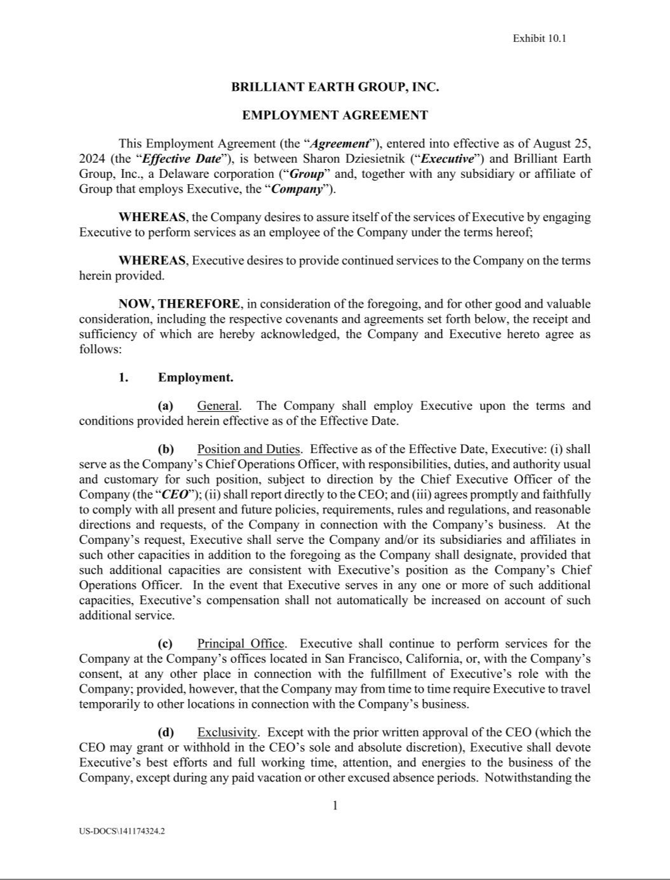

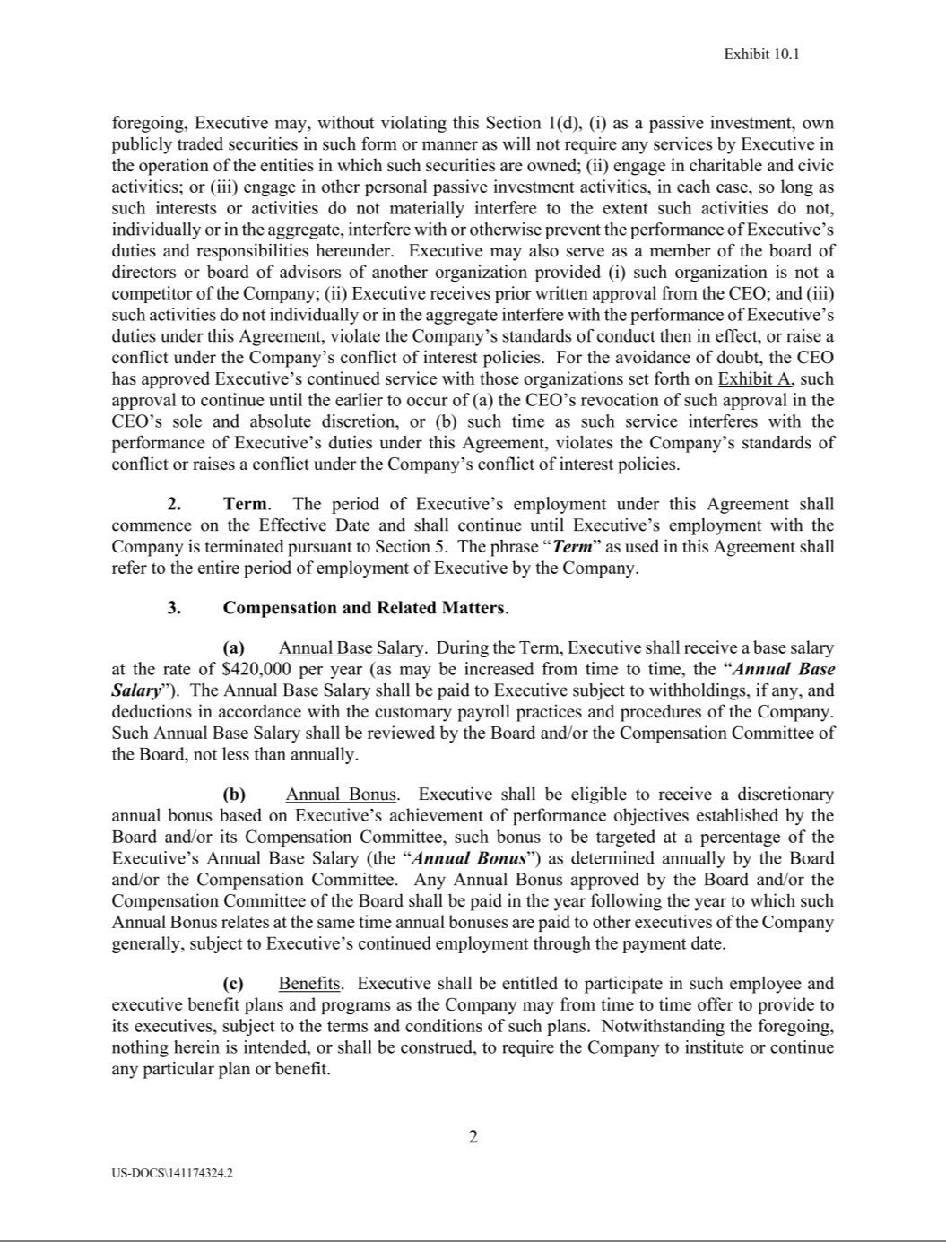

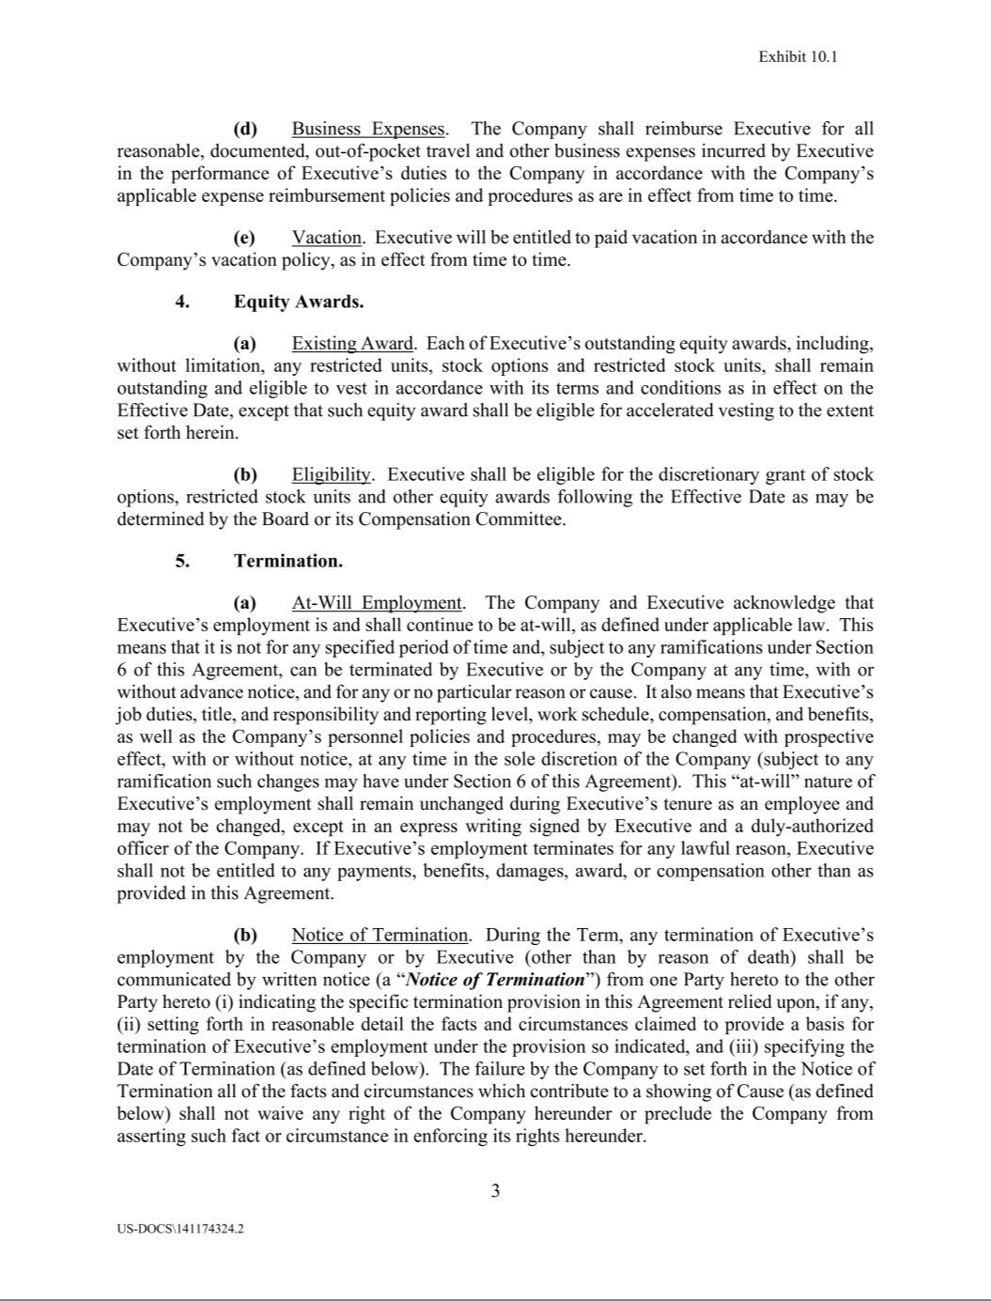

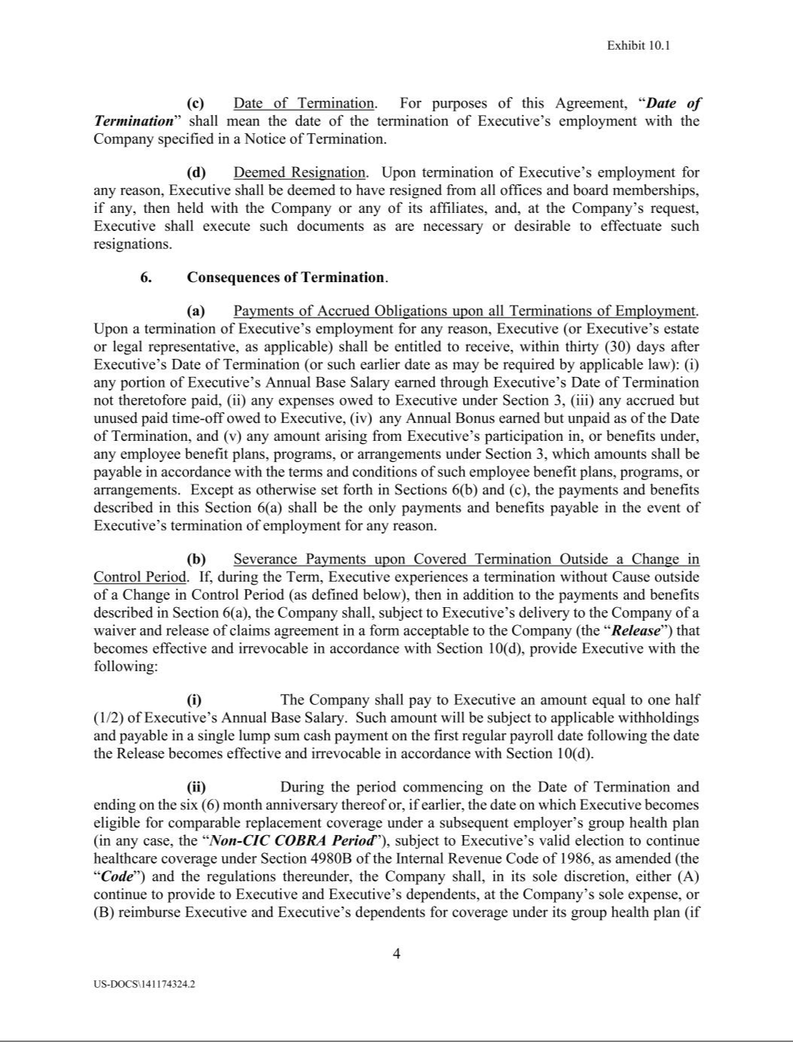

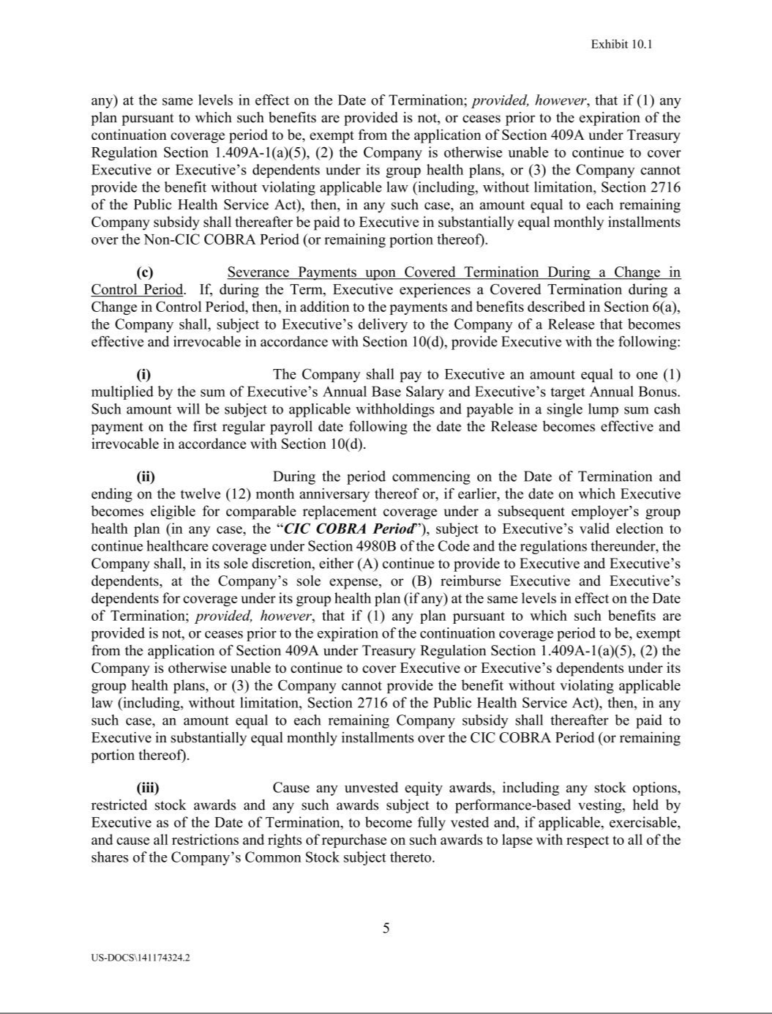

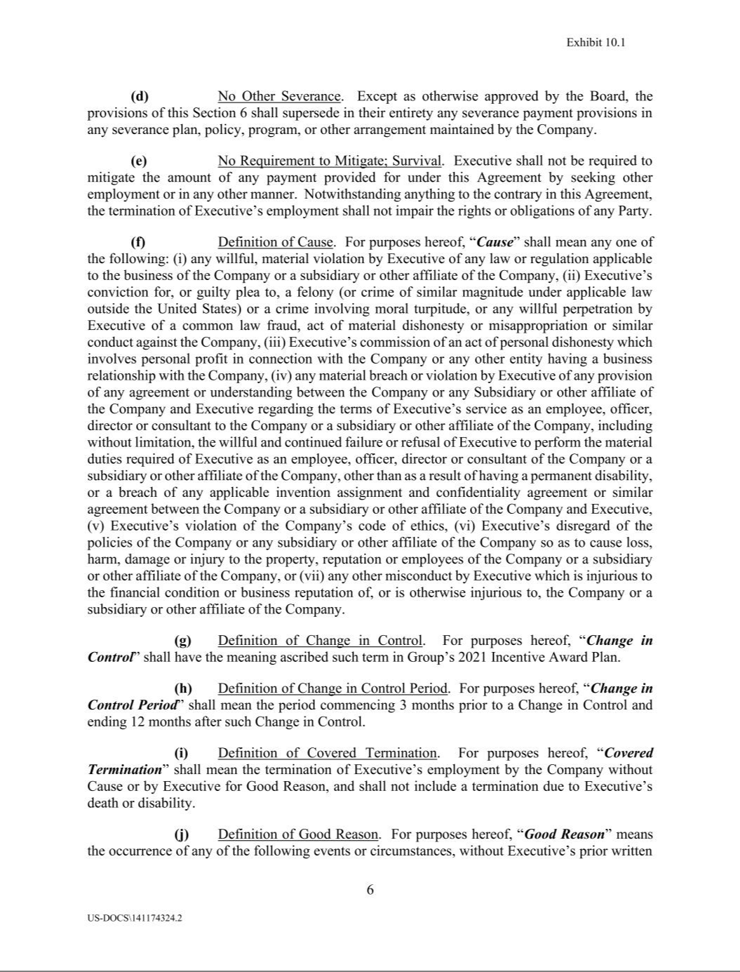

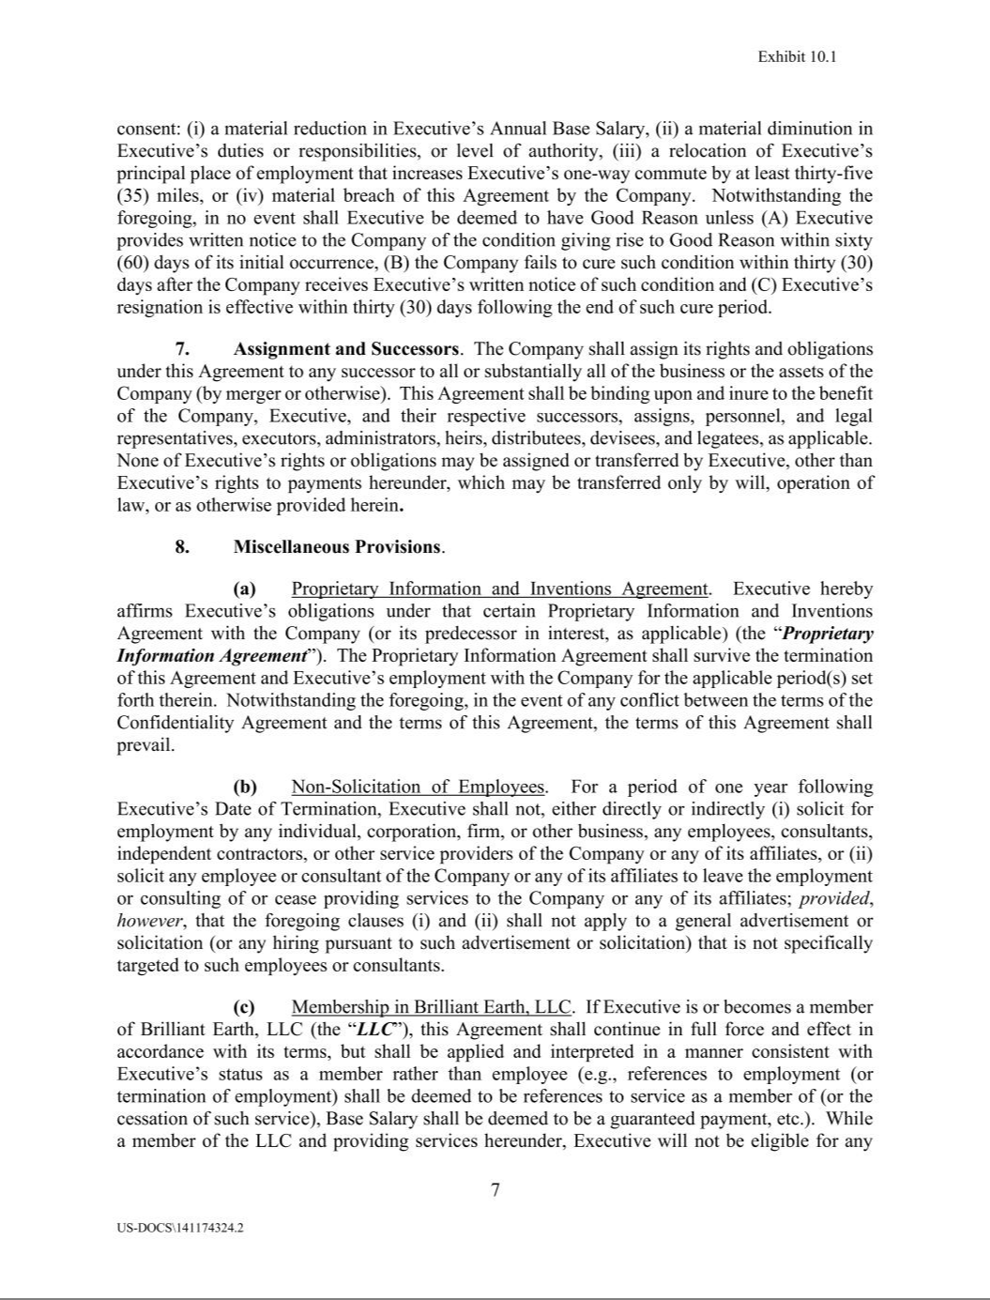

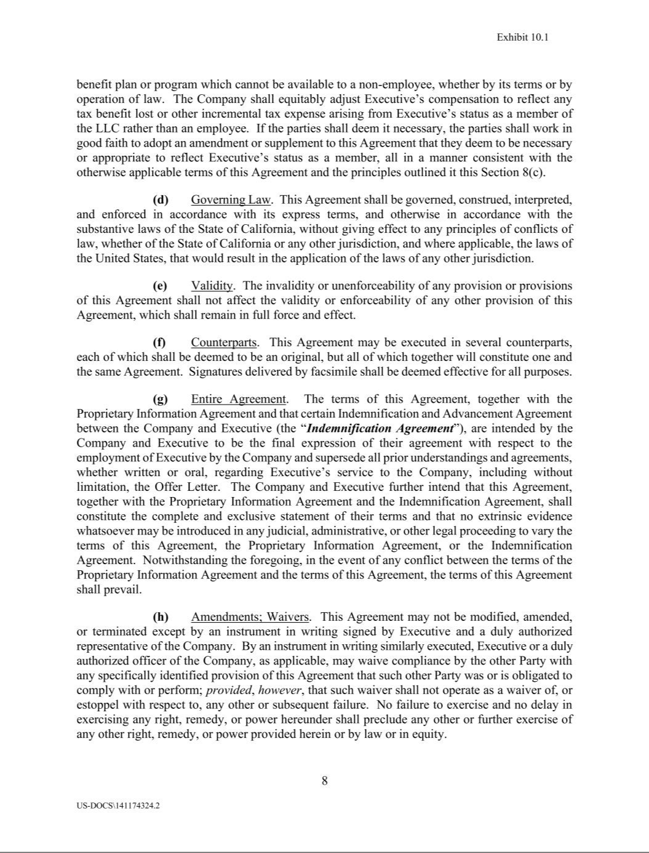

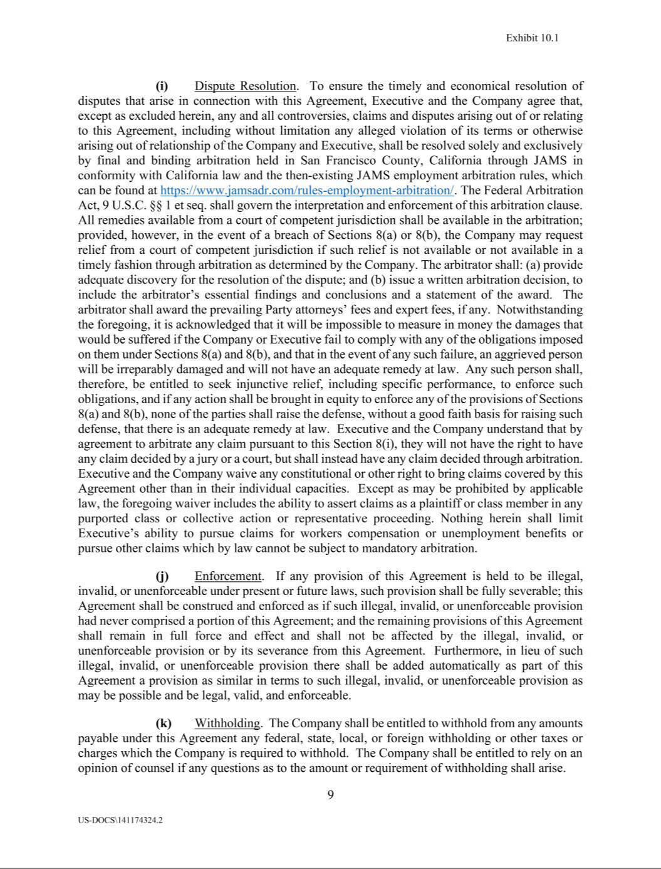

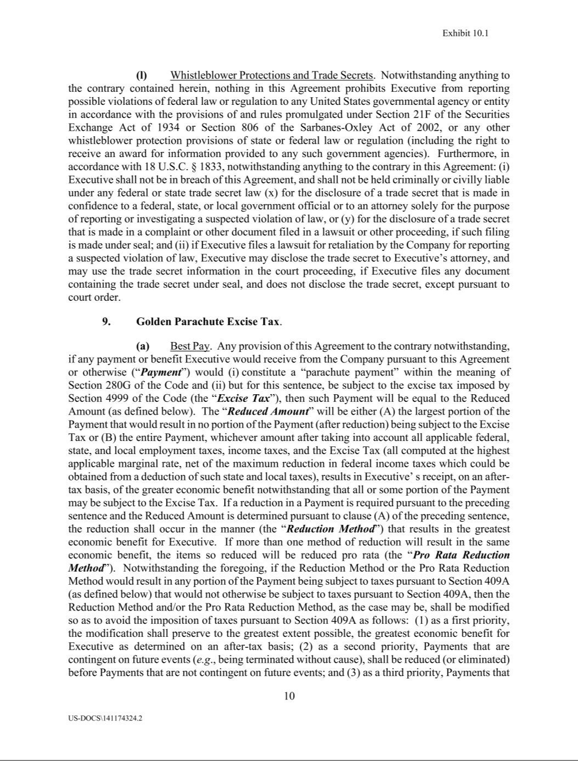

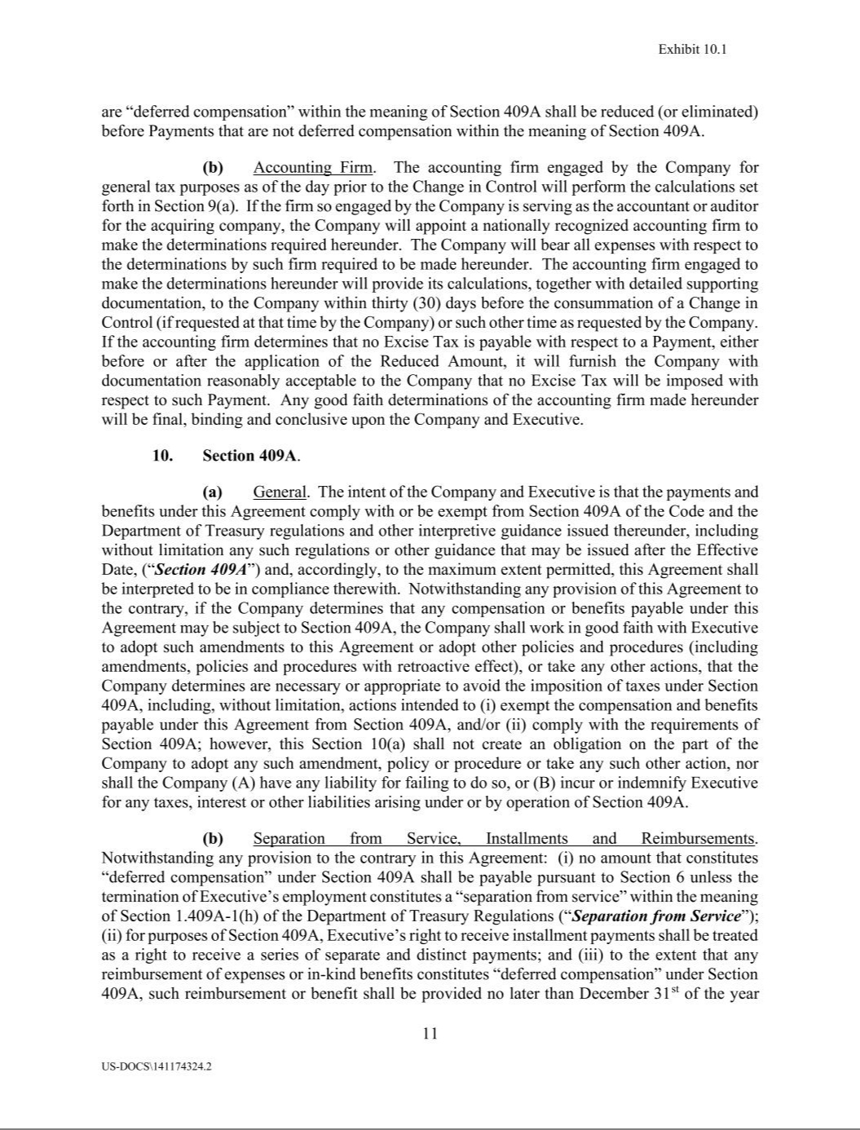

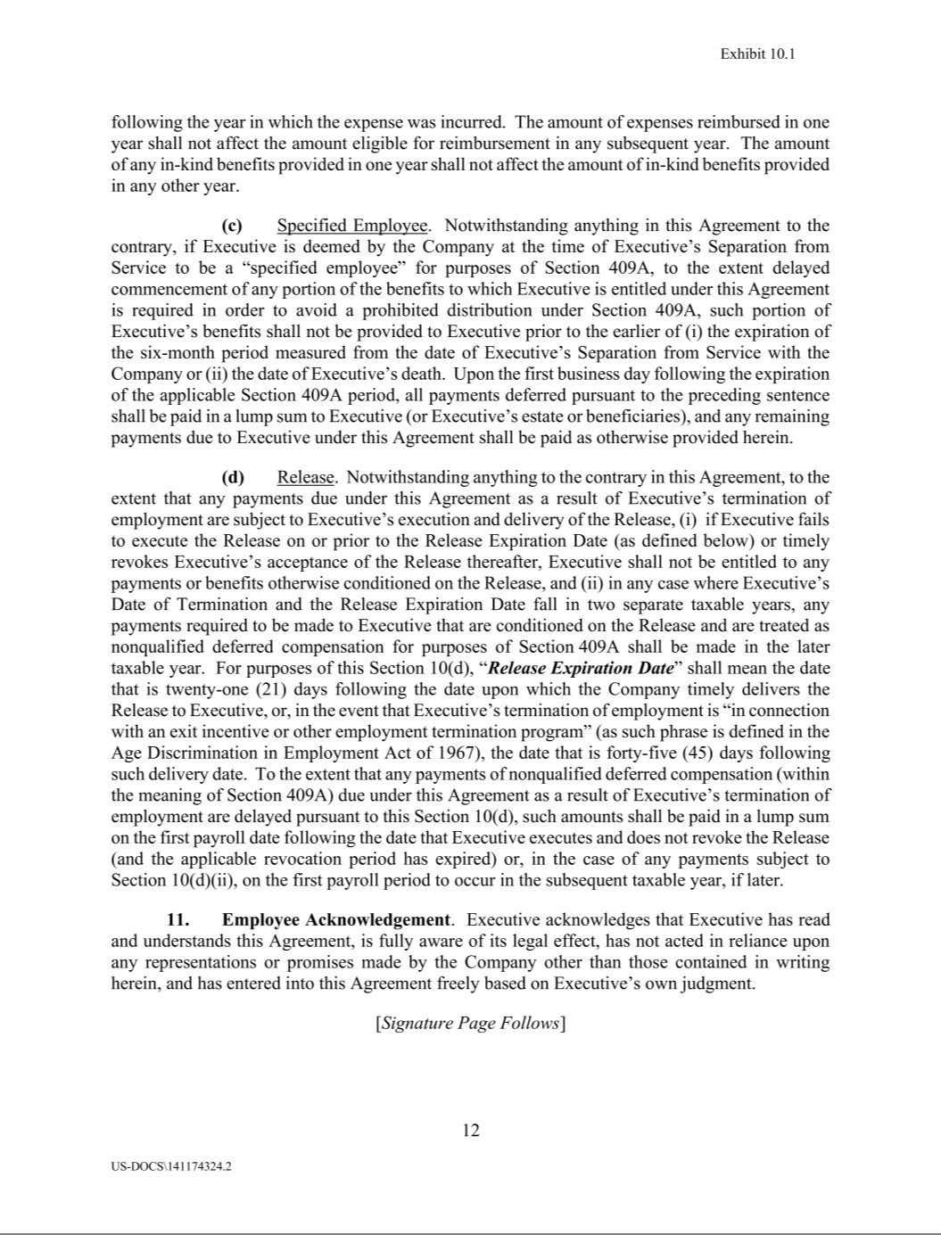

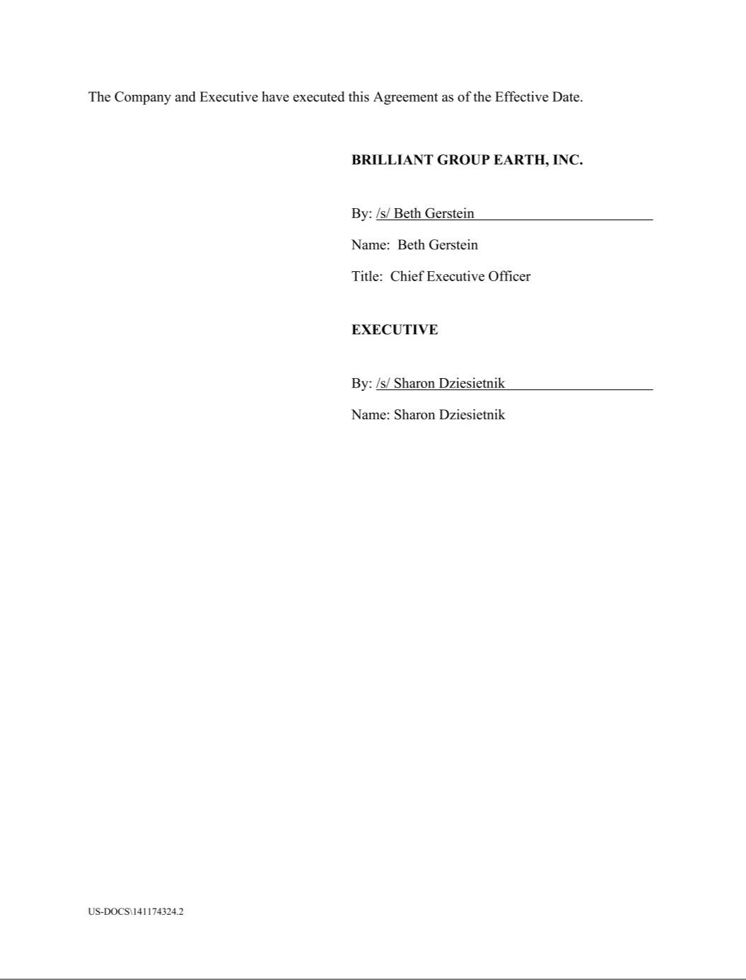



Exhibit 31.1

CERTIFICATION

I, Beth Gerstein, certify that:

      - I have reviewed this Quarterly Report on Form 10-Q of Brilliant Earth Group, Inc.;

      - Based on my knowledge, this report does not contain any untrue statement of a material fact or omit to state a material fact necessary to make the statements made, in light of the circumstances under which such statements were made, not misleading with respect to the period covered by this report;

      - Based on my knowledge, the financial statements, and other financial information included in this report, fairly present in all material respects the financial condition, results of operations and cash flows of the registrant as of, and for, the periods presented in this report;

      - The registrant’s other certifying officer and I are responsible for establishing and maintaining disclosure controls and procedures (as defined in Exchange Act Rules 13a-15(e) and 15d-15(e)) and internal control over financial reporting (as defined in Exchange Act Rules 13a-15(f) and 15d-15(f)) for the registrant and have:

        - Designed such disclosure controls and procedures, or caused such disclosure controls and procedures to be designed under our supervision, to ensure that material information relating to the registrant, including its consolidated subsidiaries, is made known to us by others within those entities, particularly during the period in which this report is being prepared;

        - Designed such internal control over financial reporting, or caused such internal control over financial reporting to be designed under our supervision, to provide reasonable assurance regarding the reliability of financial reporting and the preparation of financial statements for external purposes in accordance with generally accepted accounting principles;

        - Evaluated the effectiveness of the registrant’s disclosure controls and procedures and presented in this report our conclusions about the effectiveness of the disclosure controls and procedures, as of the end of the period covered by this report based on such evaluation; and

        - Disclosed in this report any change in the registrant’s internal control over financial reporting that occurred during the registrant’s most recent fiscal quarter (the registrant’s fourth fiscal quarter in the case of an annual report) that has materially affected, or is reasonably likely to materially affect, the registrant’s internal control over financial reporting; and

- The registrant’s other certifying officer and I have disclosed, based on our most recent evaluation of internal control over financial reporting, to the registrant’s auditors and the audit committee of the registrant’s board of directors (or persons performing the equivalent functions):

    - All significant deficiencies and material weaknesses in the design or operation of internal control over financial reporting which are reasonably likely to adversely affect the registrant’s ability to record, process, summarize and report financial information; and

  - Any fraud, whether or not material, that involves management or other employees who have a significant role in the registrant’s internal control over financial reporting.

Date: November 8, 2024
By: /s/ Beth Gerstein
Name: Beth Gerstein
Title: Chief Executive Officer

(Principal Executive Officer)

Exhibit 31.2

CERTIFICATION

I, Jeffrey Kuo, certify that:

- I have reviewed this Quarterly Report on Form 10-Q of Brilliant Earth Group, Inc.;

- Based on my knowledge, this report does not contain any untrue statement of a material fact or omit to state a material fact necessary to make the statements made, in light of the circumstances under which such statements were made, not misleading with respect to the period covered by this report;

- Based on my knowledge, the financial statements, and other financial information included in this report, fairly present in all material respects the financial condition, results of operations and cash flows of the registrant as of, and for, the periods presented in this report;

- The registrant’s other certifying officer and I are responsible for establishing and maintaining disclosure controls and procedures (as defined in Exchange Act Rules 13a-15(e) and 15d-15(e)) and internal control over financial reporting (as defined in Exchange Act Rules 13a-15(f) and 15d-15(f)) for the registrant and have:

  - Designed such disclosure controls and procedures, or caused such disclosure controls and procedures to be designed under our supervision, to ensure that material information relating to the registrant, including its consolidated subsidiaries, is made known to us by others within those entities, particularly during the period in which this report is being prepared;

  - Designed such internal control over financial reporting, or caused such internal control over financial reporting to be designed under our supervision, to provide reasonable assurance regarding the reliability of financial reporting and the preparation of financial statements for external purposes in accordance with generally accepted accounting principles;

  - Evaluated the effectiveness of the registrant’s disclosure controls and procedures and presented in this report our conclusions about the effectiveness of the disclosure controls and procedures, as of the end of the period covered by this report based on such evaluation; and

  - Disclosed in this report any change in the registrant’s internal control over financial reporting that occurred during the registrant’s most recent fiscal quarter (the registrant’s fourth fiscal quarter in the case of an annual report) that has materially affected, or is reasonably likely to materially affect, the registrant’s internal control over financial reporting; and

- The registrant’s other certifying officer and I have disclosed, based on our most recent evaluation of internal control over financial reporting, to the registrant’s auditors and the audit committee of the registrant’s board of directors (or persons performing the equivalent functions):

  - All significant deficiencies and material weaknesses in the design or operation of internal control over financial reporting which are reasonably likely to adversely affect the registrant’s ability to record, process, summarize and report financial information; and

  - Any fraud, whether or not material, that involves management or other employees who have a significant role in the registrant’s internal control over financial reporting.

Date: November 8, 2024
By: /s/ Jeffrey Kuo
Name: Jeffrey Kuo
Title: Chief Financial Officer
(Principal Financial Officer)

Exhibit 32.1

Certification Pursuant to 18 U.S.C. Section 1350,
As Adopted Pursuant to Section 906 of the Sarbanes-Oxley Act of 2002

In connection with the Quarterly Report on Form 10-Q of Brilliant Earth Group, Inc. (the “Company”) for the period ended September 30, 2024 (the “Report”), as filed with the Securities and Exchange Commission on the date hereof, I, the undersigned, certify, pursuant to 18 U.S.C. Section 1350, as adopted pursuant to Section 906 of the Sarbanes-Oxley Act of 2002, to the best of my knowledge, that:

- The Report fully complies with the requirements of Section 13(a) or Section 15(d) of the Securities Exchange Act of 1934; and

- The information contained in the Report fairly presents, in all material respects, the financial condition and results of operations of the Company.

Date: November 8, 2024
By: /s/ Beth Gerstein
Name: Beth Gerstein
Title: Chief Executive Officer

(Principal Executive Officer)

Exhibit 32.2

Certification Pursuant to 18 U.S.C. Section 1350,
As Adopted Pursuant to Section 906 of the Sarbanes-Oxley Act of 2002

In connection with the Quarterly Report on Form 10-Q of Brilliant Earth Group, Inc. (the “Company”) for the period ended September 30, 2024 (the “Report”), as filed with the Securities and Exchange Commission on the date hereof, I, the undersigned, certify, pursuant to 18 U.S.C. Section 1350, as adopted pursuant to Section 906 of the Sarbanes-Oxley Act of 2002, to the best of my knowledge, that:

- The Report fully complies with the requirements of Section 13(a) or Section 15(d) of the Securities Exchange Act of 1934; and

- The information contained in the Report fairly presents, in all material respects, the financial condition and results of operations of the Company.

Date: November 8, 2024
By: /s/ Jeffrey Kuo
Name: Jeffrey Kuo
Title: Chief Financial Officer
(Principal Financial Officer)

