Table of Contents

UNITED STATES

SECURITIES AND EXCHANGE COMMISSION

Washington, D.C. 20549

FORM 10-Q

(Mark One)

- QUARTERLY REPORT PURSUANT TO SECTION 13 OR 15(d) OF THE SECURITIES EXCHANGE ACT OF 1934

For the quarterly period ended March 31, 2025

OR

- TRANSITION REPORT PURSUANT TO SECTION 13 OR 15(d) OF THE SECURITIES EXCHANGE ACT OF 1934

For the transition period from | to
Commission File Number 001-40836

Brilliant Earth Group, Inc.

(Exact name of registrant as specified in its charter)

 |  | Delaware |  |  |  |  | 87-1015499
(State or other jurisdiction of incorporation or organization) |  |  |  |  |  |  | (I.R.S. Employer Identification Number)
 | 300 Grant Avenue, Third Floor
 | San Francisco, CA |  |  |  |  |  | 94108
 | (Address of principal executive offices) |  |  |  |  |  |  | (Zip Code)
 |  |  |  | (800) 691-0952
 |  |  |  | (Registrant's telephone number, including area code)
 |  |  |  |  | N/A
 |  | (Former name, former address and former fiscal year, if changed since last report)
 |  |  |  | Securities registered pursuant to Section 12(b) of the Act:
 | Title of each class |  |  |  | Trading Symbol(s) |  |  | Name of each exchange on which registered
Class A common stock, $0.0001 par value per share |  |  |  |  | BRLT |  |  |  | The Nasdaq Global Market

Indicate by check mark whether the registrant (1) has filed all reports required to be filed by Section 13 or 15(d) of the Securities Exchange Act of 1934 during the preceding 12 months (or for such shorter period that the registrant was required to file such reports), and (2) has been subject to such filing requirements for the past 90 days. Yes ☒ No ☐

Indicate by check mark whether the registrant has submitted electronically every Interactive Data File required to be submitted pursuant to Rule 405 of Regulation S-T (§232.405 of this chapter) during the preceding 12 months (or for such shorter period that the registrant was required to submit such files). Yes ☒ No ☐

Indicate by check mark whether the registrant is a large accelerated filer, an accelerated filer, a non-accelerated filer, a smaller reporting company or an emerging growth company. See the definitions of “large accelerated filer,” “accelerated filer,” “smaller reporting company” and “emerging growth company” in Rule 12b-2 of the Exchange Act.

Large accelerated filer | ☐ | Accelerated filer | ☐
Non-accelerated filer | ☒ | Smaller reporting company | ☒
 |  | Emerging growth company | ☒

If an emerging growth company, indicate by check mark if the registrant has elected not to use the extended transition period for complying with any new or revised financial accounting standards provided pursuant to Section 13(a) of the Exchange Act. ☐
Indicate by check mark whether the registrant is a shell company (as defined in Rule 12b-2 of the Exchange Act). Yes ☐ No ☒

As of May 9, 2025, there were 14,352,321 shares of the registrant's Class A common stock, $0.0001 par value per share, outstanding, 35,841,905 shares of the registrant's Class B common stock, $0.0001 par value per share, outstanding, 49,119,976 shares of the registrant's Class C common stock, $0.0001 par value per share, outstanding and no shares of the registrant's Class D common stock, $0.0001 per share, outstanding.

1

Table of Contents

 |  |  |  |  |  |  |  |  |  |  |  |  | Table of Contents
 |  |  |  |  |  |  |  |  |  |  |  |  |  |  | Page
Part I - Financial Information
 | Item 1. Financial Statements. |  |  |  |  |  |  |  |  |  |  |  |  |  | 5
 | Item 2. Management's Discussion and Analysis of Financial Condition and Results of Operations. |  |  |  |  |  |  |  |  |  |  |  |  |  |  | 21
 | Item 3. Quantitative and Qualitative Disclosures About Market Risk. |  |  |  |  |  |  |  |  |  |  |  |  |  |  | 33
 | Item 4. Controls and Procedures. |  |  |  |  |  |  |  |  |  |  |  |  |  | 34
Part II - Other Information
 | Item 1. Legal Proceedings. |  |  |  |  |  |  |  |  |  |  |  |  |  | 36
 | Item 1A. Risk Factors. |  |  |  |  |  |  |  |  |  |  |  |  |  |  | 36
 | Item 2. Unregistered Sales of Equity Securities and Use of Proceeds |  |  |  |  |  |  |  |  |  |  |  |  |  |  | 36
 | Item 3. Defaults Upon Senior Securities. |  |  |  |  |  |  |  |  |  |  |  |  |  | 37
 | Item 4. Mine Safety Disclosures. |  |  |  |  |  |  |  |  |  |  |  |  |  |  | 37
 | Item 5. Other Information. |  |  |  |  |  |  |  |  |  |  |  |  |  |  | 37
 | Item 6. Exhibits. |  |  |  |  |  |  |  |  |  |  |  |  |  |  | 38
Signatures |  |  |  |  |  |  |  |  |  |  |  |  |  |  |  | 39

2

Table of Contents

CAUTIONARY NOTE REGARDING FORWARD-LOOKING STATEMENTS

This Quarterly Report on Form 10-Q contains forward-looking statements. We intend such forward-looking statements to be covered by the safe harbor provisions for forward-looking statements contained in Section 27A of the Securities Act of 1933, as amended (the “Securities Act”), and Section 21E of the Securities Exchange Act of 1934, as amended (the “Exchange Act”). All statements other than statements of historical facts contained in this Quarterly Report on Form 10-Q may be forward-looking statements. Statements regarding our future results of operations and financial position, business strategy, plans and objectives of management for future operations, including, among others, statements regarding expected growth, introduction of new products, market opportunity, future capital expenditures, and debt service obligations, are forward-looking statements. In some cases, you can identify forward-looking statements by terms, such as “anticipate,” “believe,” “contemplate,” “continue,” “could,” “estimate,” “evolve,” “expect,” “intend,” “may,” “plan,” “potential,” “predict,” “seek,” “should,” “strategy,” “target,” “will,” or “would,” or the negative of these terms or other similar expressions. Accordingly, we caution you that any such forward-looking statements are not guarantees of future performance and are subject to risks, assumptions, and uncertainties that are difficult to predict.

We have based these forward-looking statements largely on our current expectations and projections about future events and trends that we believe may affect our financial condition, results of operations, business strategy, short-term and long-term business operations and objectives, and financial needs. Although we believe that the expectations reflected in these forward-looking statements are reasonable as of the date made, actual results may prove to be materially different from the results expressed or implied by the forward-looking statements. These forward-looking statements are subject to a number of risks, uncertainties, and assumptions, including, but not limited to risks related to: fluctuations in the pricing and supply of diamonds, other gemstones, and precious metals, particularly responsibly sourced natural and lab-grown diamonds and repurposed precious metals such as gold; increases in labor costs for manufacturing such as wage rate increases, as well as inflation, and energy prices; risks related to an overall decline in the health of the economy and other factors impacting consumer spending, such as recessionary or inflationary conditions, governmental instability, the impact of any changes in trade policy, including the imposition of new or increased tariffs on goods imported into the United States and any resulting retaliatory trade actions by other governments, war and fears of war, and natural disasters; our ability to cost-effectively turn existing customers into repeat customers or to acquire new customers; our rapid growth in recent years and limited operating experience at our current scale of operations; our ability to manage growth effectively; increased lead times, and supply shortages and supply changes; our expansion plans in the United States; our ability to compete in the fine jewelry retail industry; our ability to maintain and enhance our brand and to engage or expand our base of customers may be impaired and our business, financial condition, and results of operations may suffer; our ability to effectively develop and expand our sales and marketing capabilities and increase our customer base and achieve broader market acceptance of our e-commerce and omnichannel approach to shopping for fine jewelry; our profitability and cash flows may be negatively affected if we are not successful in managing our inventory balances and inventory shrinkage; a decline in sales of Design Your Own rings; our heavy reliance on our information technology systems, as well as those of our third-party vendors and service providers, for our business to effectively operate and to safeguard confidential information and risks related to any significant failure, inadequacy or interruption of these systems, security breaches or loss of data; the impact of environmental, social, and governance matters on our business and reputation; our ability to manage risks related to our e-commerce and omnichannel business; our ability to effectively anticipate and respond to changes in consumer preferences and shopping patterns, and introduce new products and programs that appeal to new or existing customers; our dependence on distributions from Brilliant Earth, LLC, our principal asset, to pay our taxes and expenses, including payments under the Tax Receivable Agreement (as defined herein) to Continuing Equity Owners (as defined herein) in respect to certain tax benefits; risks related to our obligations to make substantial cash payments under the Tax Receivable Agreement and risks related to our organizational structure; and the other risks, uncertainties and factors described in Part I, Item 1A, “Risk Factors” in our Annual Report on Form 10-K for the fiscal year ended December 31, 2024 (the “2024 Form 10-K”) filed with the Securities and Exchange Commission (the “SEC”) on March 13, 2025. Other sections of this Quarterly Report on Form 10-Q, including Part I, Item 2. “Management's Discussion and Analysis of Financial Condition and Results of Operations”, include additional factors that could adversely impact our business and financial performance.

Moreover, we operate in a very competitive and rapidly changing environment and new risks emerge from time to time. In light of these risks, uncertainties, and assumptions, the future events and trends discussed in this

3

Table of Contents

Quarterly Report on Form 10-Q may not occur and actual results could differ materially and adversely from those anticipated or implied in the forward-looking statements.

You should not rely upon forward-looking statements as predictions of future events. This Quarterly Report on Form 10-Q and the documents that we have filed as exhibits should be read with the understanding that our actual future results, levels of activity, performance and achievements may be materially different from what we expect. We qualify all of our forward-looking statements by these cautionary statements. These forward-looking statements speak only as of the date of this Quarterly Report on Form 10-Q. Except as required by applicable law, we undertake no obligation to update or revise any forward-looking statements contained in this Quarterly Report on Form 10-Q, whether as a result of any new information, future events or otherwise.

BASIS OF PRESENTATION

As used in this Quarterly Report on Form 10-Q, unless the context otherwise requires, references to:

- “we,” “us,” “our,” the “Company,” “Brilliant Earth,” and similar references refer to Brilliant Earth Group, Inc., and, unless otherwise stated, all of its subsidiaries, including Brilliant Earth, LLC.

- “Continuing Equity Owners” refers collectively to holders of LLC Interests (as defined below) and our Class B common stock and Class C common stock, including our Founders (as defined below) and Mainsail (as defined below), who may, exchange at each of their respective options, in whole or in part from time to time, their LLC Interests (along with an equal number of shares of Class B common stock or Class C common stock (and such shares shall be immediately cancelled), as applicable), for, at our election (determined solely by our independent directors (within the meaning of the Nasdaq rules) who are disinterested), cash or newly-issued shares of our Class A common stock or Class D common stock, as applicable.

- “Founders” refers to Beth Gerstein, our Co-Founder and Chief Executive Officer, Eric Grossberg, our Co-Founder and Executive Chairman, and Just Rocks, Inc., a Delaware corporation, which is jointly owned and controlled by our Founders.

- “LLC Interests” or “LLC Units” refers to the common units of Brilliant Earth, LLC, including those that we purchased with the net proceeds from our initial public offering (“IPO”), which occurred on September 23, 2021.

- “LLC Agreement” refers to Brilliant Earth, LLC's amended and restated limited liability company agreement, which became effective prior to the consummation of the IPO.

- “Mainsail” refers to Mainsail Partners III, L.P., our sponsor and a Delaware limited partnership, and certain funds affiliated with Mainsail Partners III, L.P., including Mainsail Incentive Program, LLC, and Mainsail Co-Investors III, L.P.

- “SVB Credit Agreement” refers to the credit agreement entered into on May 24, 2022, by Brilliant Earth, LLC, as borrower, and Silicon Valley Bank, as administrative agent and collateral agent for the lenders, which provides for a secured term loan credit facility of $65.0 million (the “SVB Term Loan”) and a secured revolving credit facility in an amount of up to $40.0 million (the “SVB Revolving Facility”, and together with the SVB Term Loan, the “SVB Credit Facilities”).
- “TRA” refers to the Tax Receivable Agreement with Brilliant Earth, LLC and the Continuing Equity Owners that provides for the payment by Brilliant Earth Group, Inc. to the Continuing Equity Owners of 85% of the amount of tax benefits, if any, that Brilliant Earth Group, Inc. actually realizes (or in some circumstances is deemed to realize) related to certain tax basis adjustments and payments made under the TRA.

4

Table of Contents

Part I - Financial Information

Item 1. Financial Statements

Brilliant Earth Group, Inc.

UNAUDITED CONDENSED CONSOLIDATED BALANCE SHEETS

(in thousands, except share and per share amounts)

 |  |  |  |  |  | March 31, |  |  |  | December 31,
 |  |  |  |  |  | 2025 |  |  |  | 2024
 |  |  |  | Assets
Current assets:
Cash and cash equivalents |  |  |  |  |  | $ | 147,338 |  | $ | 161,925
Restricted cash |  |  |  |  |  |  | 217 |  |  | 216
Inventories, net |  |  |  |  |  |  | 39,848 |  |  | 38,292
Prepaid expenses and other current assets |  |  |  |  |  |  | 10,553 |  |  | 10,980
Total current assets |  |  |  |  |  |  | 197,956 |  |  | 211,413
Property and equipment, net |  |  |  |  |  |  | 21,293 |  |  | 21,626
Deferred tax assets |  |  |  |  |  |  | 9,768 |  |  | 9,636
Operating lease right of use assets |  |  |  |  |  |  | 37,127 |  |  | 35,222
Other assets |  |  |  |  |  |  | 3,506 |  |  | 3,348
Total assets |  |  |  |  |  | $ | 269,650 |  | $ | 281,245
 |  |  | Liabilities and stockholders' equity
Current liabilities:
Accounts payable |  |  |  |  |  | $ | 13,378 |  | $ | 15,733
Accrued expenses and other current liabilities |  |  |  |  |  |  | 23,940 |  |  | 31,714
Deferred revenue |  |  |  |  |  |  | 23,099 |  |  | 18,926
Current portion of operating lease liabilities |  |  |  |  |  |  | 6,742 |  |  | 6,108
Current portion of long-term debt |  |  |  |  |  |  | 20,000 |  |  | 5,688
Total current liabilities |  |  |  |  |  |  | 87,159 |  |  | 78,169
Long-term debt, net of debt issuance costs |  |  |  |  |  |  | 34,522 |  |  | 50,010
Operating lease liabilities |  |  |  |  |  |  | 37,260 |  |  | 35,856
Payable pursuant to the Tax Receivable Agreement |  |  |  |  |  |  | 7,737 |  |  | 7,828
Total liabilities |  |  |  |  |  |  | 166,678 |  |  | 171,863
Commitments and contingencies (Note 10)
Stockholders' equity
Preferred stock, $0.0001 par value, 10,000,000 shares authorized, none issued and outstanding at March 31, 2025 and December 31, 2024, respectively |  |  |  |  |  |  | — |  |  | —
Class A common stock, $0.0001 par value, 1,200,000,000 shares authorized; 14,789,781 shares issued and 14,405,340 shares outstanding at March 31, 2025; 14,125,925 |  |  |  |  |  |  | 1 |  |  | 1
shares issued and 13,843,944 shares outstanding at December 31, 2024 |  |  |  |  |  |  | 1 |  |  | 1
Class B common stock, $0.0001 par value, 150,000,000 shares authorized; |  |  |  | 35,839,403 | and 35,820,912 shares outstanding at March 31, 2025 and December 31, 2024, |  | 4 |  |  | 4
respectively |  |  |  |  |  |  | 4 |  |  | 4
Class C common stock, $0.0001 par value, 150,000,000 shares authorized; 49,119,976 shares outstanding at March 31, 2025 and December 31, 2024, respectively |  |  |  |  |  |  | 5 |  |  | 5
Class D common stock, $0.0001 par value, 150,000,000 shares authorized; none issued and outstanding at March 31, 2025 and December 31, 2024, respectively |  |  |  |  |  |  | — |  |  | —
Additional paid-in capital |  |  |  |  |  |  | 11,397 |  |  | 11,169
Treasury stock, at cost; | 384,441 | and | 281,981 shares at March 31, 2025 and December 31, 2024, respectively |  |  |  | (801) |  |  | (638)
Retained earnings |  |  |  |  |  |  | 4,322 |  |  | 4,788
Stockholders' equity attributable to Brilliant Earth Group, Inc. |  |  |  |  |  |  | 14,928 |  |  | 15,329
Non-controlling interests attributable to Brilliant Earth, LLC |  |  |  |  |  |  | 88,044 |  |  | 94,053
Total stockholders' equity |  |  |  |  |  |  | 102,972 |  |  | 109,382
Total liabilities and stockholders' equity |  |  |  |  |  | $ | 269,650 |  | $ | 281,245

The accompanying notes are an integral part of these unaudited condensed consolidated financial statements.

5

Table of Contents

Brilliant Earth Group, Inc.

UNAUDITED CONDENSED CONSOLIDATED STATEMENTS OF OPERATIONS

(in thousands, except share and per share amounts)

Three Months Ended

March 31,

 |  | 2025 |  |  | 2024
Net sales | $ | 93,884 |  | $ | 97,337
Cost of sales |  | 38,842 |  |  | 39,031
Gross profit |  | 55,042 |  |  | 58,306
Operating expenses:
Marketing and advertising |  | 22,962 |  |  | 23,096
General and administrative |  | 35,603 |  |  | 34,333
Total operating expenses |  | 58,565 |  |  | 57,429
(Loss) income from operations |  | (3,523) |  |  | 877
Interest expense |  | (1,115) |  |  | (1,214)
Other income, net |  | 1,240 |  |  | 1,477
(Loss) income before tax |  | (3,398) |  |  | 1,140
Income tax benefit (expense) |  | 131 |  |  | (73)
Net (loss) income |  | (3,267) |  |  | 1,067
Net (loss) income allocable to non-controlling interest |  | (2,801) |  |  | 928
Net (loss) income allocable to Brilliant Earth Group, Inc. | $ | (466) |  | $ | 139
Earnings per share:
Basic | $ | (0.03) |  | $ | 0.01
Diluted | $ | (0.03) |  | $ | 0.01
Weighted average shares of common stock outstanding:
Basic |  | 14,111,624 |  |  | 12,736,014
Diluted |  | 14,111,624 |  |  | 97,850,288

The accompanying notes are an integral part of these unaudited condensed consolidated financial statements.

6

Table of Contents

Brilliant Earth Group, Inc.

UNAUDITED CONDENSED CONSOLIDATED STATEMENTS OF CHANGES IN STOCKHOLDERS' EQUITY

(in thousands except share amounts)

 |  |  |  |  |  |  |  |  |  |  |  |  |  |  |  | Brilliant Earth Group, Inc. Stockholders' Equity
 |  | Class A Common Stock |  |  |  |  |  |  |  |  | Class B Common Stock |  |  |  |  |  |  |  | Class C Common Stock |  |  |  |  |  |  |  |  |  |  |  |  |  |  |  |  |  |  |  |  | Non-Controlling Interest
 |  |  |  |  |  |  |  |  |  |  |  |  |  |  |  |  |  |  |  |  |  |  |  |  | Additional |  |  |  |  |  |  |  |  |  |  |  |  |  |  |  |  |  |  |  |  |  |  |  | Total
 |  |  | Shares |  |  | Amount |  |  |  |  | Shares |  |  |  | Amount |  |  |  | Shares |  |  | Amount |  |  | Paid-In |  |  | Treasury Stock |  |  |  |  | Retained |  |  | Stockholders' |  |  |  | Units |  |  |  | Amounts |  |  |  |  | Stockholders'
 |  |  | Shares |  |  |  |  |  |  |  |  |  |  |  |  |  |  |  |  |  |  |  |  |  | Capital |  |  |  |  |  |  |  | Earnings |  |  | Equity |  |  |  |  |  |  |  |  |  |  |  |  | Equity
Balance, January 1, 2025 |  |  | 13,843,944 | $ |  | 1 |  |  |  |  | 35,820,912 |  |  | $ |  | 4 |  | 49,119,976 |  |  | $ | 5 |  | $ | 11,169 |  | $ |  | (638) |  |  | $ | 4,788 |  | $ | 15,329 |  |  |  | 84,940,888 |  |  | $ |  | 94,053 |  | $ |  | 109,382
Tax distributions to members |  |  | — |  |  |  | — |  |  |  | — |  |  |  |  | — |  |  | — |  |  | — |  |  | — |  |  |  | — |  |  |  |  | — |  |  | — |  |  |  |  | — |  |  | (5,349) |  |  |  | (5,349)
Conversion of Class B to |  |  | 2,700 |  |  |  | — |  |  |  | (2,700) |  |  |  |  | — |  |  | — |  |  | — |  |  | — |  |  |  | — |  |  |  |  | — |  |  | — |  |  | (2,700) |  |  |  |  |  | — |  |  |  | —
Class A common stock |  |  | 2,700 |  |  |  | — |  |  |  | (2,700) |  |  |  |  |  |  |  |  |  |  |  |  |  |  |  |  |  |  |  |  |  |  | — |  |  |  |  |  |  |  |  |  |  |  | — |  |  |  | —
RSU vesting during period |  |  | 661,156 |  |  |  | — |  |  |  | — |  |  |  |  | — |  |  | — |  |  | — |  |  |  |  |  |  | — |  |  |  |  | — |  |  | — |  |  |  |  | — |  |  |  | — |  |  |  | —
Repurchases of common stock |  |  | (102,460) |  |  |  | — |  |  |  | — |  |  |  |  | — |  |  | — |  |  | — |  |  | — |  |  |  | (163) |  |  |  |  | — |  | (163) |  |  |  |  |  | — |  |  |  | — |  |  | (163)
Class B shares issued upon |  |  | — |  |  |  | — |  |  |  | 21,191 |  |  |  |  | — |  |  | — |  |  | — |  |  |  |  |  |  | — |  |  |  |  | — |  |  | — |  |  | 21,191 |  |  |  |  |  | — |  |  |  | —
vesting of LLC units |  |  | — |  |  |  | — |  |  |  | 21,191 |  |  |  |  |  |  |  |  |  |  |  |  |  |  |  |  |  |  |  |  |  |  | — |  |  |  |  |  |  |  |  |  |  |  | — |  |  |  | —
Equity-based compensation |  |  | — |  |  |  | — |  |  |  | — |  |  |  |  | — |  |  | — |  |  | — |  |  | 2,342 |  |  |  | — |  |  |  |  | — |  | 2,342 |  |  |  |  |  | — |  |  | 27 |  |  |  | 2,369
Net loss |  |  | — |  |  |  | — |  |  |  | — |  |  |  |  | — |  |  | — |  |  | — |  |  | — |  |  |  | — |  |  |  | (466) |  |  | (466) |  |  |  |  |  | — |  |  | (2,801) |  |  |  | (3,267)
Rebalancing of controlling |  |  | — |  |  |  | — |  |  |  | — |  |  |  |  | — |  |  | — |  |  | — |  |  | (2,114) |  |  |  | — |  |  |  |  | — |  | (2,114) |  |  |  |  |  | — |  |  | 2,114 |  |  |  |  | —
and noncontrolling interests |  |  | — |  |  |  | — |  |  |  |  |  |  |  |  |  |  |  |  |  |  |  |  |  |  |  |  |  |  |  |  |  |  | — |  |  |  |  |  |  |  | — |  |  |  |  |  |  |  | —
Balance, March 31, 2025 |  |  | 14,405,340 |  | $ | 1 |  |  |  |  | 35,839,403 |  |  | $ |  | 4 |  | 49,119,976 |  |  | $ | 5 |  | $ | 11,397 |  |  | $ | (801) |  |  | $ | 4,322 |  | $ | 14,928 |  |  |  | 84,959,379 |  |  |  | $ | 88,044 |  |  | $ | 102,972
 |  |  |  |  |  |  |  |  |  |  |  |  |  |  |  | Brilliant Earth Group, Inc. Stockholders' Equity
 |  |  | Class A Common Stock |  |  |  |  |  |  |  | Class B Common Stock |  |  |  |  |  |  |  | Class C Common Stock |  |  |  |  |  |  |  |  |  |  |  |  |  |  |  |  |  |  |  |  | Non-Controlling Interest
 |  |  |  |  |  |  |  |  |  |  |  |  |  |  |  |  |  |  |  |  |  |  |  |  | Additional |  |  |  |  |  |  |  |  |  |  |  |  |  |  |  |  |  |  |  |  |  | Total
 |  |  |  |  |  |  |  |  |  |  |  |  |  |  |  |  |  |  |  |  |  |  |  |  | Paid-In |  |  |  | Treasury |  |  | Retained |  |  | Stockholders' |  |  |  |  |  |  |  |  |  |  | Stockholders'
 |  |  | Shares |  |  |  | Amount |  |  |  | Shares |  |  |  |  | Amount |  |  | Shares |  |  | Amount |  |  | Capital |  |  |  | Stock |  |  | Earnings |  |  |  | Equity |  |  |  | Units |  |  | Amounts |  |  |  | Equity
 | Balance, January 1, 2024 |  | 12,522,146 |  |  | $ |  | 1 |  |  | 35,688,349 |  |  |  | $ | 4 |  | 49,119,976 |  |  | $ | 5 |  | $ | 8,275 |  | $ |  | — |  | $ |  | 4,247 | $ |  | 12,532 |  |  |  | 84,808,325 |  | $ | 84,924 |  | $ |  |  |  | 97,456
 | Tax distributions to |  |  | — |  |  |  | — |  |  | — |  |  |  |  | — |  |  | — |  |  | — |  |  | — |  |  |  | — |  |  |  | — |  |  | — |  |  |  | — |  |  | (988) |  |  |  |  |  | (988)
 | members |  |  |  |  |  |  |  |  |  |  |  |  |  |  |  |  |  |  |  |  |  |  |  |  |  |  |  |  |  |  |  | — |  |  |  |  |  |  |  |  |  |  |  |  |  |  |  | (988)
 | Conversion of Class B to |  | 16,260 |  |  |  |  | — |  |  | (16,260) |  |  |  |  | — |  |  | — |  |  | — |  |  | — |  |  |  | — |  |  |  | — |  |  | — |  |  |  | (16,260) |  |  |  | — |  |  |  |  | —
 | Class A common stock |  |  |  |  |  |  |  |  |  |  |  |  |  |  |  |  |  |  |  |  |  |  |  |  |  |  |  |  |  |  |  | — |  |  |  |  |  |  | (16,260) |  |  |  | — |  |  |  |  | —
 | RSU vesting during period |  | 506,264 |  |  |  |  | — |  |  | — |  |  |  |  | — |  |  | — |  |  | — |  |  | — |  |  |  | — |  |  |  | — |  |  | — |  |  |  | — |  |  |  | — |  |  |  |  | —
 | Repurchases of common |  | (32,371) |  |  |  |  | — |  |  | — |  |  |  |  | — |  |  | — |  |  | — |  |  | — |  |  |  | (100) |  |  |  | — |  |  | (100) |  |  |  | — |  |  |  | — |  |  |  |  | (100)
 | stock |  |  |  |  |  |  |  |  |  |  |  |  |  |  |  |  |  |  |  |  |  |  |  |  |  |  |  | (100) |  |  |  | — |  |  | (100) |  |  |  |  |  |  |  | — |  |  |  |  | (100)
 | Class B shares issued upon |  |  | — |  |  |  | — |  |  | 84,187 |  |  |  |  | — |  |  | — |  |  | — |  |  | — |  |  |  | — |  |  |  | — |  |  | — |  |  |  | 84,187 |  |  |  | — |  |  |  |  | —
 | vesting of LLC units |  |  |  |  |  |  |  |  |  |  |  |  |  |  |  |  |  |  |  |  |  |  |  |  |  |  |  |  |  |  |  | — |  |  |  |  |  |  | 84,187 |  |  |  | —
 | Change in deferred tax
 | asset and TRA liability
 | related to redemption of |  |  | — |  |  |  | — |  |  | — |  |  |  |  | — |  |  | — |  |  | — |  |  | (164) |  |  |  | — |  |  |  | — |  |  | (164) |  |  |  | — |  |  |  | — |  |  |  |  | (164)
 | LLC Units |  |  |  |  |  |  |  |  |  |  |  |  |  |  |  |  |  |  |  |  |  |  |  | (164) |  |  |  |  |  |  |  | — |  |  | (164) |  |  |  |  |  |  |  | — |  |  |  |  | (164)
 | Equity-based compensation |  |  | — |  |  |  | — |  |  | — |  |  |  |  | — |  |  | — |  |  | — |  |  | 2,541 |  |  |  | — |  |  |  | — |  |  | 2,541 |  |  |  | — |  |  | 46 |  |  |  |  |  | 2,587
 | Net income |  |  | — |  |  |  | — |  |  | — |  |  |  |  | — |  |  | — |  |  | — |  |  | — |  |  |  | — |  |  |  | 139 |  |  | 139 |  |  |  | — |  |  | 928 |  |  |  |  |  | 1,067
 | Rebalancing of controlling |  |  | — |  |  |  | — |  |  | — |  |  |  |  | — |  |  | — |  |  | — |  |  | (1,674) |  |  |  | — |  |  |  | — |  |  | (1,674) |  |  |  | — |  |  | 1,674 |  |  |  |  |  | —
 | and non-controlling interest |  |  |  |  |  |  |  |  |  |  |  |  |  |  |  |  |  |  |  |  |  |  |  | (1,674) |  |  |  |  |  |  |  | — |  |  | (1,674)
 | Balance, March 31, 2024 |  | 13,012,299 |  |  | $ |  | 1 |  |  | 35,756,276 |  |  |  | $ | 4 |  | 49,119,976 |  |  | $ | 5 |  | $ | 8,978 |  | $ |  | (100) |  | $ |  | 4,386 | $ |  | 13,274 |  |  |  | 84,876,252 |  | $ | 86,584 |  | $ |  |  |  | 99,858

The accompanying notes are an integral part of these unaudited condensed consolidated financial statements.

7

Table of Contents

Brilliant Earth Group, Inc.

UNAUDITED CONDENSED CONSOLIDATED STATEMENTS OF CASH FLOWS

(in thousands)

Three Months Ended

March 31,

 | 2025 |  |  |  | 2024
Operating activities
Net (loss) income | $ | (3,267) |  | $ | 1,067
Adjustments to reconcile net (loss) income to net cash provided by operating activities:
Depreciation |  | 1,488 |  |  | 1,203
Equity-based compensation |  | 2,369 |  |  | 2,587
Non-cash operating lease cost |  | 1,561 |  |  | 1,281
Amortization of debt issuance costs |  | 70 |  |  | 69
Deferred tax (benefit) expense |  | (131) |  |  | 73
Other |  | 117 |  |  | (65)
Changes in assets and liabilities:
Inventories |  | (1,673) |  |  | (1,051)
Prepaid expenses and other current assets |  | 661 |  |  | 15
Other assets |  | (184) |  |  | (312)
Accounts payable, accrued expenses and other current liabilities |  | (10,649) |  |  | (12,544)
Deferred revenue |  | 4,173 |  |  | 3,259
Operating lease liabilities |  | (1,662) |  |  | (1,372)
Net cash used in operating activities |  | (7,127) |  |  | (5,790)
Investing activities
Purchases of property and equipment |  | (727) |  |  | (562)
Net cash used in investing activities |  | (727) |  |  | (562)
Financing activities
Payments on SVB term loan |  | (1,220) |  |  | (813)
Repurchases of common stock |  | (163) |  |  | (100)
Payment of debt issuance costs |  | — |  |  | (100)
Tax distributions to members |  | (5,349) |  |  | (988)
Net cash used in financing activities |  | (6,732) |  |  | (2,001)
Net decrease in cash, cash equivalents and restricted cash |  | (14,586) |  |  | (8,353)
Cash, cash equivalents and restricted cash at beginning of period |  | 162,141 |  |  | 156,020
Cash, cash equivalents and restricted cash at end of period | $ | 147,555 |  | $ | 147,667
Reconciliation of cash, cash equivalents and restricted cash
Cash and cash equivalents | $ | 147,338 |  | $ | 147,454
Restricted cash |  | 217 |  |  | 213
Total cash, cash equivalents, and restricted cash | $ | 147,555 |  | $ | 147,667
Non-cash investing and financing activities
Right-of-use assets obtained in exchange for new operating lease liabilities | $ | 3,700 |  | $ | 3,441
Change in deferred tax assets associated with redemption of LLC Units |  | (1) |  |  | (177)
TRA Obligation associated with redemption of LLC Units |  | 2 |  |  | (13)
Purchases of property and equipment included in accounts payable and accrued liabilities |  | 428 |  |  | 273
Change in APIC related to redemption of LLC Units |  | — |  |  | (164)

The accompanying notes are an integral part of these unaudited condensed consolidated financial statements

8

Table of Contents

Brilliant Earth Group, Inc.

NOTES TO THE UNAUDITED CONDENSED CONSOLIDATED FINANCIAL STATEMENTS

- DESCRIPTION OF BUSINESS AND SUMMARY OF SIGNIFICANT ACCOUNTING POLICIES

Brilliant Earth Group, Inc. was formed as a Delaware corporation on June 2, 2021 for the purpose of facilitating an initial public offering (“IPO”) and executing other related organizational transactions to acquire and carry on the business of Brilliant Earth, LLC. Brilliant Earth, LLC was originally incorporated in Delaware on August 25, 2005, and subsequently converted to a limited liability company on November 29, 2012. Brilliant Earth Group, Inc., the sole managing member of Brilliant Earth, LLC, consolidates Brilliant Earth, LLC and both are collectively referred to herein as the “Company”.

The Company designs, procures and sells ethically sourced diamonds, gemstones and jewelry online and through showrooms operating within the United States (“U.S.”).

Co-headquarters are located in San Francisco, California and Denver, Colorado.

Basis of Presentation

The unaudited condensed consolidated financial statements have been prepared in accordance with U.S. generally accepted accounting principles (“GAAP”) and the requirements of the Securities and Exchange Commission (the “SEC”) for interim reporting. As permitted under those rules, certain footnotes or other financial information that are normally required by GAAP can be condensed or omitted. These interim results are not necessarily indicative of the results to be expected for the fiscal year ending December 31, 2025, or for any other interim period or for any other future year.

The condensed consolidated balance sheet as of December 31, 2024 has been derived from the audited consolidated financial statements of the Company, which are included in the Company's Annual Report on Form 10-K for the year ended December 31, 2024 (the “2024 Form 10-K”). In the opinion of management, the unaudited condensed consolidated financial statements reflect all adjustments consisting only of normal recurring adjustments necessary to state fairly the financial position, results of operations and cash flows for the periods presented in conformity with GAAP applicable to interim periods. These unaudited condensed consolidated financial statements should be read in conjunction with the audited consolidated financial statements and the related notes thereto as of and for the year ended December 31, 2024, as disclosed in the 2024 Form 10-K.

Certain reclassifications have been made to prior period amounts to conform to the current presentation. These reclassifications had no impact on net (loss) income, cash flows or stockholders’ equity previously reported.

There have been no material changes or updates to the Company's significant accounting policies from those described in the audited consolidated financial statements included in the 2024 Form 10-K except for the updates noted below.

Principles of Consolidation and Non-Controlling Interest

The unaudited condensed consolidated financial statements include the accounts of the Company and its controlled subsidiary, Brilliant Earth, LLC. All intercompany balances and transactions have been eliminated in consolidation.

9

Table of Contents

The non-controlling interest on the unaudited condensed consolidated statements of operations represents the portion of earnings or loss attributable to the economic interest in Brilliant Earth, LLC held by the Continuing Equity Owners. The non-controlling interest on the unaudited condensed consolidated balance sheets represents the portion of net assets of the Company attributable to the Continuing Equity Owners, based on the portion of the LLC Interests owned by such unit holders. As of March 31, 2025, the non-controlling interest was 85.5%. At the end of each reporting period, equity related to Brilliant Earth, LLC that is attributable to Brilliant Earth Group, Inc. and the Continuing Equity Owners is rebalanced to reflect Brilliant Earth Group, Inc.'s and the Continuing Equity Owners' ownership in Brilliant Earth, LLC.

Use of Estimates

The preparation of financial statements in conformity with GAAP requires management to make estimates and assumptions that affect the reported amounts of assets and liabilities, the disclosure of contingent assets and liabilities at the date of the financial statements and the reported amounts of revenues and expenses during the reporting period. Estimates are based on historical experience and on various other assumptions that are believed to be reasonable under the circumstances. Some of the more significant estimates include inventory valuation, allowance for sales returns, estimates of current and deferred income taxes payable pursuant to the TRA, useful lives and depreciation of long-lived assets. Actual results could differ materially from those estimates. On an ongoing basis, the Company reviews its estimates to ensure that they appropriately reflect changes in its business or new information available.

Fair Value Measurements

Fair value is the price that would be received to sell an asset or paid to transfer a liability in an orderly transaction between market participants at the measurement date.

GAAP establishes a fair value hierarchy which requires an entity to maximize the use of observable inputs and minimize the use of unobservable inputs when measuring fair value.

GAAP prescribes three levels of inputs that may be used to measure fair value:

Level 1 Valuation based on quoted prices (unadjusted) observed in active markets for

identical assets or liabilities.

Level 2 Valuation techniques based on inputs that are quoted prices of similar

instruments in active markets; quoted prices for identical or similar instruments

in markets that are not in active markets; inputs other than quoted prices used in a

valuation model that are observable for that instrument; and inputs that are

derived from, or corroborated by, observable market data by correlation or other

means.

Level 3 Valuation techniques with significant unobservable market inputs.

The Company is required to disclose its estimate of the fair value of material financial instruments, including those recorded as assets or liabilities in its financial statements, in accordance with GAAP.

At March 31, 2025 and December 31, 2024, there were no financial instruments (assets or liabilities) measured at fair value on a recurring basis.

10

Table of Contents

The carrying amounts of cash and cash equivalents, restricted cash, accounts payable and accrued expenses and other current liabilities approximate fair value due to their short-term maturities. The carrying value of long-term debt, net of debt issuance costs, also approximates its fair value, which has been estimated by management based on the consideration of applicable interest rates (including certain instruments at variable or floating rates) for similar types of borrowing arrangements and were classified as Level 2.

Cash and Cash Equivalents

As of March 31, 2025 and December 31, 2024, money market fund accounts included in cash equivalents was $72.4 million and $71.6 million, respectively, and classified as Level 1 financial instruments. During the three months ended March 31, 2025 and 2024, the Company recognized interest income of $1.2 million and $1.5 million, respectively.

Segment Information

The Company operates in one operating and reporting segment which is the retail sale of diamonds, gemstones and jewelry. See Note 3, Revenue, for disclosure of total net sales by geography. The Company’s chief operating decision maker (“CODM”), the Chief Executive Officer (“CEO”), has chosen to review financial information presented on a consolidated basis for purposes of making operating decisions and assessing financial performance. The CODM utilizes net (loss) income to assess financial performance and allocate resources.

The CODM does not review assets at a different asset level or category other than as presented on the unaudited condensed consolidated balance sheets.

The CODM is provided with and uses the consolidated expenses as noted on the face of the unaudited condensed consolidated statements of operations.

Recent Accounting Pronouncements

Accounting Pronouncements Issued but Not Yet Adopted

In December 2023, the FASB issued ASU 2023-09, Income Taxes (Topic 740): Improvements to Income Tax Disclosures. The amendments in this update are intended to enhance the transparency and decision usefulness of income tax disclosures primarily through changes to the rate reconciliation and income taxes paid information. This update is effective for annual periods beginning after December 15, 2024, with early adoption permitted. This ASU will have no impact on the Company's consolidated financial statements except for additional disclosures and we are currently evaluating the impact on the income tax related disclosures.

In November 2024, the FASB issued ASU 2024-03, to improve financial reporting under ASC 220, Income Statement-Reporting Comprehensive Income. The guidance requires entities to disclose additional information about specific expense categories related to cost of sales and operating expenses in the notes to financial statements at interim and annual reporting periods. This ASU will be effective for fiscal years beginning after December 15, 2026, and interim periods within fiscal years beginning after December 15, 2027. Early adoption is permitted. We are still evaluating the impacts this ASU will have on our financial statements and related disclosures.

11

Table of Contents

2. EARNINGS PER SHARE

Basic earnings per share is computed by dividing net (loss) income applicable to Brilliant Earth Group, Inc. by the weighted average shares of Class A common stock outstanding (and Class D common stock, if outstanding) during the period. Diluted earnings per share is computed by adjusting the net (loss) income available to Brilliant Earth Group, Inc. and the weighted average shares outstanding to give effect to potentially dilutive securities. Shares of Class B and Class C common stock are not entitled to receive any distributions or dividends and are therefore excluded from this presentation since they are not participating securities.

Basic and diluted earnings per share of Class A common stock have been computed as follows (in thousands, except share and per share amounts):

 |  | Three Months Ended
 |  | March 31,
Numerator:
Numerator: |  | 2025 |  |  | 2024
Net (loss) income attributable to Brilliant Earth Group, Inc., BASIC | $ | (466) |  | $ | 139
Add: Net (loss) income impact from assumed redemption of all LLC Units to common stock |  | (2,801) |  |  | 928
Add (less): Income tax benefit (expense) on net (loss) income attributable to NCI |  | 712 |  |  | (237)
Net (loss) income attributable to Brilliant Earth Group, Inc., after adjustment for assumed | $ | (2,555) |  | $ | 830
conversion, DILUTED | $ | (2,555) |  | $ | 830
Denominator:
Weighted average shares of common stock outstanding, BASIC |  | 14,111,624 |  |  | 12,736,014
Dilutive effects of:
Vested LLC Units that are exchangeable for common stock |  | — |  |  | 84,821,000
Unvested LLC Units that are exchangeable for common stock |  | — |  |  | 102,040
RSUs |  | — |  |  | 191,234
Weighted average shares of common stock outstanding, DILUTED |  | 14,111,624 |  |  | 97,850,288
BASIC earnings per share | $ | (0.03) |  | $ | 0.01
DILUTED earnings per share | $ | (0.03) |  | $ | 0.01

Net (loss) income attributable to the non-controlling interest is added back to net (loss) income in the fully dilutive computation and has been adjusted for income taxes which would have been benefited (expensed) had the (loss) income been recognized by Brilliant Earth Group, Inc., a taxable entity. The weighted average common shares outstanding in the diluted computation per share assumes all outstanding LLC Units are converted and the Company will elect to issue shares of common stock upon redemption rather than cash-settle.

12

Table of Contents

For the three months ended March 31, 2025 and 2024, the dilutive impact of LLC Units convertible into common stock were included in the computation of diluted earnings per share under the if-converted method, except when the effect would be anti-dilutive. The dilutive impact of unvested LLC Units and RSUs were included using the treasury stock method, except when the effect would be anti-dilutive.

The following table presents the securities for the three months ended March 31, 2025 and 2024, that have been excluded from the computations of earnings per share because such impact would have been anti-dilutive:
Three Months Ended

March 31,

2025 |  |  |  | 2024
Vested LLC Units |  | 84,947,596 |  | —
RSUs |  | 3,587,487 |  | 3,062,750
Stock options |  | 665,905 |  | 750,420
Unvested LLC Units |  | 17,587 |  | 18,290

3. REVENUE

Disaggregation of Revenue

The following table discloses total net sales by geography for the three months ended March 31, 2025 and 2024 (in thousands):

Three Months Ended

March 31,

 | 2025 |  |  |  | 2024
United States | $ | 90,631 |  | $ | 93,653
International |  | 3,253 |  |  | 3,684
Total net sales | $ | 93,884 |  | $ | 97,337

Contract Balances

Transactions where payment has been received from customers, but control has not transferred, are recorded as customer deposits in deferred revenue and revenue recognition is deferred until delivery has occurred.

As of March 31, 2025, December 31, 2024, and December 31, 2023, total deferred revenue that includes our contract balances was $23.1 million, $18.9 million, and $19.6 million, respectively.

During the three months ended March 31, 2025 and 2024, the Company recognized $17.6 million and $16.2 million, respectively, of revenue that was deferred as of December 31, 2024 and December 31, 2023, respectively.

Sales Returns and Allowances

A returns asset account and a refund liabilities account are maintained to record the effects of estimated product returns and sales returns allowance. Returns asset and refund liabilities are updated at

13

Table of Contents

the end of each financial reporting period and the effect of such changes are accounted for in the period in which such changes occur.

The Company estimates anticipated product returns in the form of a refund liability based on historical return percentages and current period sales levels and accrues a related returns asset for goods expected to be returned in salable condition less any expected costs to recover such goods, including return shipping costs that the Company may incur.

As of March 31, 2025 and December 31, 2024, refund liabilities balances were $1.4 million and $2.9 million, respectively, and are included as a provision for sales returns and allowances within accrued expenses and other current liabilities in the unaudited condensed consolidated balance sheets.

As of March 31, 2025 and December 31, 2024, returns asset balances were $0.6 million and $1.1 million, respectively, and are included within prepaid expenses and other current assets in the unaudited condensed consolidated balance sheets.

4. INVENTORIES, NET

Inventories, net consist of the following (in thousands):

 | March 31, |  |  |  | December 31,
 | 2025 |  |  |  | 2024
Loose diamonds | $ | 6,491 |  | $ | 6,097
Fine jewelry and other |  | 34,011 |  |  | 32,732
Allowance for inventory obsolescence |  | (654) |  |  | (537)
Total inventories, net | $ | 39,848 |  | $ | 38,292

The allowance for inventory obsolescence consists of the following (in thousands):

Three Months Ended

March 31,

 | 2025 |  |  |  | 2024
Balance at beginning of period | $ | (537) |  | $ | (355)
Change in allowance for inventory obsolescence |  | (117) |  |  | 66
Balance at end of period | $ | (654) |  | $ | (289)

As of March 31, 2025 and December 31, 2024, the Company had $16.2 million and $15.6 million, respectively, in consigned inventory held on behalf of suppliers which is not recorded in the unaudited condensed consolidated balance sheets.

14

Table of Contents

5. ACCRUED EXPENSES AND OTHER CURRENT LIABILITIES

Accrued expenses and other current liabilities consist of the following (in thousands):

 | March 31, |  |  |  | December 31,
 | 2025 |  |  |  | 2024
Vendor expenses | $ | 10,558 |  | $ | 12,609
Accrued payroll expenses |  | 3,508 |  |  | 6,191
Sales and other tax payable accrual |  | 2,673 |  |  | 4,276
Provision for sales returns and allowances |  | 1,423 |  |  | 2,869
Current portion of TRA |  | 93 |  |  | —
Other |  | 5,685 |  |  | 5,769
Total accrued expenses and other current liabilities | $ | 23,940 |  | $ | 31,714

Included in accrued expenses and other current liabilities is a provision for sales returns and allowances. Returns are estimated based on past experience and current expectations and are recorded as an adjustment to revenue. Activity for the three months ended March 31, 2025 and 2024, was as follows (in thousands):

Three Months Ended

March 31,

 | 2025 |  |  |  | 2024
Balance at beginning of period | $ | 2,869 |  | $ | 2,449
Provision |  | 5,925 |  |  | 5,942
Returns and allowances |  | (7,371) |  |  | (6,904)
Balance at end of period | $ | 1,423 |  | $ | 1,487

6. LEASES

Total operating lease costs were as follows (in thousands):

 |  |  |  | Three Months Ended
 |  |  |  | March 31,
 | Classification |  |  | 2025 |  |  | 2024
Operating lease costs | General and administrative expense |  | $ | 2,154 |  | $ | 1,855
Operating lease costs | Cost of sales |  |  | 68 |  |  | 68
Variable lease costs | General and administrative expense |  |  | 432 |  |  | 329
Variable lease costs | Cost of sales |  |  | 43 |  |  | 34
Sublease income | General and administrative expense |  |  | (53) |  |  | —
Total lease costs |  |  | $ | 2,644 |  | $ | 2,286

15

Table of Contents

The maturity analysis of the operating lease liabilities as of March 31, 2025 was as follows (in thousands):

 |  | Amount
For the remainder of the year ending December 31, 2025 | $ | 6,606
Years ending December 31,
2026 |  | 10,006
2027 |  | 8,693
2028 |  | 7,537
2029 |  | 6,689
2030 |  | 5,359
Thereafter |  | 8,159
Total minimum lease payments |  | 53,049
Less: imputed interest |  | (9,047)
Net present value of operating lease liabilities |  | 44,002
Less: current portion |  | (6,742)
Long-term portion | $ | 37,260

As of March 31, 2025, future minimum tenant operating receipts remaining under the third party sublease were $0.4 million with a remaining sublease term of 1.7 years.

The weighted-average remaining lease term and weighted-average discount rate on long-term leases was as follows:

Three Months Ended

March 31,

2025 |  |  |  | 2024
Weighted-average remaining lease term - operating leases |  |  | 6.0 years |  | 7.0 years
Weighted-average discount rate - operating leases |  |  | 6.1 % | 5.6 %

Cash paid for amounts included in the measurement of lease liabilities was $2.3 million and $1.9 million for the three months ended March 31, 2025 and 2024, respectively.

7. DEBT

The following table summarizes the net carrying amount of the Company's outstanding debt as of March 31, 2025 and December 31, 2024, net of debt issuance costs (in thousands):

 |  |  |  |  | March 31, 2025 |  |  |  |  |  |  |  |  | December 31, 2024
 | Outstanding principal |  |  |  | Debt issuance costs |  |  | Net carrying amount |  | Outstanding principal |  |  |  | Debt issuance costs |  |  | Net carrying amount
Current portion | $ | 20,000 |  | $ | — |  | $ | 20,000 |  | $ | 5,688 |  | $ | — |  | $ | 5,688
Long term |  | 34,844 |  |  | (322) |  |  | 34,522 |  |  | 50,375 |  |  | (365) |  |  | 50,010
Total debt | $ | 54,844 |  | $ | (322) |  | $ | 54,522 |  | $ | 56,063 |  | $ | (365) |  | $ | 55,698

Credit Agreement - Silicon Valley Bank

On May 24, 2022, Brilliant Earth, LLC, as borrower, and Silicon Valley Bank (“SVB”), as

16

Table of Contents

administrative agent and collateral agent for the lenders, entered into the SVB Credit Agreement which provides for a secured term loan credit facility of $65.0 million (the “SVB Term Loan”) and a secured revolving credit facility in an amount of up to $40.0 million (the “SVB Revolving Facility,” and together with the SVB Term Loan, the “SVB Credit Facilities”). The SVB Credit Facilities mature on May 24, 2027 (the “Maturity Date”).

The SVB Credit Facilities are subject to customary affirmative covenants and negative covenants as well as financial maintenance covenants. The financial covenants are tested at the end of each fiscal quarter, and require that (a) the Company and its subsidiaries not have a Consolidated Fixed Charge Coverage Ratio (defined as the ratio of (i) Consolidated EBITDA, less cash taxes (including tax distributions), less certain capital expenditures, less cash dividends and other cash restricted payments, to (ii) the sum of cash interest expense and scheduled principal payments on outstanding debt (in each case, as further defined in the SVB Credit Agreement)) of less than 1.25 to 1.00, (b) the Company and its subsidiaries not have a Consolidated Total Leverage Ratio of more than 4.00 to 1.00, and (c) Brilliant Earth, LLC and its subsidiaries not have a Consolidated Borrower Leverage Ratio (defined substantially similar as Consolidated Total Leverage Ratio, but limited to Brilliant Earth, LLC and its subsidiaries) in excess of 3.00 to 1.00 (which level is subject to temporary increases to 4.00 to 1.00 in connection with certain acquisitions).

Subsequent to March 31, 2025, the Company entered into the Second Amendment (as defined in Note 11. “Subsequent Events”). See Note 11, Subsequent Events, for further discussion.

The Company's debt effective interest rate was 8.07% and 8.10% for the three months ended March 31, 2025 and 2024, respectively.

As of March 31, 2025, there were no amounts outstanding under the SVB Revolving Facility.

As of March 31, 2025, the aggregate future principal payments under the SVB Term Loan were as follows (in thousands):

 |  | Principal
For the remainder of the year ending December 31, 2025 | $ | 20,000
Years ending December 31,
2026 |  | —
2027 |  | 34,844
Total aggregate future principal payments | $ | 54,844

17

Table of Contents

8. EQUITY-BASED COMPENSATION

Grants of Restricted Stock Units

The following table summarizes the activity related to the Company's restricted stock units (“RSUs”) for the three months ended March 31, 2025:

 | Number of RSUs |  |  |  | Weighted average grant date fair value
Balance as of December 31, 2024, unvested |  | 3,847,636 | $ |  | 4.29
Granted |  | 1,382,379 | $ |  | 1.62
Vested |  | (661,156) | $ |  | 4.47
Forfeited |  | (30,317) | $ |  | 4.02
Balance as of March 31, 2025, unvested |  | 4,538,542 | $ |  | 3.45

Total compensation expense for RSUs was $2.2 million and $2.4 million for the three months ended March 31, 2025 and 2024, respectively, and is included in general and administrative expenses in the unaudited condensed consolidated statements of operations.

As of March 31, 2025, total compensation cost related to unvested RSUs not yet recognized is $14.1 million and is expected to be recognized over a weighted-average period of approximately 2.2 years.

9. INCOME TAXES AND TAX RECEIVABLE AGREEMENT

Overview of Income Taxes

Brilliant Earth Group, Inc. is taxed as a subchapter C corporation and is subject to federal and state income taxes. Brilliant Earth Group, Inc.'s sole material asset is its ownership interest in Brilliant Earth, LLC, which is a limited liability company that is taxed as a partnership for U.S. federal and certain state and local income tax purposes. Brilliant Earth, LLC's net taxable income or loss and related tax credits, if any, are passed through to its members on a pro-rata basis and included in the member's tax returns. The income tax burden on the earnings taxed to the non-controlling interest holders is not reported by the Company in its unaudited condensed consolidated financial statements under GAAP.

The Company files U.S. federal and certain state income tax returns. The income tax returns of the Company are subject to examination by U.S. federal and state taxing authorities for various time periods, depending on those jurisdictions' rules, generally after the income tax returns are filed.

Tax Provision and Deferred Tax Asset

At the end of each interim period, Brilliant Earth Group, Inc. estimates the effective tax rate expected to be applicable for the full fiscal year. This differs from the method utilized at the end of an annual period. The Company's effective tax rate of 3.86% for the three months ended March 31, 2025, differs from the U.S. federal statutory tax rate of 21% primarily due to income associated with the non-controlling interest, state tax expense and other permanent items.

18

Table of Contents

The Company recorded net increases in deferred tax assets of $0.1 million during the three months ended March 31, 2025, with a corresponding recognition of an income tax benefit. The Company has determined it is more-likely-than-not that it will be able to realize this deferred tax asset in the future.

Tax Receivable Agreement

As each of the Continuing Equity Owners elect to convert their LLC Interests into Class A common stock or Class D common stock, as applicable, Brilliant Earth Group, Inc. will succeed to their aggregate historical tax basis which will create a net tax benefit to the Company. These tax benefits are expected to be amortized over 15 years pursuant to Sections 743(b) and 197 of the Code. The Company will only recognize a deferred tax asset for financial reporting purposes when it is “more-likely-than-not” that the tax benefit will be realized.

In addition, as part of the IPO, the Company entered into a the TRA with the Continuing Equity Owners to pay 85% of the tax savings from the tax basis adjustment to them as such savings are realized. Amounts payable under the TRA are contingent upon, among other things, generation of sufficient future taxable income during the term of the TRA. The amounts to be recorded for both the deferred tax assets and the liability for our obligations under the TRA will be estimated at the time of any purchase or redemption as a reduction to shareholders' equity, and the effects of changes in any of our estimates after this date will be included in net (loss) income. Similarly, the effect of subsequent changes in the enacted tax rates will be included in net (loss) income.

As of March 31, 2025, related to the TRA, the Company has recorded (i) a deferred tax asset in the amount of $8.4 million, (ii) a corresponding estimated liability with a balance of $7.8 million representing 85% of the projected tax benefits to the Continuing Equity Owners; and (iii) $0.6 million of additional paid-in capital.

10. COMMITMENTS AND CONTINGENCIES

Legal Proceedings

In the ordinary course of business, the Company may be subject from time to time to various proceedings, lawsuits, disputes or claims. In addition, the Company is regularly subject to examination by various tax authorities. Although the Company cannot predict with assurance the outcome of any litigation or audit, it does not believe there are currently any such actions that, if resolved unfavorably, would have a material impact on the Company's financial condition, results of operations or cash flows. The Company accrues for loss contingencies when losses become probable and are reasonably estimable. If the reasonable estimate of the loss is a range and no amount within the range is a better estimate, the minimum amount of the range is recorded as a liability. The Company does not accrue for contingent losses that, in its judgment, are considered to be reasonably possible, but not probable; however, to the extent possible, the Company discloses the range of such reasonably possible losses.

On December 5, 2022, plaintiff Veronica Cusimano, a former employee of the Company, filed a representative action against the Company pursuant to the Private Attorneys General Act of 2004 in California Superior Court, Los Angeles County. The complaint alleges, on behalf of the plaintiff and similarly situated employees and former employees in California, various claims under the California Labor Code related to wages, overtime, meal and rest breaks, reimbursement of business expenses, wage statements and records, and other similar allegations. The plaintiff seeks civil penalties, attorneys' fees and costs in unspecified amounts, and other unspecified damages. On February 10, 2023, the Company

19

Table of Contents

filed a petition to compel arbitration on the basis of an agreement between the plaintiff and the Company to arbitrate any claims between them. On April 28, 2023, the petition was denied. On May 9, 2023, the Company appealed the Superior Court's denial of its petition to compel arbitration to the California Court of Appeal, Second Appellate District. On February 24, 2025, the Court of Appeal affirmed the Superior Court's ruling. Since the appellate court's ruling, the plaintiff has indicated the intent to amend the complaint. The Company intends to vigorously defend the claims, and, at this time, any liability related to the alleged claims is not currently probable or reasonably estimable.

11. SUBSEQUENT EVENTS

Subsequent to March 31, 2025, we entered into the Second Amendment dated May 13, 2025 to the SVB Credit Agreement (the “Second Amendment”), pursuant to which the lenders agreed to suspend the requirement to comply with the (i) Consolidated Fixed Charge Coverage Ratio covenant for the period ended March 31, 2025 through and including the fiscal quarter ending March 31, 2026 and (ii) the Consolidated Borrower Leverage Ratio covenant for the period ended March 31, 2025. In addition, the Second Amendment increased the interest rate margin applicable to the SVB Revolving Facility and Term Loan by 10 basis points for the period commencing on the effective date of the Second Amendment through (but not including) April 1, 2026. The Second Amendment also requires us to maintain Balance Sheet Cash (defined as unrestricted cash and cash equivalents held in accounts with the Lenders and their affiliates) in an amount greater than one and one half (1.5) times the sum of the aggregate principal amount outstanding under the SVB Revolving Facility (including issued letters of credit) and the aggregate principal amount of the SVB Term Loan outstanding at such time, which requirement applies at all times commencing on the effective date of the Second Amendment until the last day of the fiscal quarter ending March 31, 2026. After such time, the minimum Balance Sheet Cash covenant will no longer apply.

Subsequent to March 31, 2025, the Company made principal payments totaling $20 million on the SVB Term Loan. The total amount of payments made have been reported as current portion of long-term debt on the unaudited condensed balance sheet as of March 31, 2025. No additional principal payments are required until the Maturity Date.

20

Table of Contents

Item 2. MANAGEMENT'S DISCUSSION AND ANALYSIS OF FINANCIAL CONDITION AND RESULTS OF OPERATIONS

The following discussion and analysis of our financial condition and results of operations should be read in conjunction with the information presented in the unaudited condensed consolidated financial statements and related notes included elsewhere in this Quarterly Report on Form 10-Q, as well as our audited consolidated financial statements and related notes for the fiscal year ended December 31, 2024, as disclosed in our 2024 Form 10-K. In addition to historical information, the following discussion contains forward-looking statements, such as statements regarding our expectation for future performance, growth, liquidity and capital resources, that involve risks, uncertainties and assumptions that could cause actual results to differ materially from our expectations. Our actual results may differ materially from those contained in or implied by any forward-looking statements. Factors that could cause such differences include those identified below and those described in “Cautionary Note Regarding Forward-Looking Statements,” and “Risk Factors” in this Quarterly Report on Form 10-Q and Part I, Item 1A. “Risk Factors” in our 2024 Form 10-K. We assume no obligation to update any of these forward-looking statements.

Company Overview

Brilliant Earth is an innovative, digitally native omnichannel jewelry company, and a global leader in ethically sourced fine jewelry. We offer exclusive designs with superior craftsmanship and supply chain transparency, delivered to customers through a highly personalized omnichannel experience.

Our extensive collection of premium-quality diamond engagement and wedding rings, gemstone rings, and fine jewelry is conceptualized by our leading in-house design studio and then brought to life by expert jewelers. From our award-winning jewelry designs to our responsibly sourced materials, at Brilliant Earth we aspire to exceptional standards in everything we do.

Our mission is to create a more transparent, sustainable, compassionate, and inclusive jewelry industry, and we are proud to offer customers distinctive and thoughtfully designed products that they can truly feel good about wearing.

We were founded in 2005 as an e-commerce company with an ambitious mission and a single showroom in San Francisco. We have rapidly scaled our business while remaining focused on our mission and elevating the omnichannel customer experience. Through our intuitive digital commerce platform and personalized individual appointments in our showrooms, we cater to the shopping preferences of tech-savvy next-generation consumers. We create an educational, joyful, and approachable experience that is unique in the jewelry industry. Today, Brilliant Earth has sold to consumers in over 50 countries.

Throughout our history, we have invested in technology to create a seamless customer experience, inform our data-driven decision-making, improve efficiencies, and advance our mission. Our technology enables dynamic product visualization, augmented reality try-on, blockchain-verified transparency, and rapid fulfillment of our flagship Design Your Own product, a custom design process. We leverage data capabilities to improve our marketing and operational efficiencies, personalize the customer experience, curate showroom inventory and merchandising, inform real estate decisions, and develop new product designs that reflect consumer preferences. We believe the Brilliant Earth digital experience drives higher satisfaction, engagement, and conversion both online and in-showroom.

21

Table of Contents

Below is a summary of our performance for the three months ended March 31, 2025:

- Net sales of $93.9 million, down 3.5% compared to $97.3 million for the three months ended March 31, 2024;

- Net loss of $3.3 million, down 406.2% compared to $1.1 million for the three months ended March 31, 2024;
- Net loss margin of (3.5)%, compared to net income margin of 1.1% for the three months ended March 31, 2024;

- Adjusted EBITDA of $1.1 million, down 78.8%, compared to $5.1 million for the three months ended March 31, 2024; and
- Adjusted EBITDA margin of 1.1%, compared to 5.2% for the three months ended March 31, 2024.

See the section below titled “Non-GAAP Financial Measures” for information regarding Adjusted EBITDA and Adjusted EBITDA Margin, including reconciliations to the most directly comparable financial measures prepared in accordance with U.S. generally accepted accounting principles (“GAAP”).

We operate in one operating and reporting segment, the retail sale of diamonds, gemstones and jewelry.

Key Factors Affecting Our Performance

Our Ability to Increase Brand Awareness

Increasing brand awareness and growing favorable brand equity have been and remain key to our growth. We have a significant opportunity to continue to grow our brand awareness, broaden our customer reach, and maximize lifetime value through brand and performance marketing. We have made and expect to continue to make significant investments to strengthen the Brilliant Earth brand through our dynamic marketing strategy, which includes brand marketing campaigns across email, digital, social media, earned media, and media placements with key influencers. In order to compete effectively and increase our share of the jewelry market, we must maintain our strong customer experience, produce compelling products, and continue our mission of creating a more transparent, sustainable, compassionate and inclusive jewelry industry. Our performance will also depend on our ability to increase the number of consumers aware of Brilliant Earth and our product assortment. We believe our brand strength will enable us to continue to expand across categories and channels, to deepen relationships with consumers, and to expand our presence in the U.S. and international markets.

Cost-Effective Acquisition of New Customers and Retention of Existing Customers.

We have historically had attractive customer acquisition economics, including substantial first order profitability. To continue to grow our business, we must continue to acquire new customers and retain existing customers in a cost-effective manner. The success of our customer acquisition strategy depends on a number of factors, including the level and pattern of consumer spending in the products that we offer, and our ability to cost-effectively drive traffic to our website and showrooms and to convert these visitors to customers. With our strong brand resonance and passionate customer base, we generate significant earned and organic traffic, impressions, and media placements. We continually evolve our dynamic marketing strategies, optimizing our messaging, creative assets, and spending across channels.

22

Table of Contents

We also believe our expanded fine jewelry assortment and strategic customer acquisition will continue to drive fine jewelry orders from new customers and repeat orders from existing customers.

Our Ability to Continue Successfully Growing and Managing our Omnichannel Presence

Our ability to successfully grow and manage our omnichannel presence in new markets and locations is an important factor to our success. Historically, we have been successful in new geographic markets we have entered, and we have continued to expand our premium showroom footprint nationwide. We intend to continue leveraging our marketing strategy and growing brand awareness to drive increased qualified consumer traffic to and sales from our website and premium showrooms.

We believe growing and managing our showrooms will drive accelerated growth by increasing our average order value (“AOV”) compared to e-commerce orders, improving conversion in the showrooms’ metro regions compared to pre-opening conversion, and raising our brand awareness. We intend to strategically open showrooms in the future, and we believe we can achieve broad national showroom coverage with far fewer locations than many traditional retailers. We rely on this highly efficient showroom model to complement our digital strategy and to drive future growth and profitability.

Our Ability to Successfully Introduce New Products

Product expansion allows us significant opportunity to drive new and repeat purchases by expanding purchase occasions beyond engagement and bridal. We intend to leverage our in-house design capabilities and nimble data-driven product development to expand product assortment for special occasions and self-purchase. In addition, we will have more opportunity to enhance and leverage our customer relationship management (“CRM”) and data-segmentation capabilities to increase repeat purchases and lifetime value. We have consistently invested in technology to create a seamless customer experience, including dynamic visualization, augmented reality try-on, and automated, rapid fulfillment, and we intend to continue investing in technology to enhance the digital and showroom experience and help drive conversion. Expanding affiliations and brand collaborations will also broaden our existing assortment, reinforce our brand ethos, and feature like-minded designers, which will help to drive both new and repeat purchases.

International Expansion

We are in the early stages of selling globally, and a larger geographic footprint will help drive future growth. Our proof-points from localizing our website for Canada, Australia, and the United Kingdom, and our sales to customers from over 50 countries, provide encouraging signs for future global expansion. We see strong potential in launching e-commerce in new overseas markets and new showrooms in countries where we have already established a localized digital presence. We plan to drive brand awareness through localized marketing channels and expect our data-driven technology platform to continue providing insights for product recommendations and inventory management.

23

Table of Contents

Operational and Marketing Efficiency

We have a unique, asset-light operating model with attractive working capital dynamics, capital-efficient showrooms, and a vast virtual inventory of premium natural and lab-grown diamonds that allows us to offer a broad selection of diamonds while keeping our balance sheet inventory low. This has driven attractive inventory turns and allows us to operate with negative working capital, which we define as our current assets less cash minus our current liabilities. Our showroom strategy minimizes the inefficiencies of traditional, retail-first jewelers. Our showrooms are primarily appointment-driven with large catchment regions, so we are less reliant on expensive high foot traffic retail locations. Our showroom locations and formats vary from interior, upper floor locations to more recently higher traffic pedestrian and retail mall locations. In all locations, we also curate showroom inventory for scheduled visits and require limited inventory in each location. Our tech-enabled jewelry consultants can support online customers when not in appointment, increasing workforce utilization. As we continue to scale our business, our future success is dependent on maintaining this capital efficient operating model and driving continued operational improvement as we expand to new locations both in the U.S. and internationally.

Costs of Operating as a Public Company

The costs of operating as a public company are significant as we are subject to the reporting, listing, and compliance requirements of various governing bodies and applicable securities laws and regulations. Since becoming a public company, compliance with rules and regulations has increased and may continue to increase our legal, financial, and technology compliance costs, and to make some activities more difficult, time-consuming, and costly. Remaining compliant and satisfying our obligations as a public company, while maintaining forecasted gross margins and operating results, and attracting and retaining qualified persons to serve on our board of directors, our board committees, or as our executive officers is critical to our future success.

Macroeconomic Trends

We believe we are well-positioned at the intersection of key macro-level trends impacting our industry. Consumers are increasingly seeking brands that reflect their values and provide supply chain transparency. This has contributed to our strong brand affinity and loyalty, and further differentiates us from our competitors. Consumers are increasingly favoring seamless omnichannel shopping experiences, and we believe our model is well-suited to satisfy these consumer preferences.

In addition, several of the materials that go into the manufacturing of our products are sourced internationally. Tariffs on imports into the U.S. have had an impact on our materials costs and have the potential to further impact our business depending on the outcome of changes in U.S. trade policy and any corresponding actions by other countries in which companies with which we do business are located. Similarly, increases in prices of gold and other precious metals have also had an impact on our materials costs and have the potential to further impact our business. Any deterioration in macroeconomic conditions resulting from uncertainties and effects from tariffs, increases in the costs of materials, especially of gold and other precious metals, increased congestion and/or new import/export restrictions at ports that we rely on for our business, or delays or disruptions in the delivery of materials could adversely impact our business, financial condition, and operating results.

24

Table of Contents

The current inflationary environment and changes in macro-level consumer spending trends, due to volatile macro-economic conditions have had a negative impact on sales and could further negatively impact our operating results.

Seasonality

A larger share of our annual revenues and profits traditionally occur in the fourth quarter because it includes the November and December holiday sales period.

Components of Results of Operations

For a description of the components of our results of operations, refer to Part II, Item 7, “Management’s Discussion and Analysis of Financial Condition and Results of Operations” of our 2024 Form 10-K.

Results of Operations

The results of operations data in the following table for the periods presented have been derived from the unaudited condensed consolidated financial statements included elsewhere in this Quarterly Report on Form 10-Q.

25

Table of Contents

Comparison of Three Months Ended March 31, 2025 and 2024

The following table sets forth our statements of operations for the three months ended March 31, 2025 and 2024, including amounts and percentages of net sales for each period and the period-to-period change in dollars and percent (amounts in thousands):
 |  |  |  |  |  |  |  | Three Months Ended March 31,
 |  | 2025 |  |  |  |  |  | 2024 |  |  |  |  |  | Period change
 |  | Amount |  |  | Percent |  |  | Amount |  |  | Percent |  |  | Amount |  | Percent
Net sales | $ | 93,884 |  |  | 100.0 % |  | $ | 97,337 |  |  | 100.0 % |  | $ | (3,453) | (3.5)%
Cost of sales |  | 38,842 |  |  | 41.4 % |  |  | 39,031 |  |  | 40.1 % |  |  | (189) | (0.5)%
Gross profit |  | 55,042 |  |  | 58.6 % |  |  | 58,306 |  |  | 59.9 % |  |  | (3,264) | (5.6)%
Operating expenses:
Marketing and advertising |  | 22,962 |  |  | 24.5 % |  |  | 23,096 |  |  | 23.7 % |  | $ | (134) | (0.6)%
General and administrative |  | 35,603 |  |  | 37.9 % |  |  | 34,333 |  |  | 35.3 % |  |  | 1,270 | 3.7 %
Total operating expenses |  | 58,565 |  |  | 62.4 % |  |  | 57,429 |  |  | 59.0 % |  |  | 1,136 | 2.0 %
(Loss) income from operations |  | (3,523) |  |  | (3.8)% |  |  | 877 |  |  | 0.9 % |  |  | (4,400) | (501.7)%
Interest expense |  | (1,115) |  |  | 1.2 % |  |  | (1,214) |  |  | 1.2 % |  |  | (99) | (8.2)%
Other income, net |  | 1,240 |  |  | 1.3 % |  |  | 1,477 |  |  | 1.5 % |  |  | (237) | (16.0)%
(Loss) income before tax |  | (3,398) |  |  | (3.6)% |  |  | 1,140 |  |  | 1.2 % |  |  | (4,538) | (398.1)%
Income tax benefit (expense) |  | 131 |  |  | 0.1 % |  |  | (73) |  |  | (0.1)% |  |  | 204 | 279.5 %
Net (loss) income |  | (3,267) |  |  | (3.5)% |  |  | 1,067 |  |  | 1.1 % |  |  | (4,334) | (406.2)%
Net (loss) income allocable to non-controlling interest |  | (2,801) |  |  | (3.0)% |  |  | 928 |  |  | 1.0 % |  |  | (3,729) | (401.8)%
Net (loss) income allocable to Brilliant Earth Group, Inc. | $ | (466) |  |  | (0.5)% |  | $ | 139 |  |  | 0.1 % |  | $ | (605) | (435.3)%

Net Sales

Net sales for the three months ended March 31, 2025 decreased by $3.5 million, or 3.5%, compared to the three months ended March 31, 2024. The decrease in net sales was due to a decrease of 14.2% in AOV, partially offset by an increase in order volumes of 12.4%.

The decrease in AOV was driven by comparatively stronger performance of engagement rings priced below $5,000 and a higher mix of lower price point products, including fine jewelry.

The 12.4% increase in order volumes was due to strong performance in lower price point products, including fine jewelry, continued effectiveness of our customer acquisition and retention activities and the opening of new showrooms.

Gross Profit

Gross profit for the three months ended March 31, 2025 decreased by $3.3 million, or 5.6%, compared to the three months ended March 31, 2024. Gross margin, expressed as a percentage and calculated as gross profit divided by net sales, decreased by 130 basis points for the three months ended March 31, 2025 compared to the three months ended March 31, 2024, primarily driven by higher gold

26

Table of Contents

costs and labor/occupancy costs related to our fulfillment and distribution center. This decrease was partially offset by continued optimization of our pricing engine, procurement efficiencies, and other efforts to manage our gross margins to target levels.

Operating Expenses

Operating expenses for the three months ended March 31, 2025 increased by $1.1 million, or 2.0%, compared to the three months ended March 31, 2024. Operating expenses as a percentage of net sales increased by 340 basis points for the three months ended March 31, 2025 compared to the three months ended March 31, 2024. The increase in operating expenses was primarily driven by an increase in other general and administrative expenses of $1.3 million partially offset by decreases in marketing expenses of $0.3 million for the period.

The increase in other general and administrative expenses was primarily driven by increases in information technology and other software-related costs, pre-opening expenses from new showrooms, and increases in rent, and lease-related expenses compared to the three months ended March 31, 2024. The decrease in marketing expenses compared to the three months ended March 31, 2024 resulted from our continued focus on improving the effectiveness and efficiency of our marketing program.

Interest Expense

Interest expense for the three months ended March 31, 2025 decreased by $0.1 million, or 8.2%, compared to the three months ended March 31, 2024, primarily due to a decrease in the average principal debt outstanding as compared to the three months ended March 31, 2024.

Other Income, net

Other income, net for the three months ended March 31, 2025 decreased by $0.2 million, or 16.0%, compared to the three months ended March 31, 2024, primarily due to decreased interest income earned on our cash balances. Additionally, this amount includes immaterial losses on exchange rates on consumer payments and other miscellaneous income.

Income Tax Benefit (Expense)

Brilliant Earth Group, Inc.'s income tax benefit was $0.1 million for the three months ended March 31, 2025 compared to income tax expense of $0.1 million for the three months ended March 31, 2024. The change in income taxes was primarily due to a decline in pre-tax income to a loss from operations for the three months ended March 31, 2025 as compared to the prior year.

Key Metrics

We monitor the key business metrics set forth below to help us evaluate our business and growth trends, establish budgets, measure the effectiveness of our sales and marketing efforts, and assess operational efficiencies. The calculation of the key metrics discussed below may differ from other similarly titled metrics used by other companies, securities analysts or investors.

27

Table of Contents

The following table sets forth our key performance metrics for the periods presented (amounts in thousands, except for total orders and AOV):

 |  |  |  |  | Three Months Ended
 |  |  |  |  | March 31,
 | 2025 |  |  |  | 2024 |  |  | Change |  | % Change
Net Sales | $ | 93,884 |  | $ | 97,337 |  |  | (3,453) |  | (3.5)%
Total Orders |  | 45,535 |  |  | 40,525 |  |  | 5,010 |  | 12.4 %
AOV | $ | 2,062 |  | $ | 2,402 |  | $ | (340) |  | (14.2)%

Total Orders

We define total orders as the total number of customer orders delivered less total orders returned in a given period (excluding those repair, resize, and other orders which have no revenue). We view total orders as a key indicator of the velocity of our business and an indication of the desirability of our products to our customers. Total orders, together with AOV, is an indicator of the net sales we expect to recognize in a given period. Total orders may fluctuate based on the number of visitors to our website and showrooms, and our ability to convert these visitors to customers. We believe that total orders is a measure that is useful to investors and management in understanding our ongoing operations and in an analysis of ongoing operating trends.

Average Order Value

We define average order value, or AOV, as net sales in a given period divided by total orders in that period. We believe that AOV is a measure that is useful to investors and management in understanding our ongoing operations and in an analysis of ongoing operating trends. AOV varies depending on the product type and number of items per order. AOV may also fluctuate as we expand into and increase our presence in additional product lines and price points, and open additional showrooms.

Non-GAAP Financial Measures

We report our financial results in accordance with GAAP. However, management believes that certain non-GAAP financial measures provide users of our financial information with additional useful information in evaluating our performance and liquidity, as applicable, and to more readily compare these financial measures between past and future periods. There are limitations to the use of the non-GAAP financial measures presented in this Quarterly Report on Form 10-Q. For example, our non-GAAP financial measures may not be comparable to similarly titled measures of other companies. Other companies, including companies in our industry, may calculate non-GAAP financial measures differently than we do, limiting the usefulness of those measures for comparative purposes.

Adjusted EBITDA and Adjusted EBITDA Margin

Adjusted EBITDA and Adjusted EBITDA margin, which are non-GAAP financial measures, are included in this Quarterly Report on Form 10-Q because they are used by management and our board of directors to assess our financial performance. We define Adjusted EBITDA as net (loss) income excluding interest expense, income taxes, depreciation expense, amortization of cloud-based software implementation costs, showroom pre-opening expense, equity-based compensation expense, certain non-

28

Table of Contents

operating expenses and income, and other unusual and/or infrequent costs, which we do not consider in our evaluation of ongoing operating performance. We define Adjusted EBITDA margin as Adjusted EBITDA calculated as a percentage of net sales. These non-GAAP financial measures provide users of our financial information with useful information in evaluating our operating performance and exclude certain items from net (loss) income that may vary substantially in frequency and magnitude from period to period. These non-GAAP financial measures are not meant to be considered as indicators of performance in isolation from or as a substitute for net (loss) income prepared in accordance with GAAP and should be read only in conjunction with financial information presented on a GAAP basis. Reconciliations of each of Adjusted EBITDA and Adjusted EBITDA margin to its most directly comparable GAAP financial measure, net (loss) income and net (loss) income margin, are presented below. We encourage you to review the reconciliations in conjunction with the presentation of the non-GAAP financial measures for each of the periods presented. In future periods, we may exclude similar items, may incur income and expenses similar to these excluded items, and may include other expenses, costs and non-recurring items.

The following table presents a reconciliation of net (loss) income and net (loss) income margin, the most comparable GAAP financial measures, to Adjusted EBITDA and

Adjusted EBITDA margin, respectively, for the periods presented (amounts in thousands):

Three Months Ended

March 31,

 | 2025 |  |  |  | 2024
Net (loss) income | $ | (3,267) |  | $ | 1,067
Interest expense |  | 1,115 |  |  | 1,214
Income tax (benefit) expense |  | (131) |  |  | 73
Depreciation expense |  | 1,488 |  |  | 1,203
Amortization of cloud-based software implementation costs |  | 162 |  |  | 205
Showroom pre-opening expense |  | 582 |  |  | 213
Equity-based compensation expense |  | 2,369 |  |  | 2,587
Other income, net ⁽¹⁾ |  | (1,240) |  |  | (1,477)
Adjusted EBITDA | $ | 1,078 |  | $ | 5,085
Net (loss) income margin
Net (loss) income margin |  | (3.5)% |  |  | 1.1 %
Adjusted EBITDA margin |  | 1.1 % |  |  | 5.2 %

- Other income, net consists primarily of interest and other miscellaneous income, partially offset by expenses such as losses on exchange rates on consumer payments.

Liquidity and Capital Resources

Overview

Our primary requirements for liquidity and capital are for purchases of inventory, payment of operating expenses, tax distributions to Continuing Equity Owners, debt service, and capital expenditures. Historically, these cash requirements have been met through cash provided by operating activities, cash and cash equivalents, proceeds from capital-raising activities and borrowings under our loan facilities. We have historically had negative working capital driven by our high inventory turns and typical collection of payment from customers prior to payment of suppliers. As of March 31, 2025, we had a cash balance,

29

Table of Contents

excluding restricted cash, of $147.3 million, and negative working capital, excluding non-restricted cash, of ($36.5) million.

As of March 31, 2025, the SVB Term Loan (as defined below) had an outstanding principal balance of $54.8 million, excluding unamortized debt issuance costs of $0.3 million, of which $34.8 million is classified as long-term. As of March 31, 2025, there were no amounts outstanding under the SVB Revolving Facility. Refer to Note 7. “Debt” to our unaudited condensed consolidated financial statements included elsewhere in this Quarterly Report on Form 10-Q for additional information regarding the SVB Credit Facilities, including aggregate future principal payments under the SVB Term Loan.

Subsequent to March 31, 2025, we entered into the Second Amendment dated May 13, 2025 to the SVB Credit Agreement (the “Second Amendment”), pursuant to which the lenders agreed to suspend the requirement to comply with the (i) Consolidated Fixed Charge Coverage Ratio covenant for the period ended March 31, 2025 through and including the fiscal quarter ending March 31, 2026 and (ii) the Consolidated Borrower Leverage Ratio covenant for the period ended March 31, 2025. In addition, the Second Amendment increased the interest rate margin applicable to the SVB Revolving Facility and Term Loan by 10 basis points for the period commencing on the effective date of the Second Amendment through (but not including) April 1, 2026. The Second Amendment also requires us to maintain Balance Sheet Cash (defined as unrestricted cash and cash equivalents held in accounts with the lenders and their affiliates) in an amount greater than one and one half (1.5) times the sum of the aggregate principal amount outstanding under the SVB Revolving Facility (including issued letters of credit) and the aggregate principal amount of the SVB Term Loan outstanding at such time, which requirement applies at all times commencing on the effective date of the Second Amendment until the last day of the fiscal quarter ending March 31, 2026. After such time, the minimum Balance Sheet Cash covenant will no longer apply.

Subsequent to March 31, 2025, the Company made principal payments totaling $20 million on the SVB Term Loan. The total amount of payments made have been reported as current portion of long-term debt on the unaudited condensed balance sheet as of March 31, 2025. No additional principal payments are required until the Maturity Date.

For the three months ended March 31, 2025, the Company declared and paid $5.3 million of tax distributions to, or on behalf of, members associated with their estimated income tax obligations pursuant to the LLC Agreement. We are committed to continue to make quarterly distributions in connection with member estimated income tax obligations which we expect to fund with cash flow from operations.

We believe, based on our current projections, that we have sufficient sources of liquidity to meet our projected operating, debt service, and tax distribution requirements for at least the next 12 months following the filing of this Quarterly Report on Form 10-Q.

Additional future liquidity needs may also include payments under the TRA, and state and federal taxes to the extent not offset by our deferred income tax assets, including those arising as a result of purchases or exchanges of common units for Class A and Class D common stock. Although the actual timing and amount of any payments that may be made under the TRA will vary, we expect that the payments that we will be required to make to the Continuing Equity Owners will be significant. Any payments made by us to the Continuing Equity Owners under the TRA will generally reduce the amount of overall cash flow that might have otherwise been available to us or to Brilliant Earth, LLC, and, to the

30

Table of Contents

extent that we are unable to make payments under the TRA for any reason, the unpaid amounts generally will be deferred and will accrue interest until paid by us; provided, however, that nonpayment for a specified period may constitute a material breach of a material obligation under the TRA and therefore may accelerate payments due under the TRA.

To the extent that our current liquidity is insufficient to fund future activities, we may need to raise additional funds, such as attempts to raise additional capital through the sale of equity securities or through debt financing arrangements. If we raise additional funds by issuing equity securities, the ownership of our existing stockholders will be diluted. Any additional debt financing would result in debt service obligations, and any future instruments governing such debt could provide for operating and financing covenants that could restrict our operations. We cannot ensure that we could obtain refinancing or additional financing on favorable terms or at all.

Cash Flow Analysis

The following table summarizes our cash flows for the three months ended March 31, 2025 and 2024 (in thousands):

 | Three Months Ended March 31,
 | 2025 |  |  | 2024
Net cash used in operating activities | $ | (7,127) |  | $ | (5,790)
Net cash used in investing activities |  | (727) |  |  | (562)
Net cash used in financing activities |  | (6,732) |  |  | (2,001)
Net decrease in cash, cash equivalents and restricted cash |  | (14,586) |  |  | (8,353)
Cash, cash equivalents and restricted cash at beginning of period |  | 162,141 |  |  | 156,020
Cash, cash equivalents and restricted cash at end of period | $ | 147,555 |  | $ | 147,667

Net Cash Provided By Operating Activities

For the three months ended March 31, 2025, net cash used in operating activities was $7.1 million compared to net cash used of $5.8 million for the three months ended March 31, 2024, an increase of $1.3 million. This increase was primarily driven by a decrease in net (loss) income adjusted for non-cash expense addbacks of $4.0 million. This decrease was partially offset by a $2.7 million decrease in cash used from changes in assets and liabilities related to working capital management activities. The decrease from changes in working capital was primarily due to an decrease in cash used of $2.0 million in accounts payable, accrued expenses and other current liabilities and other assets. Also impacting the decrease in cash used was an increase in cash generated of $1.6 million in deferred revenue and prepaid expenses and other current assets. These decreases in cash used in operating activities was partially offset by increases in cash used of $0.9 million in inventories and operating lease liabilities.

Net Cash Used In Investing Activities

For the three months ended March 31, 2025, net cash used in investing activities was $0.7 million compared to $0.6 million for the three months ended March 31, 2024. The increase of $0.1 million was principally due to a increase in purchases of property and equipment related to new facilities leased during the period.

31

Table of Contents

Net Cash Used In Financing Activities

For the three months ended March 31, 2025, net cash used in financing activities was $6.7 million compared to $2.0 million for the three months ended March 31, 2024. The increase of $4.7 million was primarily due to higher tax distributions paid to members pursuant to the LLC Agreement of $4.4 million and higher payments made on the SVB Term Loan (as defined below) of $0.4 million.

Additional Liquidity Requirements

We are a holding company and have no material assets other than our ownership of LLC Interests. We have no independent means of generating revenue. The LLC Agreement provides for the payment of certain distributions to the Continuing Equity Owners and to us in amounts sufficient to cover the income taxes imposed on such members with respect to the allocation of taxable income from Brilliant Earth, LLC as well as to cover our obligations under the TRA and other administrative expenses.

Regarding the ability of Brilliant Earth, LLC to make distributions to us, the terms of their financing arrangements, including the SVB Credit Facilities, contain covenants that may restrict Brilliant Earth, LLC from paying such distributions, subject to certain exceptions. Further, Brilliant Earth, LLC is generally prohibited under Delaware law from making a distribution to a member to the extent that, at the time of the distribution, after giving effect to the distribution, liabilities of Brilliant Earth, LLC (with certain exceptions), as applicable, exceed the fair value of its assets.

Under the TRA, we are required to make cash payments to the Continuing Equity Owners equal to 85% of the tax benefits, if any, that we actually realize (or in certain circumstances are deemed to realize), as a result of (1) increases in our allocable share of the tax basis of Brilliant Earth, LLC's assets resulting from (a) our purchase of LLC Interests from each Continuing Equity Owner; (b) future redemptions or exchanges of LLC Interests for Class A common stock or cash; and (c) certain distributions (or deemed distributions) by Brilliant Earth, LLC; and (2) certain tax benefits arising from payments made under the TRA. We expect the amount of cash payments that we will be required to make under the TRA will be significant. The actual amount and timing of any payments under the TRA will vary depending upon a number of factors, including the timing of redemptions or exchanges by the Continuing Equity Owners, the amount of gain recognized by the Continuing Equity Owners, the amount and timing of the taxable income we generate in the future, and the federal tax rates then applicable. Any payments made by us to the Continuing Equity Owners under the TRA will generally reduce the amount of overall cash flow that might have otherwise been available to us.

Additionally, in the event we declare any cash dividends, we intend to cause Brilliant Earth, LLC to make distributions to us in amounts sufficient to fund such cash dividends declared by us to our shareholders. Deterioration in the financial condition, earnings, or cash flow of Brilliant Earth, LLC for any reason could limit or impair their ability to pay such distributions.

If we do not have sufficient funds to pay taxes or other liabilities or to fund our operations, we may have to borrow funds, which could materially adversely affect our liquidity and financial condition and subject us to various restrictions imposed by any such lenders. To the extent that we are unable to make payments under the TRA for any reason, such payments generally will be deferred and will accrue interest until paid; provided, however, that nonpayment for a specified period may constitute a material breach of a material obligation under the TRA and therefore accelerate payments due under the TRA. In

32

Table of Contents

addition, if Brilliant Earth, LLC does not have sufficient funds to make distributions, our ability to declare and pay cash dividends will also be restricted or impaired. Contractual Obligations and Commitments

As of March 31, 2025, there were no material changes to our contractual obligations and commitments as disclosed in Part II, Item 7, “Management's Discussion and Analysis of Financial Condition and Results of Operations” of our 2024 Form 10-K.

Critical Accounting Policies and Estimates

There have been no changes to the Company's critical accounting policies and estimates from those described under “Critical Accounting Policies and Estimates” in the Management's Discussion and Analysis of Financial Condition and Results of Operations of our 2024 Form 10-K.

Recent Accounting Pronouncements

For information regarding recent accounting pronouncements, see Note 1 to our unaudited condensed consolidated financial statements and related notes thereto included elsewhere in this Quarterly Report on Form 10-Q.

JOBS Act

We qualify as an “emerging growth company” pursuant to the provisions of the JOBS Act, enacted on April 5, 2012. Section 102 of the JOBS Act provides that, among other reporting exemptions, an “emerging growth company” can take advantage of the extended transition period provided in Section 7(a)(2) (B) of the Securities Act for complying with new or revised accounting standards. We are electing to delay the adoption of new or revised accounting standards, and as a result, we may not comply with new or revised accounting standards on the relevant dates on which adoption of such standards is required for non-emerging growth companies. As a result, our unaudited condensed consolidated financial statements may not be comparable to companies that comply with new or revised accounting pronouncements as of public company effective dates.

The exemptions afforded to emerging growth companies will apply until we no longer meet the requirements of being an emerging growth company. We will remain an emerging growth company until the earlier of (a) the last day of the fiscal year (i) following the fifth anniversary of the completion of our IPO (December 31, 2026), (ii) in which we have total annual gross revenue of at least $1.235 billion or (iii) in which we are deemed to be a large accelerated filer, which means the market value of our common stock that is held by non-affiliates exceeds $700.0 million as of the last business day of our prior second fiscal quarter, and (b) the date on which we have issued more than $1.0 billion in non-convertible debt during the prior three-year period.

Item 3. Quantitative and Qualitative Disclosures About Market Risk

We are a smaller reporting company as defined by Rule 12b-2 of the Securities Exchange Act of 1934 and are not required to provide the information under this item.

33

Table of Contents

Item 4. Controls and Procedures

Evaluation of disclosure controls and procedures

Our management, with the participation of our principal executive officer and principal financial officer, conducted an evaluation of the effectiveness of our disclosure controls and procedures (as such term is defined in Rules 13a-15(e) and 15d-15(e) under the Exchange Act) as of the end of the period covered by this Quarterly Report on Form 10-Q. Based on this evaluation, our principal executive officer and principal financial officer concluded that, as of March 31, 2025, our disclosure controls and procedures were not effective due to the material weakness previously identified by management and described below.

Material Weakness

As previously disclosed in Part II, Item 9A of our 2024 Form 10-K, we identified a material weakness in internal control related to ineffective information technology general controls (“ITGCs”) in the areas of change management, user access and segregation of duties related to certain information technology (“IT”) systems that support the Company's financial reporting processes, resulting in ineffective automated and IT-dependent controls including journal entries. We believe that these control deficiencies were due to gaps in the sufficiency of IT resources and risk-assessment processes to identify and assess access in certain IT environments that could impact internal controls over financial reporting.

The material weakness did not result in any identified misstatements in our consolidated financial statements, and there were no changes to previously issued financial results. However, because the material weakness creates a reasonable possibility that a material misstatement to our consolidated financial statements would not be prevented or detected on a timely basis, the Company's management concluded the Company's internal control over financial reporting was ineffective.

Remediation

In response to this material weakness in internal control over financial reporting related to ineffective ITGCs for key IT systems, the Company has taken and is continuing to take actions to remediate change management and access related control failures. Items that have been completed and are in the process of being completed as part of our remediation plan include: (i) hired a director of ITGC position to expand the management and governance over ITGCs, (ii) developed and implemented additional company-wide training addressing internal controls, and strengthening change management procedures, (iii) enhancing processes around reviewing privileged access to key financial systems and ensuring appropriate segregation of duties, (iv) strengthening change management procedures, (v) enhancing the existing access management procedures and ownership; and (vi) establishing and monitoring metrics within information technology to track adherence to access and change management controls. Our remediation plan can only be accomplished over time and will be continually reviewed to determine that it is achieving its objectives.

The material weakness will not be considered remediated until the applicable controls operate for a sufficient period of time and management has concluded, through testing, that the controls are operating

34

Table of Contents

effectively. Furthermore, we cannot assure you that the measures we have taken to date, and actions we may take in the future, will be sufficient to remediate the control deficiencies that led to our material weakness in our internal control over financial reporting or that it will prevent or avoid potential future material weaknesses.

Changes in Internal Control over Financial Reporting

Other than the actions to remediate the material weakness in our internal control over financial reporting as described above, which are ongoing as of the date of issuance of this Form 10-Q, there have been no other changes in our internal control over financial reporting (as defined in Rules 13a-15(f) and 15d-15(f) under the Exchange Act) during the quarter ended March 31, 2025 that have materially affected, or are reasonably likely to materially affect, our internal control over financial reporting.

35

Table of Contents

Part II - Other Information

Item 1. Legal Proceedings

We are, from time to time, party to various claims and legal proceedings arising out of our ordinary course of business, but we do not believe that any of these claims or proceedings will have a material effect on our business, consolidated financial condition or results of operations.

On December 5, 2022, plaintiff Veronica Cusimano, a former employee of the Company, filed a representative action against the Company pursuant to the Private Attorneys General Act of 2004 in California Superior Court, Los Angeles County. The complaint alleges, on behalf of the plaintiff and similarly situated employees and former employees in California, various claims under the California Labor Code related to wages, overtime, meal and rest breaks, reimbursement of business expenses, wage statements and records, and other similar allegations. The plaintiff seeks civil penalties, attorneys' fees and costs in unspecified amounts, and other unspecified damages. On February 10, 2023, the Company filed a petition to compel arbitration on the basis of an agreement between the plaintiff and the Company to arbitrate any claims between them. On April 28, 2023, the petition was denied. On May 9, 2023, the Company appealed the Superior Court's denial of its petition to compel arbitration to the California Court of Appeal, Second Appellate District. On February 24, 2025, the Court of Appeal affirmed the Superior Court's ruling. Since the appellate court's ruling, the plaintiff has indicated the intent to amend the complaint. The Company intends to vigorously defend the claims, and, at this time, any liability related to the alleged claims is not currently probable or reasonably estimable.

Item 1A. Risk Factors

The Company's risk factors are described in Part I, Item 1A, “Risk Factors” of our 2024 Form 10-K. These factors could materially adversely affect our business, financial condition, liquidity, results of operations and capital position, and could cause our actual results to differ materially from our historical results or the results contemplated by any forward-looking statements contained in this Quarterly Report on Form 10-Q. There have been no material changes to our risk factors as previously disclosed in our 2024 Form 10-K.

Item 2. Unregistered Sales of Equity Securities and Use of Proceeds

Issuer Repurchases of Equity Securities

The following table presents information with respect to our repurchases of our Class A common stock during the three months ended March 31, 2025:

 |  |  |  |  |  |  |  |  | Approximate Dollar Value of
 |  |  |  |  |  |  | Total Number of shares Purchased as |  | Shares that May Yet be
 |  |  |  |  |  |  | Part of Publicly Announced Plans or |  | Purchased Under the Plans or
Period |  | Total Number of Shares Purchased |  |  | Average Price Paid per share |  | Programs¹ |  | Programs
January 1 - January 31 |  | 19,000 |  | $ | 1.84 |  | 19,000 |  | $19.3 million
February 1 -February 28 |  | 37,200 |  | $ | 1.56 |  | 37,200 |  | $19.3 million
March 1 - March 31 |  | 46,260 |  | $ | 1.47 |  | 46,260 |  | $19.2 million

- On December 8, 2023, the Company announced that the Board of Directors approved a share repurchase program authorizing the Company to purchase up to an aggregate of $20.0 million of the Company's Class A common stock through the expiration of the program on December 8, 2026. The repurchases may be executed from time to time, subject to business, economic and market conditions, corporate needs and regulatory requirements, prevailing stock prices and other considerations, through open market purchases or privately negotiated transactions, or by other means, which may include repurchases through Rule 10b5-1 plans. The repurchase

36

Table of Contents

program does not obligate the Company to acquire any particular amount of Class A common stock and may be modified, suspended or terminated at any time at the discretion of our Board of Directors.

Item 3. Defaults Upon Senior Securities

None.

Item 4. Mine Safety Disclosures

Not applicable.

Item 5. Other Information

- None.

- None.

- None.

37

Table of Contents

Item 6. Exhibits

 |  |  |  |  |  |  |  |  |  |  |  |  | Incorporated by Reference
Exhibit Number | Exhibit Description |  |  |  |  |  |  |  |  |  |  | Form | File No. | Exhibit | Filing Date | Filed / Furnished Herewith
3.1 | Amended and Restated Certificate of Incorporation of Brilliant Earth Group, Inc. |  |  |  |  |  |  |  |  |  |  | 8-K | 001-40836 | 3.1 | 9/27/2021
3.2 | Amended and Restated Bylaws of Brilliant Earth Group, Inc. |  |  |  |  |  |  |  |  |  |  | 8-K | 001-40836 | 3.2 | 9/27/2021
4.1 | Specimen Stock Certificate evidencing shares of Class A Common Stock |  |  |  |  |  |  |  |  |  |  | S-1/A | 001-40836 | 4.1 | 9/14/2021
10.1† | Second Amendment to Credit Agreement (this "Agreement") dated and effective as of |  |  |  |  |  |  |  |  |  |  |  |  |  |  | *
 | May 12, 2025, by and among Brilliant Earth, LLC, and the several banks and other
 | financial institutions or entities party hereto and Silicon Valley Bank, A Division of
 | First-Citizens, as Administrative Agent, Issuing Lender and Swingline Lender
31.1 | Certification of Chief Executive Officer pursuant to Rule 13a-14(a)/15d-14(a). |  |  |  |  |  |  |  |  |  |  |  |  |  |  | *
31.2 | Certification of Chief Financial Officer pursuant to Rule 13a-14(a)/15d-14(a). |  |  |  |  |  |  |  |  |  |  |  |  |  |  | *
32.1 | Certification of Chief Executive Officer pursuant to 18 U.S.C. Section 1350. |  |  |  |  |  |  |  |  |  |  |  |  |  |  | **
32.2 | Certification of Chief Financial Officer pursuant to 18 U.S.C. Section 1350. |  |  |  |  |  |  |  |  |  |  |  |  |  |  | **
101.INS | Inline XBRL Instance Document - the instance document does not appear in the |  |  |  |  |  |  |  |  |  |  |  |  |  |  | *
 | Interactive Data File because its XBRL tags are embedded within the Inline XBRL
 | document.
101.SCH | Inline XBRL Taxonomy Extension Schema Document |  |  |  |  |  |  |  |  |  |  |  |  |  |  | *
101.CAL | Inline XBRL Taxonomy Extension Calculation Linkbase Document |  |  |  |  |  |  |  |  |  |  |  |  |  |  | *
101.DEF | Inline XBRL Taxonomy Extension Definition Linkbase Document |  |  |  |  |  |  |  |  |  |  |  |  |  |  | *
101.LAB | Inline XBRL Taxonomy Extension Label Linkbase Document |  |  |  |  |  |  |  |  |  |  |  |  |  |  | *
101.PRE | Inline XBRL Taxonomy Extension Presentation Linkbase Document |  |  |  |  |  |  |  |  |  |  |  |  |  |  | *
104 | Cover Page Interactive Data File (formatted as Inline XBRL and contained in Exhibit |  |  |  |  |  |  |  |  |  |  |  |  |  |  | *
 | 101)

- Filed herewith.

- Furnished herewith.

- Schedules and exhibits to this Exhibit omitted pursuant to Regulation S-K Item 601(a)

(5). Brilliant Earth agrees to furnish supplementally a copy of any omitted schedule or exhibit to the SEC upon request.

38

Table of Contents

Signatures

Pursuant to the requirements of the Securities Act of 1934, the registrant has duly caused this report to be signed on its behalf by the undersigned, thereunto duly authorized.

 | Brilliant Earth Group, Inc.
May 13, 2025 | By:/s/ Jeffrey Kuo
 |  | Jeffrey Kuo
 | Chief Financial Officer
(Principal Financial Officer and Principal Accounting Officer)

39

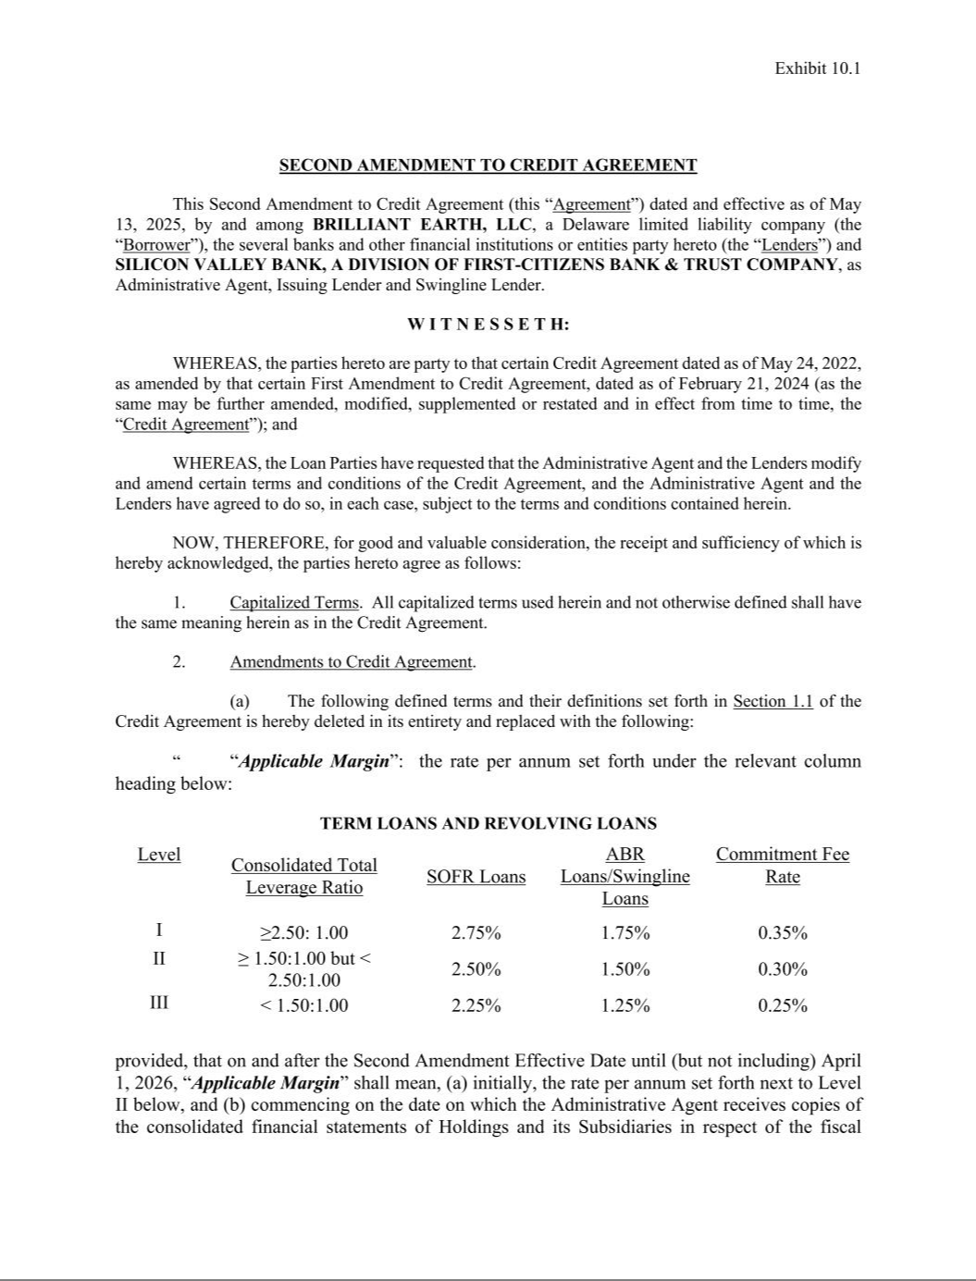

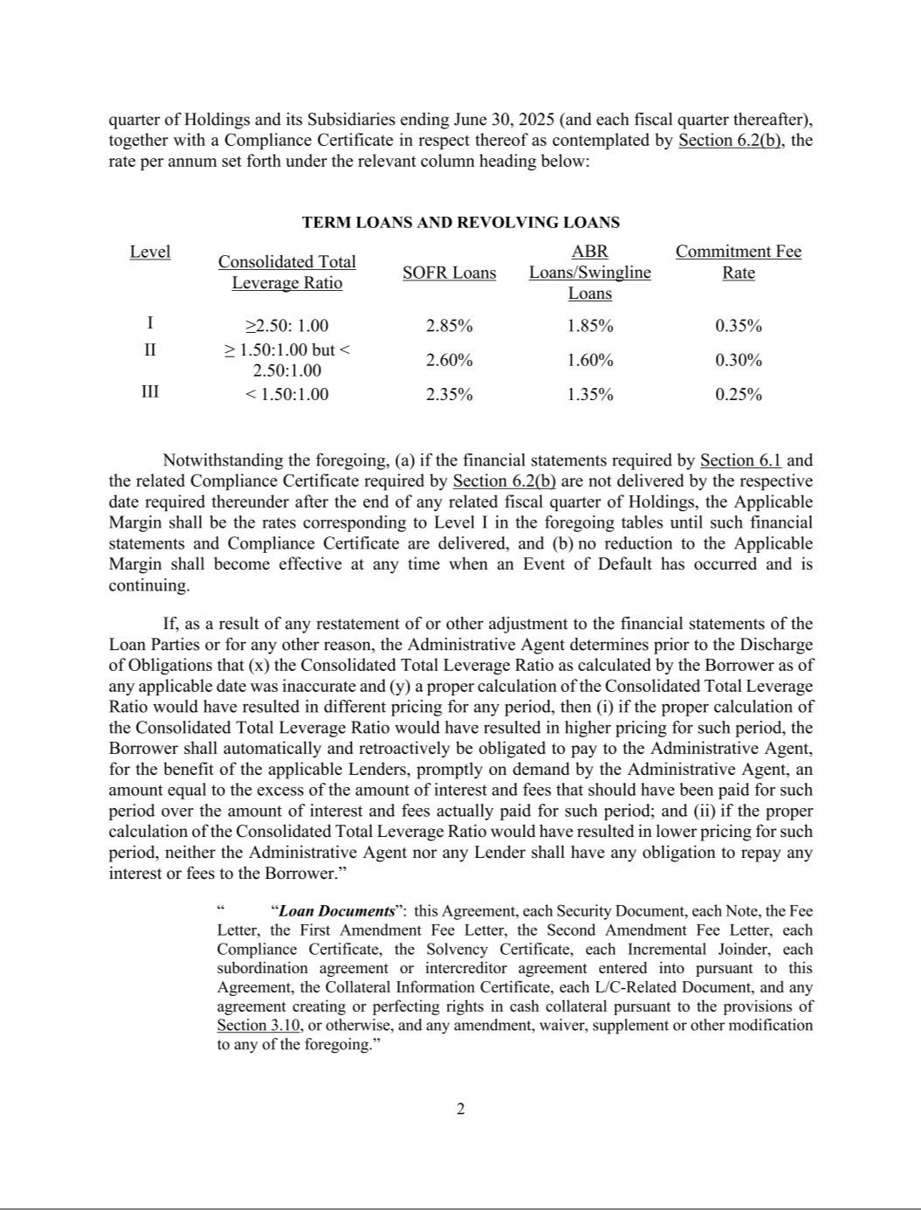

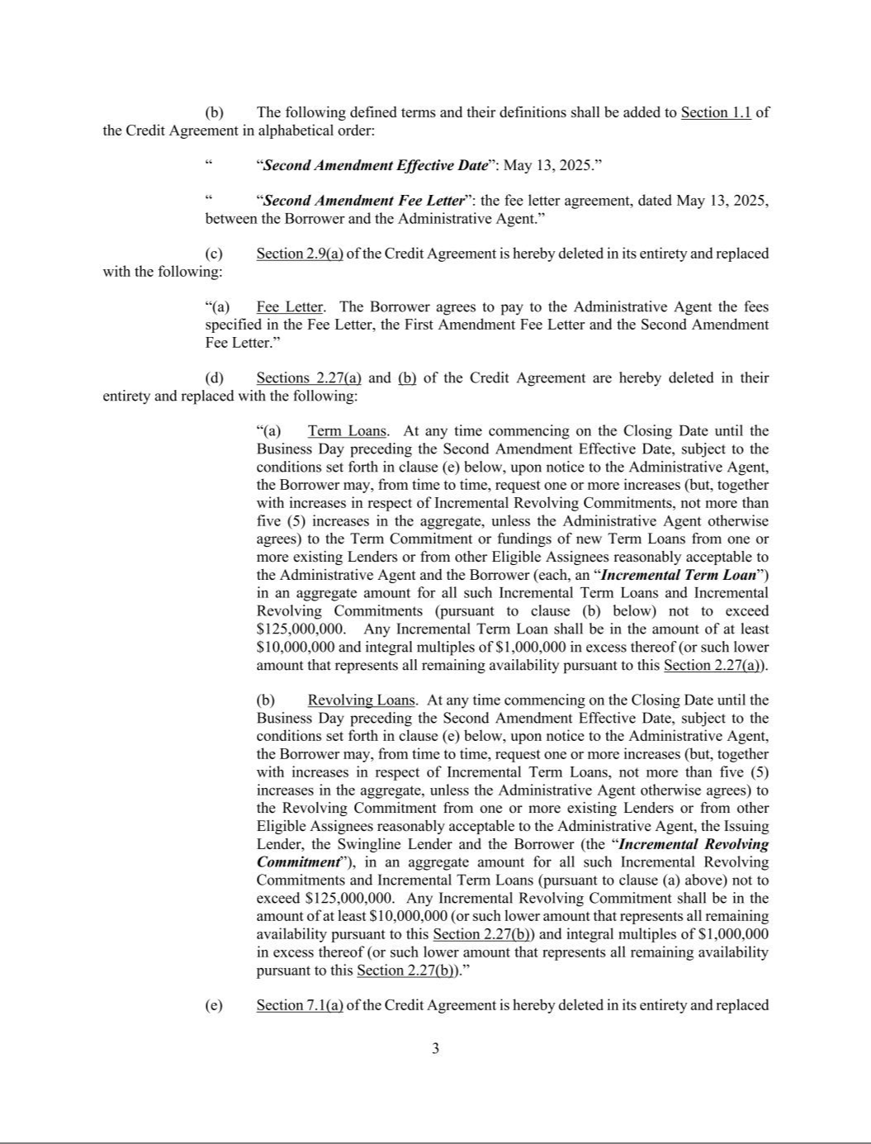

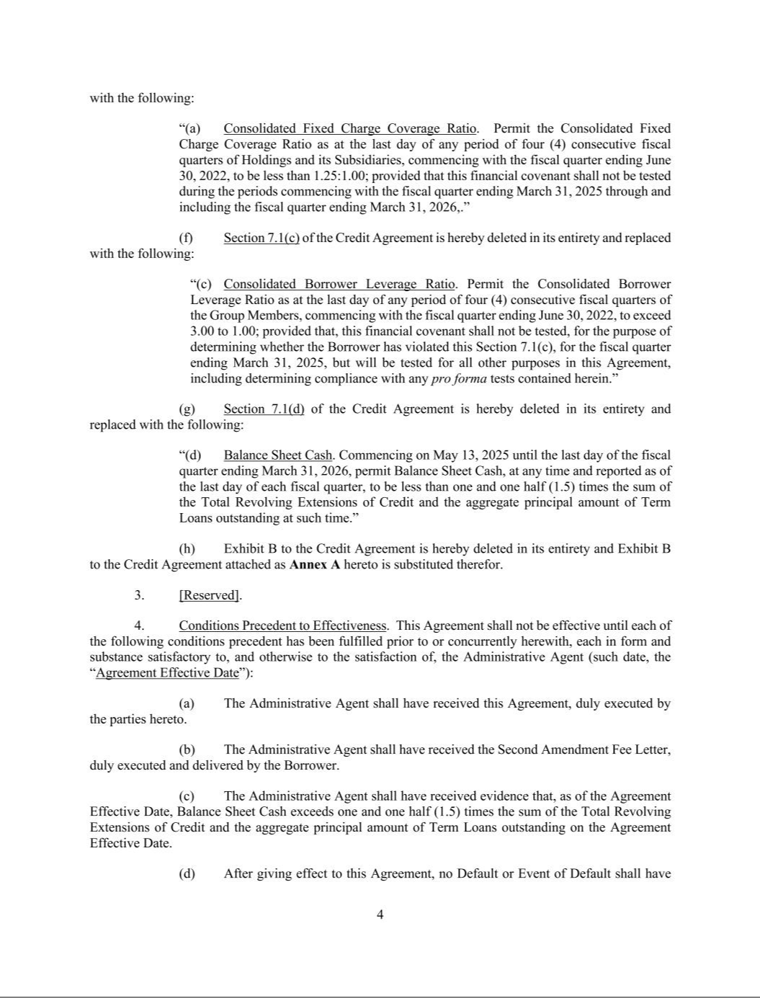

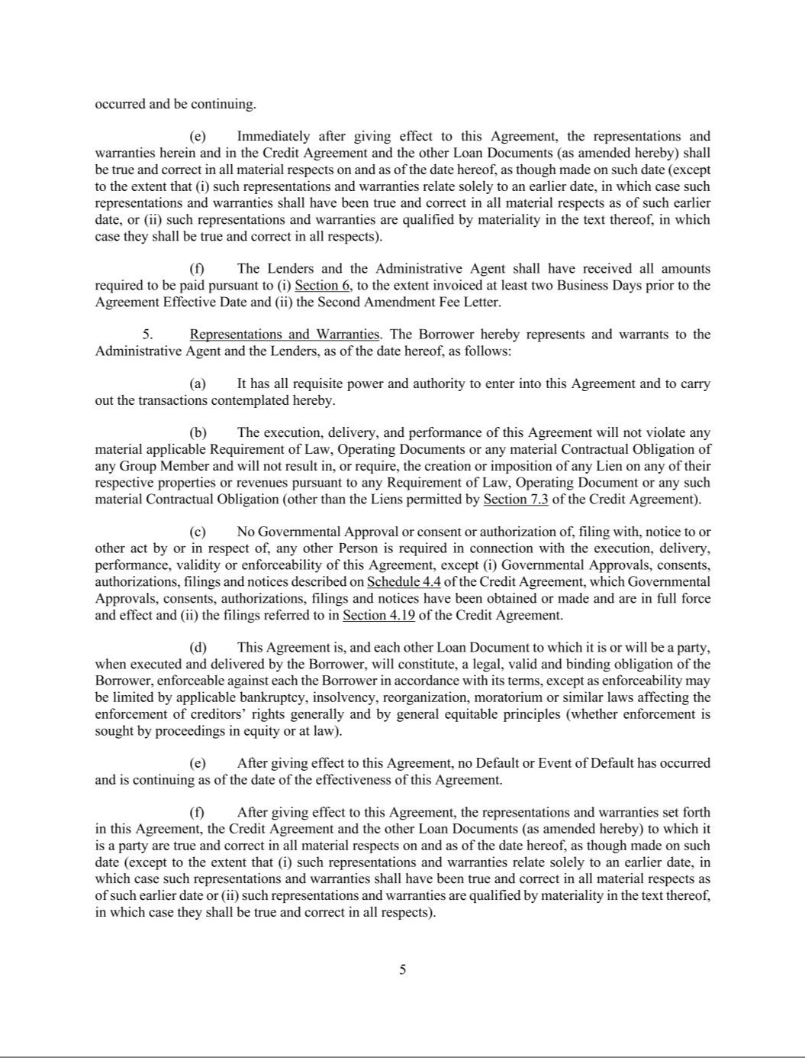

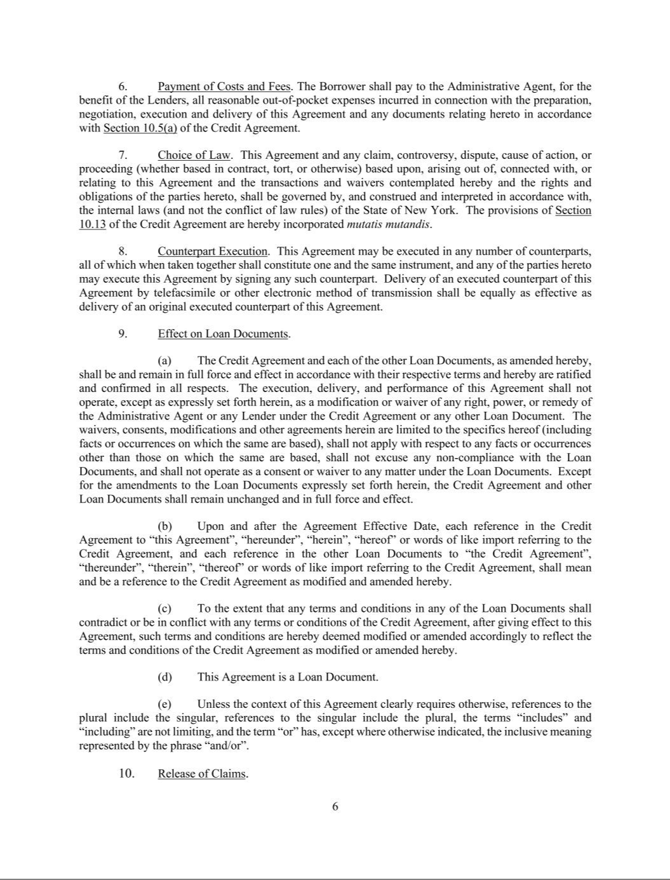

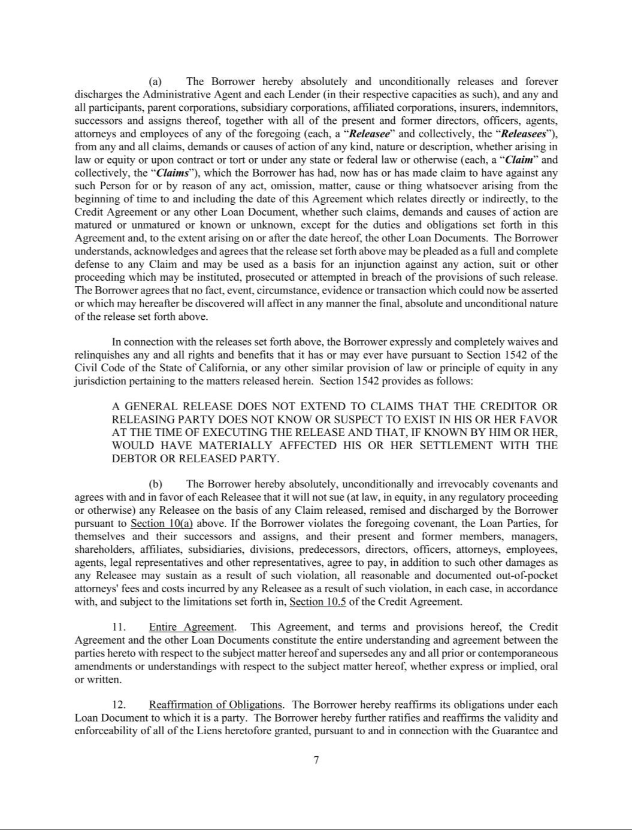

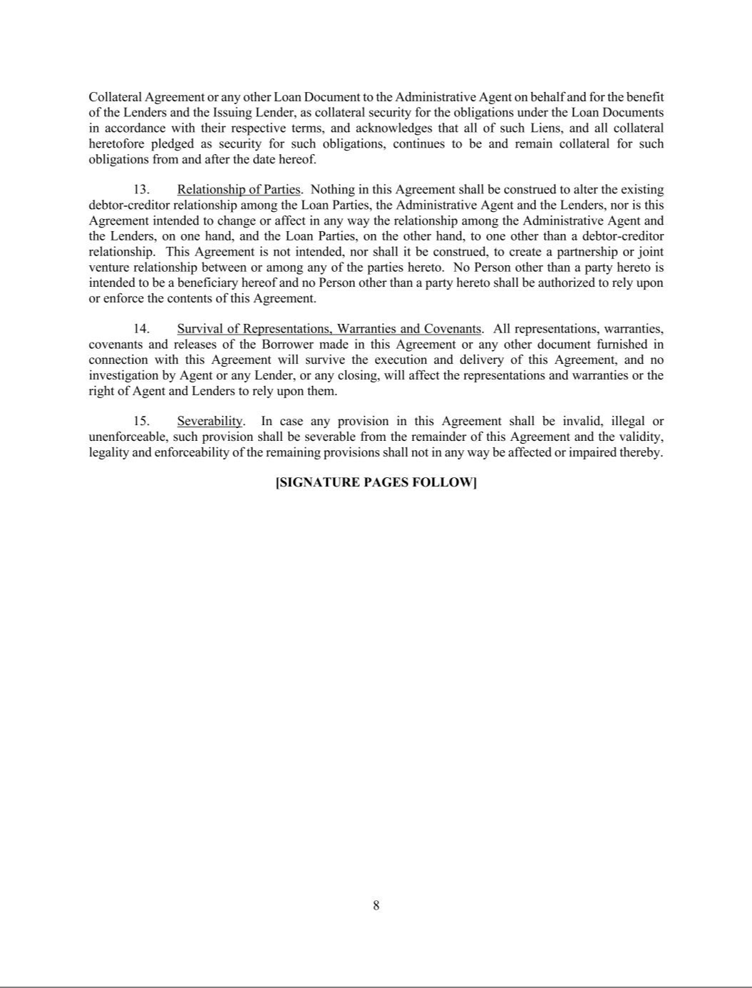

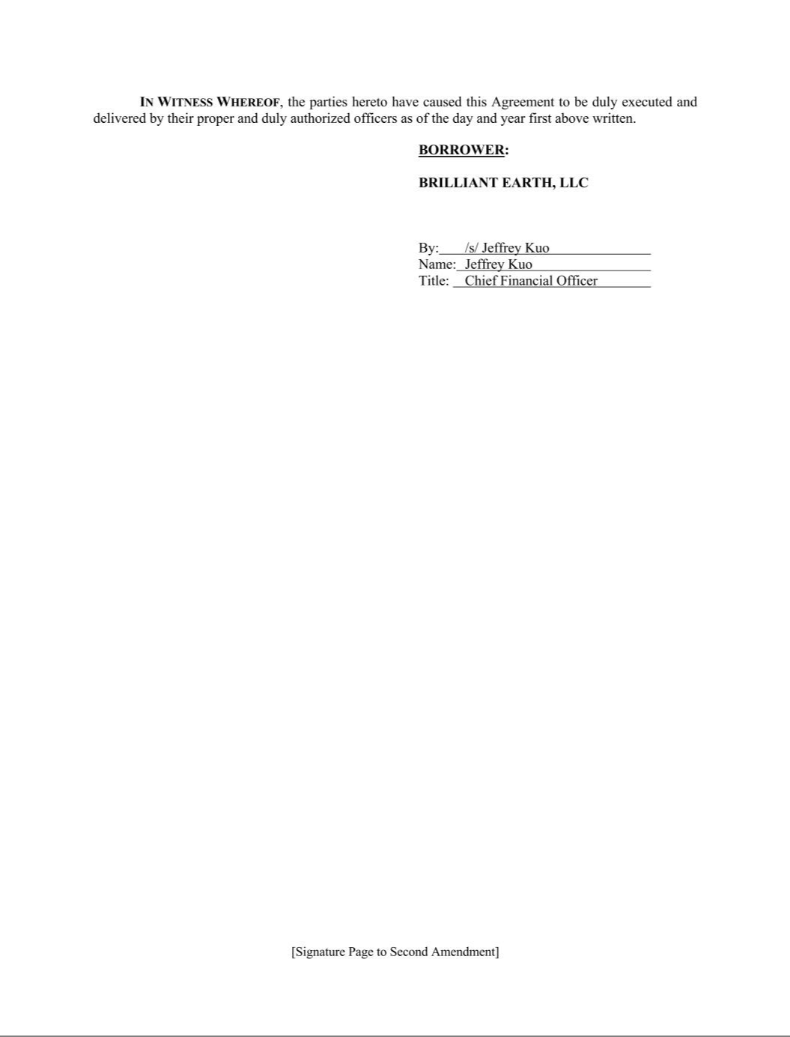

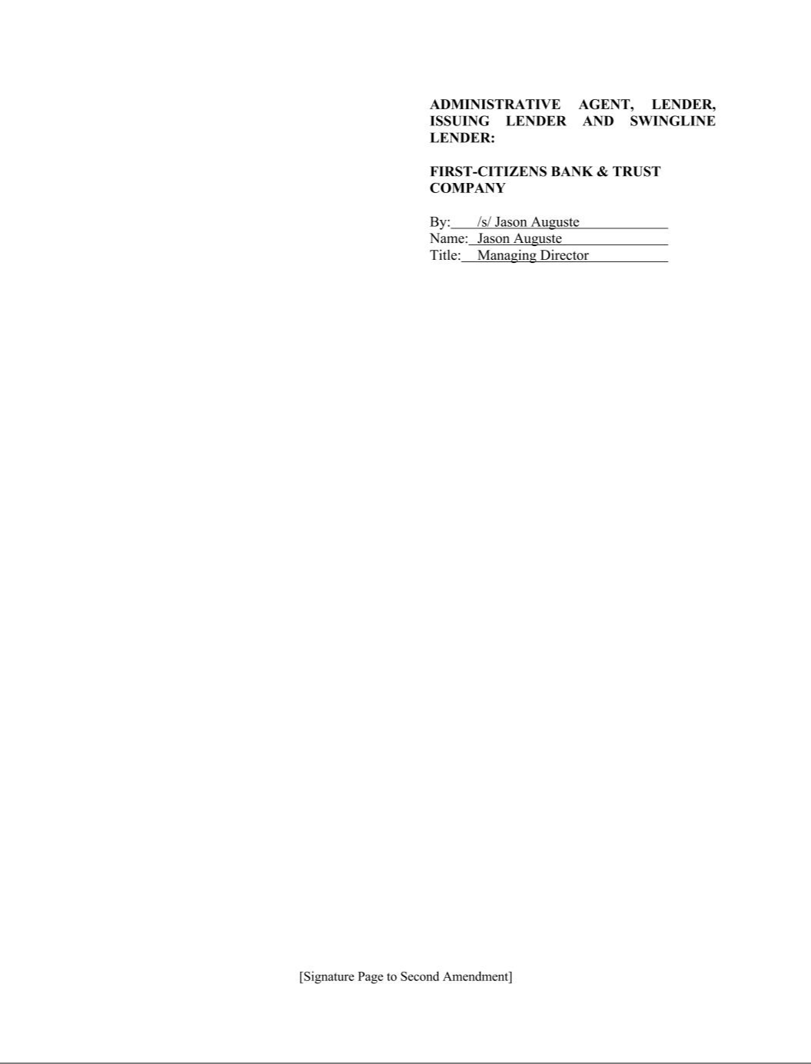







Exhibit 31.1

CERTIFICATION

I, Beth Gerstein, certify that:

      - I have reviewed this Quarterly Report on Form 10-Q of Brilliant Earth Group, Inc.;

      - Based on my knowledge, this report does not contain any untrue statement of a material fact or omit to state a material fact necessary to make the statements made, in light of the circumstances under which such statements were made, not misleading with respect to the period covered by this report;

      - Based on my knowledge, the financial statements, and other financial information included in this report, fairly present in all material respects the financial condition, results of operations and cash flows of the registrant as of, and for, the periods presented in this report;

      - The registrant’s other certifying officer and I are responsible for establishing and maintaining disclosure controls and procedures (as defined in Exchange Act Rules 13a-15(e) and 15d-15(e)) and internal control over financial reporting (as defined in Exchange Act Rules 13a-15(f) and 15d-15(f)) for the registrant and have:

        - Designed such disclosure controls and procedures, or caused such disclosure controls and procedures to be designed under our supervision, to ensure that material information relating to the registrant, including its consolidated subsidiaries, is made known to us by others within those entities, particularly during the period in which this report is being prepared;

        - Designed such internal control over financial reporting, or caused such internal control over financial reporting to be designed under our supervision, to provide reasonable assurance regarding the reliability of financial reporting and the preparation of financial statements for external purposes in accordance with generally accepted accounting principles;

        - Evaluated the effectiveness of the registrant’s disclosure controls and procedures and presented in this report our conclusions about the effectiveness of the disclosure controls and procedures, as of the end of the period covered by this report based on such evaluation; and

        - Disclosed in this report any change in the registrant’s internal control over financial reporting that occurred during the registrant’s most recent fiscal quarter (the registrant’s fourth fiscal quarter in the case of an annual report) that has materially affected, or is reasonably likely to materially affect, the registrant’s internal control over financial reporting; and

- The registrant’s other certifying officer and I have disclosed, based on our most recent evaluation of internal control over financial reporting, to the registrant’s auditors and the audit committee of the registrant’s board of directors (or persons performing the equivalent functions):

    - All significant deficiencies and material weaknesses in the design or operation of internal control over financial reporting which are reasonably likely to adversely affect the registrant’s ability to record, process, summarize and report financial information; and

  - Any fraud, whether or not material, that involves management or other employees who have a significant role in the registrant’s internal control over financial reporting.

Date: May 13, 2025
By: /s/ Beth Gerstein
Name: Beth Gerstein
Title: Chief Executive Officer

(Principal Executive Officer)

Exhibit 31.2

CERTIFICATION

I, Jeffrey Kuo, certify that:

- I have reviewed this Quarterly Report on Form 10-Q of Brilliant Earth Group, Inc.;

- Based on my knowledge, this report does not contain any untrue statement of a material fact or omit to state a material fact necessary to make the statements made, in light of the circumstances under which such statements were made, not misleading with respect to the period covered by this report;

- Based on my knowledge, the financial statements, and other financial information included in this report, fairly present in all material respects the financial condition, results of operations and cash flows of the registrant as of, and for, the periods presented in this report;

- The registrant’s other certifying officer and I are responsible for establishing and maintaining disclosure controls and procedures (as defined in Exchange Act Rules 13a-15(e) and 15d-15(e)) and internal control over financial reporting (as defined in Exchange Act Rules 13a-15(f) and 15d-15(f)) for the registrant and have:

  - Designed such disclosure controls and procedures, or caused such disclosure controls and procedures to be designed under our supervision, to ensure that material information relating to the registrant, including its consolidated subsidiaries, is made known to us by others within those entities, particularly during the period in which this report is being prepared;

  - Designed such internal control over financial reporting, or caused such internal control over financial reporting to be designed under our supervision, to provide reasonable assurance regarding the reliability of financial reporting and the preparation of financial statements for external purposes in accordance with generally accepted accounting principles;

  - Evaluated the effectiveness of the registrant’s disclosure controls and procedures and presented in this report our conclusions about the effectiveness of the disclosure controls and procedures, as of the end of the period covered by this report based on such evaluation; and

  - Disclosed in this report any change in the registrant’s internal control over financial reporting that occurred during the registrant’s most recent fiscal quarter (the registrant’s fourth fiscal quarter in the case of an annual report) that has materially affected, or is reasonably likely to materially affect, the registrant’s internal control over financial reporting; and

- The registrant’s other certifying officer and I have disclosed, based on our most recent evaluation of internal control over financial reporting, to the registrant’s auditors and the audit committee of the registrant’s board of directors (or persons performing the equivalent functions):

  - All significant deficiencies and material weaknesses in the design or operation of internal control over financial reporting which are reasonably likely to adversely affect the registrant’s ability to record, process, summarize and report financial information; and

  - Any fraud, whether or not material, that involves management or other employees who have a significant role in the registrant’s internal control over financial reporting.

Date: May 13, 2025
By: /s/ Jeffrey Kuo
Name: Jeffrey Kuo
Title: Chief Financial Officer
(Principal Financial Officer)

Exhibit 32.1

Certification Pursuant to 18 U.S.C. Section 1350,
As Adopted Pursuant to Section 906 of the Sarbanes-Oxley Act of 2002

In connection with the Quarterly Report on Form 10-Q of Brilliant Earth Group, Inc. (the “Company”) for the period ended March 31, 2025 (the “Report”), as filed with the Securities and Exchange Commission on the date hereof, I, the undersigned, certify, pursuant to 18 U.S.C. Section 1350, as adopted pursuant to Section 906 of the Sarbanes-Oxley Act of 2002, to the best of my knowledge, that:

- The Report fully complies with the requirements of Section 13(a) or Section 15(d) of the Securities Exchange Act of 1934; and

- The information contained in the Report fairly presents, in all material respects, the financial condition and results of operations of the Company.

Date: May 13, 2025
By: /s/ Beth Gerstein
Name: Beth Gerstein
Title: Chief Executive Officer

(Principal Executive Officer)

Exhibit 32.2

Certification Pursuant to 18 U.S.C. Section 1350,
As Adopted Pursuant to Section 906 of the Sarbanes-Oxley Act of 2002

In connection with the Quarterly Report on Form 10-Q of Brilliant Earth Group, Inc. (the “Company”) for the period ended March 31, 2025 (the “Report”), as filed with the Securities and Exchange Commission on the date hereof, I, the undersigned, certify, pursuant to 18 U.S.C. Section 1350, as adopted pursuant to Section 906 of the Sarbanes-Oxley Act of 2002, to the best of my knowledge, that:

- The Report fully complies with the requirements of Section 13(a) or Section 15(d) of the Securities Exchange Act of 1934; and

- The information contained in the Report fairly presents, in all material respects, the financial condition and results of operations of the Company.

Date: May 13, 2025
By: /s/ Jeffrey Kuo
Name: Jeffrey Kuo
Title: Chief Financial Officer
(Principal Financial Officer)

