UNITED STATES
SECURITIES AND EXCHANGE COMMISSION
Washington, D.C. 20549
______________
FORM 8-K
____________
CURRENT REPORT
Pursuant to Section 13 or 15(d)
of the Securities Exchange Act of 1934

Date of Report (Date of earliest event reported): March 20, 2026
Brilliant Earth Group, Inc.
(Exact name of registrant as specified in its charter)
Nevada |  |  | 001-40836 |  |  |  |  |  | 87-1015499
(State or other jurisdiction of incorporation or organization) |  |  | (Commission File Number) |  |  |  |  |  | (I.R.S. Employer Identification No.)
300 Grant Avenue, Third Floor,  San Francisco, CA |  |  |  |  |  |  |  |  | 94108
(Address of Principal Executive Offices) |  |  |  |  |  |  |  |  | (Zip Code)
Registrant's telephone number, including area code: (800) 691-0952

Check the appropriate box below if the Form 8-K filing is intended to simultaneously satisfy the filing obligation of the registrant under any of the following provisions (see General Instruction A.2. below):

☐ Written communications pursuant to Rule 425 under the Securities Act (17 CFR 230.425)
☐ Soliciting material pursuant to Rule 14a-12 under the Exchange Act (17 CFR 240.14a-12)
☐ Pre-commencement communications pursuant to Rule 14d-2(b) under the Exchange Act (17 CFR 240.14d-2(b))
☐ Pre-commencement communications pursuant to Rule 13e-4(c) under the Exchange Act (17 CFR 240.13e-4(c))

Securities registered pursuant to Section 12(b) of the Act:
Title of each class |  |  | Trading Symbol(s) |  |  | Name of each exchange on which registered
Class A common stock, $0.0001 par value per share |  |  | BRLT |  |  | The Nasdaq Global Market

Indicate by check mark whether the registrant is an emerging growth company as defined in Rule 405 of the Securities Act of 1933 (§230.405 of this chapter) or Rule 12b-2 of the Securities Exchange Act of 1934 (§240.12b-2 of this chapter).

Emerging growth company ☒

If an emerging growth company, indicate by check mark if the registrant has elected not to use the extended transition period for complying with any new or revised financial accounting standards provided pursuant to Section 13(a) of the Exchange Act. o

Item 5.02. Departure of Directors or Certain Officers; Election of Directors; Appointment of Certain Officers; Compensatory Arrangements of Certain Officers.

On March 19, 2026, Ian M. Bickley notified the Chairman of the Board of Directors (the “Board”) of Brilliant Earth Group, Inc. (the “Company”) of his resignation from the Board, including from his service on the Audit Committee and the Nominating and Corporate Governance Committee of the Board, effective March 31, 2026. Mr. Bickley has indicated to the Company that his decision to resign is as a result of recent changes in his other professional commitments, and not the result of any disagreement with the Company or its management on any matter relating to the Company’s operations, policies or practices. A copy of Mr. Bickley's resignation letter is attached to this Current Report on Form 8-K as Exhibit 99.1.

The Board intends to reduce its size to six directors and appoint Beth Kaplan, a current member of the Board, to serve as a member of the Audit Committee, effective March 31, 2026.

Forward-Looking Statements

This Current Report on Form 8-K contains forward-looking statements within the meaning of the Private Securities Litigation Reform Act of 1995. Forward-looking statements include, without limitation, statements regarding the Company’s expectations and intentions with respect to the size and composition of the Board and the anticipated appointment of a current director to serve on a committee of the Board. These statements are based on current expectations, assumptions and information available to the Company as of the date of this report. Forward-looking statements are subject to a number of risks and uncertainties that could cause actual results to differ materially from those expressed or implied by such statements, including, among others, the possibility that the Board may determine not to implement the anticipated changes to its size or committee composition, or that other factors may affect the timing or outcome of such actions. The Company undertakes no obligation to update or revise any forward-looking statements, whether as a result of new information, future events or otherwise, except as required by law.

Item 9.01 Financial Statements and Exhibits.

(d) Exhibits
Exhibit 99.1 |  |  | Resignation Letter, dated March 19, 2026, of Ian M. Bickley

SIGNATURE

Pursuant to the requirements of the Securities Exchange Act of 1934, the registrant has duly caused this report to be signed on its behalf by the undersigned hereunto duly authorized.

BRILLIANT EARTH GROUP, INC.
Date: March 20, 2026 |  |  |  |  |  |  |  |  |  |  |  |  |  |  | /s/ Alex Grab
 |  |  |  |  |  |  |  |  |  |  |  |  |  |  | Alex Grab
 |  |  |  |  |  |  |  |  |  |  |  |  |  |  | General Counsel & Corporate Secretary

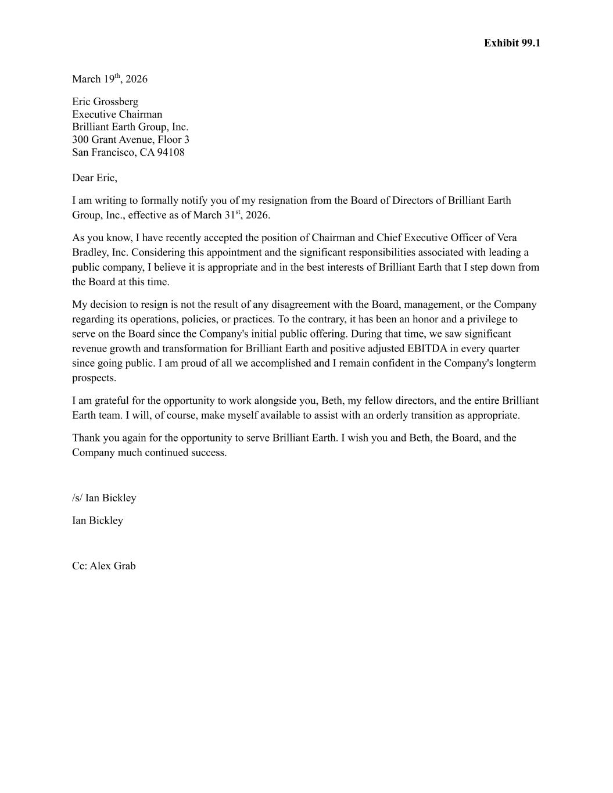

Exhibit 99.1 March 19th, 2026 Eric Grossberg Executive Chairman Brilliant Earth Group, Inc. 300 Grant Avenue, Floor 3 San Francisco, CA 94108 Dear Eric, I am writing to formally notify you of my resignation from the Board of Directors of Brilliant Earth Group, Inc., effective as of March 31st, 2026. As you know, I have recently accepted the position of Chairman and Chief Executive Officer of Vera Bradley, Inc. Considering this appointment and the significant responsibilities associated with leading a public company, I believe it is appropriate and in the best interests of Brilliant Earth that I step down from the Board at this time. My decision to resign is not the result of any disagreement with the Board, management, or the Company regarding its operations, policies, or practices. To the contrary, it has been an honor and a privilege to serve on the Board since the Company's initial public offering. During that time, we saw significant revenue growth and transformation for Brilliant Earth and positive adjusted EBITDA in every quarter since going public. I am proud of all we accomplished and I remain confident in the Company's longterm prospects. I am grateful for the opportunity to work alongside you, Beth, my fellow directors, and the entire Brilliant Earth team. I will, of course, make myself available to assist with an orderly transition as appropriate. Thank you again for the opportunity to serve Brilliant Earth. I wish you and Beth, the Board, and the Company much continued success. /s/ Ian Bickley Ian Bickley Cc: Alex Grab

